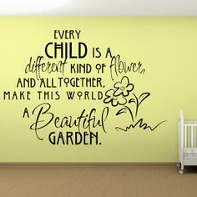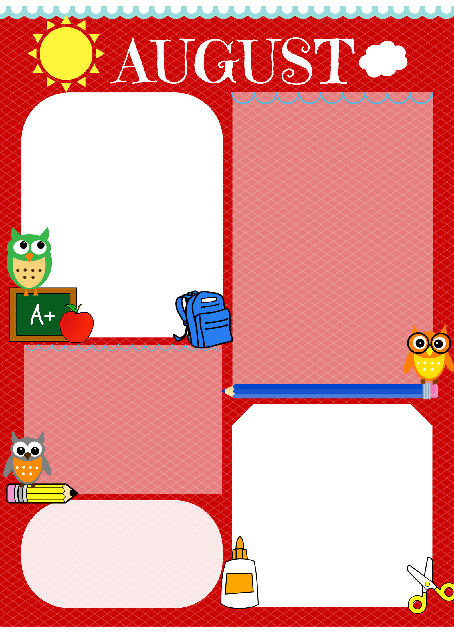

**Homework**

1. Please practice sight words
2. Read to child 15 minutes nightly
3. Practice ABC’s/Numbers/Personal Data
4. Other Homework may be assigned ☺

**UPCOMING EVENTS**

|  |  |  |  |  |
| --- | --- | --- | --- | --- |
| 1 | 2 | 3 | 4 | 5 |
| 6 | 7 | 8 | 9 | 10 |
| 11 | 12 | 13 | 14 Early Release | 15 |
| 16 | 17 | 18 | 19 | 20 |
| 21 | 22 | 23 | 24 | 25 |
| 26 | 27 | 28 | 29 | 30 |

**What we are learning......**

**Math**

Identifying Numbers

**Reading**

Phonics-Letter sounds, Comprehension-(Who? What? When? Where? Why?)

**Science**

Weather

**Social Studies**

Where do I live?

Mrs. Bullock, Mrs. Faucette, Mrs. Wells, & Mr. Cooper

**September 2016**

**Notes**

* Parents if your child wears pull ups, please be sure to send them daily, possible extras or a pack for the month.
* Thank you for all of your help as we continue to work together as a team!
* Our efforts will help your child learn!

**Who’s Got the News?**