Name ____________________

Math in the Movies

- The IBM commercial repeatedly shows ways that math can make the world better and smarter. Name two careers in which Math is needed. Tell why Math would be needed.

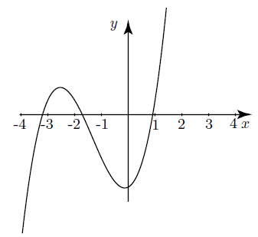
- The clip from Old School mentions Harriet’s Method of Solving Cubics, which are very complicated equations. Sometimes, it helps to graph cubic equations. How many times does this cubic equation cross the x-axis?

- If you opened two Wonka Bars out of 1,000, what percent did you open? How many bars out of 1,000 would you need to open in order to reach 40%?

- In the clip from the Simpsons, Ralph charges Bart twice the fair from Tucson to Flagstaff, minus 2/3 the fair from Albuquerque to El Paso. It costs $40 to travel from Tucson to Flagstaff, and $90 to travel from Albuquerque to El Paso. So, how much does Bart need to pay?

- The girl from Clueless doesn’t know her times tables! List all the multiples of 7, up to 84.

- In the Office episode, Michael has a surplus. A surplus is extra, left over money or products. If you had a budget of $7,000 for the year, and you spent $350 per month, what would your surplus be at the end of the year?

- You’re smarter than Abbot and Costello. Make a drawing to prove that 7 times 4 really equals 28.

- The Father of the Bride flips out when he realizes that the hot dogs and buns don’t match. There are 8 hot dogs in a package and 12 buns in a package. How many packs of hot dogs and how many packs of buns do you need to purchase in order to have the exact same number of each?

- A permutation is an arrangement of objects in a certain order. In National Treasure, they need to arrange a code in a certain order. Let’s say 4 people walk into a fast food restaurant. How many different ways can they line up to order?

- In the movie, Twenty-One, they discuss probability. If there are 4 doors, and behind one of them there is a new car, and behind one of them there is an angry tiger, what is the probability that you randomly choose the door with the car? If you opened a door that contained nothing, and you got to choose another door, what is the probability that you would randomly choose the door with the car? Explain if you would keep playing at that point or if you would quit.

- Despite the ridiculous teacher in School of Rock, music is actually full of math. For example, how many eighth notes make a quarter note? How many half notes make a whole note? How many sixteenth notes make a half note?

- In Shrek the Third, Pinocchio’s reasoning is very unclear and illogical. You’re better at logic and reasoning. Prove it by finding the mystery number: Find a three digit number. The tens digit is 3 times the hundreds digit. The sum of the digits is 15. If you reverse the digits, it is divisible by 6 and 3. What is the number?

- The boys from A Walk to Remember are forming similar isosceles triangles on the basketball court. Draw a scalene triangle. Label the sides. Now draw a similar triangle, using a factor of 2.

- Perhaps the Wizard of Oz didn’t really give the Scarecrow a brain. Why not? Because the Scarecrow from the Wizard of Oz says “The sum of the square roots of any two sides of an isosceles triangle is equal to square root of the remaining side.” But he’s wrong!

The correct equation for the Pythagorean Theorem is, “The sum of the squares of the two legs of a right triangle is equal to the square of the hypotenuse.” Prove it by finding the squares of the side lengths for these two triangles:
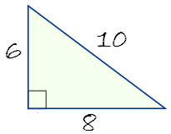
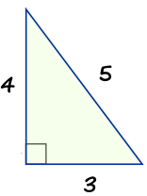

- The teacher in Stand and Deliver teaches the class about multiplying integers. Follow his advice and solve: -5 ● (-2) -7 ● (-8) -3 ● (-4)

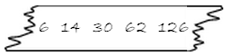
- In Numb3rs, they use Math to solve crimes. One of the ways they use Math is to reveal patterns. What is the pattern in this sequence? What would the first and the last missing numbers be?

- In the movie Good Will Hunting, a custodian solves an equation in 10 minutes. It took other people two years to find a solution. How many minutes are in two years?

- The characters in Little Big League eventually solve the problem using the equation $\frac{ab}{a+b}$. So if 1 person takes 6 hours to paint a house, and another person takes 10 hours to paint a house, how long does it take them to paint the house together?

- In Castaway, the character uses the formula πr ² to calculate the area of a circle. Using 3.14 for pi, what is the area of a circle with a diameter of 12 inches? Draw a picture of the circle.

- In Stand and Deliver, the student at the chalkboard has taken calculus for two years. A school year is about 180 days. If the class period is 45 minutes long, how many hours of calculus has he taken?

- In Mean Girls, the character is distracted by another student. What can you do to be sure you’re staying focused during Math class?

