Transformations: KEEP SHEET
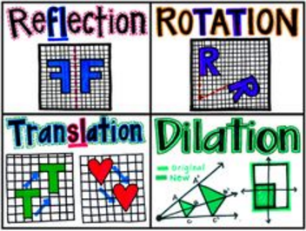
Translations (slide):  - Maintains the way the shape is facing, the shape, the size of the shape, the length of the sides, and the size of the angles. | - Left (-) or Right (+) affects the x-value.  - Up (+) or Down (-) affects the y-value.
Reflections (flip):  - Flips the way the shape is facing. Maintains the shape, the size of the shape, the length of the sides, and the size of the angles. | - Over the x-axis; (x, y) → (x, -y)  - Over the y-axis; (x, y) → (-x, y)  - Over the line y = x; (x, y) → (y, x)  - Over a given line; line will go through the coordinate.  - Example: y = 2 horizontal through the point (0, 2), all y-values on the line are equal to 2.  - Example: x = 2 horizontal through the point (2, 0), all x-values on the line are equal to 2.
Rotations (turn):  - Turns the way the shape is facing. Maintains the shape, the size of the shape, the length of the sides, and the size of the angles. | - 90⁰ counterclockwise: (x, y) → (-y, x)  - 180⁰ clockwise/counterclockwise: (x, y) → (-x, -y)  - 270⁰ counter clockwise: (x, y) → (y, -x)
Dilations (grow or shrink, resize):  - Resizes the shape. Maintains the shape and the measure of corresponding angles, but changes the size of the shape and the length of the sides. | - Scale Factor = n  - Rule: (n∙x, n∙y)
Definitions
Congruent – exact same measures. Congruent figures will have congruent corresponding angles, congruent corresponding sides, be the same shape, and be the same size.

Similar – has congruent corresponding angle measures, proportional side lengths, the same shape, but a different size image.

Neither – the angles DO NOT share the same measures.

