Franklin County Early College
High School
“Learn Today, Lead Tomorrow”

Course Information Faculty Information
Course Name: Math 2 Faculty Member: Katelyn Jones
Class Location: Room 109 Faculty Email: katelynevans@fcschools.net
Faculty Tutoring Times: Tuesday and Thursday 2:45-3:45 pm

Required Textbook and Supplies: 1.5” math only binder (NO binder keepers!!), loose leaf paper, notebook of graph paper, pencil, highlighter, good attitude, perseverance
Course Description: The fundamental purpose of Math II is to deepen and extend the mathematics that students learned in the middle grades and in Math I.
Course Outline:
Unit 1: Algebra Review Unit 7: Transformations
Unit 2: Functions & Linear Equations Unit 8: Introduction to Geometry
Unit 3: Factoring & Solving Quadratics Unit 9: Triangles
Unit 4: Solving Quadratics & Applications Unit 10: Trigonometry
Unit 5: Radical Equations Unit 11: Probability
Unit 6: Polynomials & Function Analysis

Mission Statement: Franklin County Early College High School’s mission is to provide small learning communities to prepare students for academic rigor, relevant coursework to build school and community relationships embracing 21st century skills
The framework of the early college high school is to ensure each student earns a high school diploma and a two year degree or transferable college credits in five years or less. Another objective of the early college high school is to improve high school graduation, college attendance and completion rate and to integrate students into the college culture at the high school level.
Evaluation: Percentage Value Evaluation Item Grading Scale:
45% Tests/Projects A = 100 – 90
15% Classwork B = 89 – 80
15% Homework C = 79 – 70
25% Quizzes D = 69– 60
100% TOTAL F = 59 and below
Classroom Rules:
- Arrive on time to class.
- Come to class prepared with all materials required for learning.
- Do not interrupt the learning process for you, for me, or for your classmates.
- Take responsibility for your own actions and for your own learning.
- All school rules apply in this classroom.

Homework: Homework is essential to learning math well. Learning math is like learning a sport, you have to practice it. Homework and classwork will be given often and checked 100% of the time. They will be graded on completion. Each student will begin the grading period with 100 points in the homework category. Whenever a student completes the homework, the grade will remain a 100. For a homework assignment where the student only completes roughly half of the homework assignment, 1 point will be deducted from their homework grade. For a homework assignment where the student attempts less than half of the problems or shows no work, 2 points will be deducted from their homework grade.

Students are required to SHOW work to receive credit. Homework will NOT be accepted LATE.

Classwork: The classwork grade will be determined by several factors. The classwork portion will be executed in the same manner as homework. Classwork is expected to be finished in class unless extenuating circumstances prohibit a student finishing his/her work.

Warm-Up: Students are expected to complete the warm-up daily in their notebook. Warms-ups will be an extension of the material taught the previous day.
Notebooks: Students are expected to keep a math specific notebook (their 1.5” binder). Students will write the warm-up to begin each day. Students are expected to take notes, and write examples. Notebooks will be collected and graded on organization each test day for a classwork grade.
Quizzes: Quizzes will be announced and will be posted on the Daily Board Announcements on the whiteboard in class. All quizzes will be recorded.

Tests: Tests will be given at the end of every unit. Students are encouraged to read notes and practice similar problems given in class to always be prepared for a test.

Tutoring: Tutoring is designed for the teachers to answer specific questions about homework, lessons and/or classwork. This is not a time for re-teaching! Students need to attempt problems before asking for help.

Class Attendance:
Students are expected to be in class daily, prepared, on time, and for the entire class period. Excessive tardies and early dismissals could result in school suspension. Five or more absences could result in failure of a class.

Students are expected to use the restroom or get a drink at the beginning or end of class. Students will be given six tickets at the beginning of every nine weeks. Once class is underway, a student must present a ticket to leave the room (bathroom, water, see another teacher, etc. This does not apply when the student is called out of the room by the office or another teacher). Each unused ticket may be used as a point on any assignment at the end of the grading period.

Unacceptable Behaviors: Sleeping, laying head down, eating, disruptive behaviors such as talking, playing, and walking around the room, being disrespectful to teacher or others, and/or being on a cellphone

Classroom Wish List: The following items I would love to have for my classroom, but is not required for students/parents to buy….just if you’re feeling a little generous. :)
- Mechanical pencils - Tissue boxes
- Pens (black or blue) - Colored pencils (12 count)
- Highlighters (any colors) - Colored copy paper
- Colored Markers (10 count) - Hand sanitizer
- Skinny Expo Markers (black)

Remind: Students are required to enroll in Remind notifications. Parents are strongly encouraged to enroll in Remind notifications. Through Remind, I will send out important information regarding class, homework, and various other announcements. Don’t worry, I won’t blow your phone up.
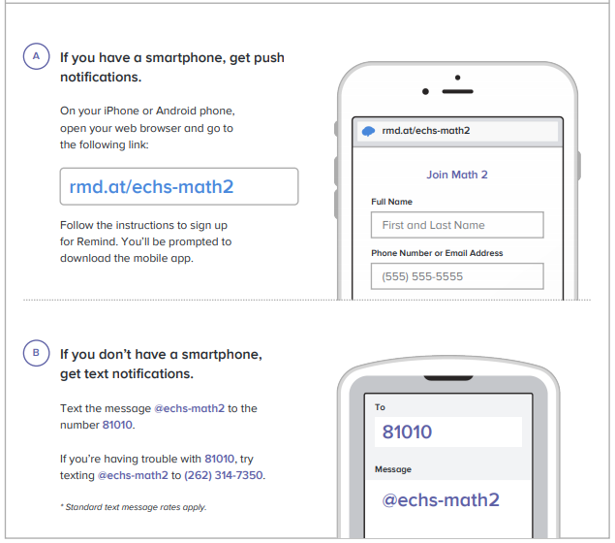

PARENTS: Please read the above information and sign below.
Cut off bottom portion and give to your child to return.
For any questions and concerns, please email me at katelynevans@fcschools.net.

---------------------------------------------------------------------------------------------------------------------------------------
STUDENT NAME: _____________________________________

PARENT/GUARDIAN NAME(S): ______________________________________

PARENT/GUARDIAN SIGNATURE: ______________________________________

PARENT EMAIL(S): ____________________________________________

PARENT PHONE NUMBER(S): _________________________________________

*If writing multiple emails or phone numbers, please designate which parent/guardian is associated with it.

