Franklin County Early College
High School
“Learn Today, Lead Tomorrow”

Course Information Faculty Information
Course Name: MW Senior Seminar Faculty Member: Katelyn Jones
Class Location: Room 109 Faculty Email: katelynevans@fcschools.net

Required Supplies: 1.5” binder, loose leaf paper, good attitude, writing utensil, CHARGED laptop/computer

Course Description: The fundamental purpose of Senior Seminar is to prepare students for life beyond high school, whether that means college, work force, or the military.

Course Outline:
January – time management and study skills
February – money and budgeting
March - guest speakers
April - work on and finalize projects
May - present projects

Mission Statement: Franklin County Early College High School’s mission is to provide small learning communities to prepare students for academic rigor, relevant coursework to build school and community relationships embracing 21st century skills
The framework of the early college high school is to ensure each student earns a high school diploma and a two year degree or transferable college credits in five years or less. Another objective of the early college high school is to improve high school graduation, college attendance and completion rate and to integrate students into the college culture at the high school level.
Evaluation: Number of Points Evaluation Item Grading Scale:
20% Weekly Attendance A = 100 – 90
35% Classwork & Participation B = 89 – 80
45% Semester Project C = 79 – 70
100% TOTAL D = 69 – 60
F = 59 and below

Classroom Rules:
- Arrive on time to class.
- Come to class prepared with all materials required for learning.
- Do not interrupt the learning process for you, for me, or for your classmates.
- Take responsibility for your own actions and for your own learning.
- All school rules apply in this classroom.

Class Attendance:
Students are expected to be in class daily, prepared, on time, and for the entire class period. Excessive tardies and early dismissals could result in school suspension. Five or more unexcused absences could result in failure of a class. Three tardies equals one absence. If a student has five or more unexcused absences at the end of the semester, the student will receive a “FF” (failure due to absences) on their report card and will have to report to summer school to make up the time. If the student does not report to school to make up the time, the student will receive an “F” for the course, regardless of the student’s original grade.

Students are expected to use the restroom or get a drink at the beginning or end of class. Students will be given six tickets at the beginning of a grading period. Once class is underway, a student must present a ticket to leave the room (bathroom, water, see another teacher, etc. This does not apply when the student is called out of the room by the office or another teacher). At the end of the marking period the student may redeem each unused ticket for one point on any assignment.

Unacceptable behaviors: Sleeping, laying head down, eating, disruptive behaviors such as talking, playing, and walking around the room, being disrespectful to teacher or others, and or being on a cellphone or laptop when not authorized to do so

NO LATE WORK IS ACCEPTED.

Since this class only meets on Mondays and Wednesdays, students may NOT come to class on a Tuesday or Thursday and expect to be considered present on a Monday or Wednesday. You can only make up the work missed in class, not the day you missed.

Remind: Students are required to enroll in Remind notifications. Parents are strongly encouraged to enroll in Remind notifications. Through Remind, I will send out important information regarding class, homework, and various other announcements.

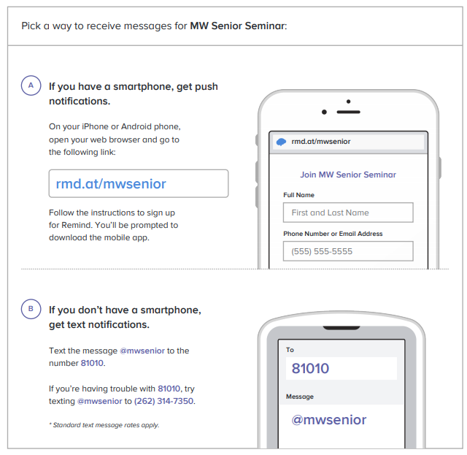

PARENTS: Please read the above information and sign below.
Cut off bottom portion and give to your child to return.
For any questions and concerns, please email me at katelynevans@fcschools.net.

---------------------------------------------------------------------------------------------------------------------------------------
STUDENT NAME: _____________________________________

PARENT/GUARDIAN NAME(S): ______________________________________

PARENT/GUARDIAN SIGNATURE: ______________________________________

PARENT EMAIL(S): ____________________________________________

PARENT PHONE NUMBER(S): _________________________________________

*If writing multiple emails or phone numbers, please designate which parent/guardian is associated with it.

