Chapter 7 Cellular Respiration
- Most energy from an original carbon glucose molecule being broken down to CO2 with net ATP -post glycolysis but before electron transport chain - is in the form of (NADH or NAD+)

- Name the TWO types of electron carriers produced in the citric acid cycle.
NADH AND FADH2
- What process in eukaryotic cells will proceed with or without O2?
GLYCOLYSIS
- Name the process that produces the MOST ATP when glucose is completely oxidized to CO2 and H2O.
OXIDATIVE PHOSPHOROLATION (CHEMIOSMOSIS)
- What is the primary role of oxygen in cellular respiration?
ACTAS AN ACCEPTOR FOR ELECTRONS & HYDROGREN; FORMING WATER
- What is the difference between catabolic and anabolic pathways?
CATABOLIC; BREAKS DOWN MOLECULES AND ANABOLIC; SMALL MOLECULES BUILD LARGER COMPLEX MOLECULES
- Write out the formula for cellular respiration. What is oxidized? What is reduced?
FORMULA IN YOUR NOTES!
C6H12O6 – OXIDIZED AND O2 IS REDUCED
- When NAD+ gains a H atom, the molecule becomes (oxidized, reduced)
- When an athlete exhausts his or her ATP supply, what likely happens?
CATABOLIC PROCESSES ARE ACTIVATED THAT GENERATE MORE ATP
- What are ALL products produced by glycolysis?
2 NADH, 2 PYRUVATE & 2 ATP
- List the sequence (in order) of complete oxidation process of glucose (start to finish)
GLUCOSE-GLYCOLYSIS-PYRUVATE OXIDATION-CITRIC ACID CYCLE-ELECTRON TRANSPORT CHAIN
- Why is glycolysis considered to be one of the FIRST metabolic pathways to evolve?
DOES NOT INVOLOVE ORGANELLES OR SPECIALIZED STRUCTURES, DOES NOT REQUIRE O2, PRESENT IN MOST ORGANISMS

Chapter 8 Photosynthesis
- The process of photosynthesis most likely originated in (prokaryotes or eukaryotes)
PROKARYOTES
- Name the location of chlorophyll in autotrophic bacteria.
INFOLDED PLASMA MEMBRANE
- Plant photosynthesize in the (light or dark), but respire in (light or dark or both)

- When oxygen is released due to photosynthesis, it is a direct by product of SPLITTING WATER MOLECULES
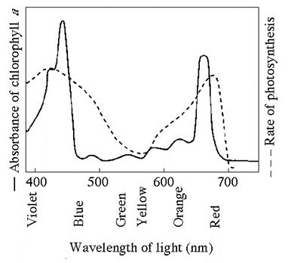
- What wavelength of light is the LEAST effective driving photosynthesis? 700NM
- What colors are the MOST effective for driving photosynthesis? VIOLET - BLUE
- What is the difference between autotrophs and heterotrophs? Be specific.
AUTOTROPHS CAN NOURSIH THEMSELVES
- Why do the leaves of deciduous trees change colors in autumn?
CARTENOIDS & OTHER PIGMENTS ARE STILL PRESENT IN LEAVES
- As electrons are passed through the electron carriers with photosystem II, the lose energy. What happens to this energy?
IT IS USED TO SYNTHESIZE ATP
- In photosynthesis, chemiosmosis moves proteins from ___STROMA___ to ____THYLAKOID SPACE_________.

- Name the TWO products of light reactions that are used in Calvin Cycle.
ATP AND NADPH
- What is the primary function of the Calvin Cycle?
SYTNTHESIZE SIMPLE SUGARS FROM CO2

