Chapter 7 Cellular Respiration
- Most energy from an original carbon glucose molecule being broken down to CO2 with net ATP -post glycolysis but before electron transport chain - is in the form of (NADH or NAD+)

- Name the TWO types of electron carriers produced in the citric acid cycle.

- What process in eukaryotic cells will proceed with or without O2?

- Name the process that produces the MOST ATP when glucose is completely oxidized to CO2 and H2O.

- What is the primary role of oxygen in cellular respiration?

- What is the difference between catabolic and anabolic pathways?

- Write out the formula for cellular respiration. What is oxidized? What is reduced?

- When NAD+ gains a H atom, the molecule becomes (oxidized, reduced)

- When an athlete exhausts his or her ATP supply, what likely happens?

- What are ALL products produced by glycolysis?

- List the sequence (in order) of complete oxidation process of glucose (start to finish)

- Why is glycolysis considered to be one of the FIRST metabolic pathways to evolve?

Chapter 8 Photosynthesis
- The process of photosynthesis most likely originated in (prokaryotes or eukaryotes)

- Name the location of chlorophyll in autotrophic bacteria.

- Plant photosynthesize in the (light or dark), but respire in (light or dark or both)

- When oxygen is released due to photosynthesis, it is a direct by product of ________

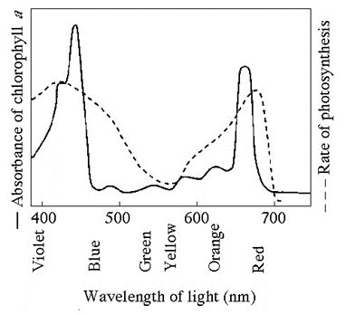
- What wavelength of light is the LEAST effective driving photosynthesis?
- What colors are the MOST effective for driving photosynthesis?
- What is the difference between autotrophs and heterotrophs? Be specific.

- Why do the leaves of deciduous trees change colors in autumn?

- As electrons are passed through the electron carriers with photosystem II, the lose energy. What happens to this energy?

- In photosynthesis, chemiosmosis moves proteins from ____________ to ________________.

- Name the TWO products of light reactions that are used in Calvin Cycle.

- What is the primary function of the Calvin Cycle?

