Cell Structure and Transport Test Review
1. Know all the vocabulary words in the chapter
2. Know the significance scientists who contributed to the cell theory.
- Hooke
-Leewenhoek
-Schleiden
-Schwann
-Virchow
3. List the three parts of the Cell Theory
4. List the features that are common to all cells
5. Know the difference between prokaryote and eukaryote; give examples of each.
6. Identify and label the cell membrane, know the components of the membrane
8. Identify organelles related to both plant and animal cells; be able to describe their functions
9. Understand how the cell functions, be able to identify cell components in an analogy (like Cell City)
10. Describe the differences between plant and animal cells
11. Be able to label components on both a plant and animal cell diagram
12. Label the three images below as isotonic/ hypertonic/ hypotonic (with regard to the solution the cell is placed in)
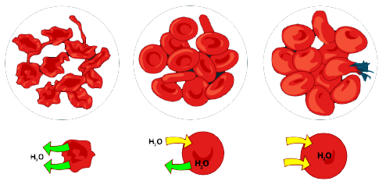
13. Movement across the cell membrane that does not require energy is called
[ active / passive ] transport.
14. The difference in the concentration of a substance across a space is called a concentration [ equilibrium / gradient ].
15. If there is a concentration gradient, substances will move from an area of high concentration to an area of [ equal / low ] concentration.
16. The cell membrane is [ selectively permeable / impermeable ].
17. [ Equilibrium / Diffusion ] is the simplest type of passive transport.
18. The diffusion of water through a selectively permeable membrane is called [ osmosis / diffusion ].
19. The direction of water movement across the cell membrane depends on the concentration of free water[ molecules / solutions ].
20. A solution that causes a cell to swell is called a [ hypertonic / hypotonic ] solution.
21. Organelles that collect excess water inside the cell and force water out are called
[ diffusion organelles / contractile vacuoles ]
22. The process of taking material into the cell by infolding of the cell membrane is called [ endocytosis / exocytosis ]
23. In [ facilitated / molecular ] diffusion, membrane proteins help molecules across the membrane.
24. In diffusion, molecules [ spread out / condense ]
25. The lipid bilayer describes [ a type of transport / the cell membrane ]
26. Facilitated diffusion moves substances down their concentration gradient [ with / without ] using the cell's energy.

