Louisburg High School

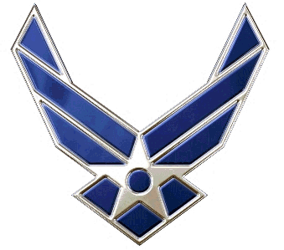

Basic Cadet Guide
NC-20054
21 January 2020

Ms. Melissa Thomas
Principal, Louisburg High School

Major (Retired) Anthony F. Bond
Senior Aerospace Science Instructor

Master Sergeant (Retired) James Goodine
Aerospace Science Instructor

Table of Contents
AIR FORCE JROTC MISSION 3
USAF CORE VALUES 3
CADET HONOR CODE………………………………………….3
AFJROTC MOTTO.........................................................................4
AFJROTC OBJECTIVES 4
CADET CREED 5
CADET CONDUCT 6
RULES OF THE AFJROTC CLASSROOM 7
ADMISSION STANDARDS……………………………………..7
PROHIBITION ON PHYSICAL DISCIPLINE AND HAZING…8
MILITARY COURTSEY…………………………………………9
SALUTING………………………………………………………..9
CADET PROMOTION GUIDE 11
REQUIREMENTS FOR PROMOTION………………………...13
UNIT MANNING DOCUMENT 15
JOB DESCRIPTIONS 16
UNIFORM GRADING CRITERIA…….……………………….18
GRADING CRITERA 19
CHAIN OF COMMAND 19
CURRICULUM-IN-ACTION……………………………………21
LEADERSHIP DEVELOPMENT REQUIREMENTS …………21
CADET AWARDS GUIDELINES………………………………22
CADET APPEARANCE AND GROOMING STANDARDS.….23

Air Force JROTC Mission

Mission. The mission of Air Force Junior Reserve Officers Training Corps (AFJROTC) is to “Develop citizens of character, dedicated to serving their nation and community.”

Goal. The goal of AFJROTC program is to instill in high school cadets the values of citizenship, service to the United States, personal responsibility, and a sense of accomplishment.

USAF CORE VALUES

INTEGRITY FIRST

SERVICE BEFORE SELF

EXCELLENCE IN ALL WE DO

CADET HONOR CODE

The Honor Code is specific and clear in what it demands. A cadet is expected to have complete integrity in both word and deed, avoid evasive statements, does individual work in class, and yet is willing to assist others in a sense of cooperation and reaching common group goals.

The Code belongs to the Cadets.

Maintaining its high standards of trustworthiness is the responsibility of each cadet. This requires self control and conscious effort at all times. Eventually it becomes an ingrained habit and part of the cadet’s total ethical code and lifestyle.

The Honor Code, by stressing that there can be no toleration of lying, cheating, or stealing, emphasizes that HONOR is a common standard of the Cadet Corps.

Each cadet is expected to commit this code to memory and to live by it.

AFJROTC Motto

Building Better Citizens for America

AFJROTC OBJECTIVES

The objectives of the AFJROTC are to:
- Develop informed responsible citizens
- Strengthen character
- Help form habits of self-discipline
- Promote and understand the basic elements and requirements for national security
- Develop respect for and a understanding of the need for a constituted authority in a democratic society

Our unit accomplishes our mission and objectives through activities like military drill, ceremonies, classroom studies and numerous school and community service projects. We follow standard Air Force policies by wearing uniforms once a week and adhering to all military customs and courtesies in all activities.

CADET CREED

I am an Air Force Junior ROTC Cadet.

I am connected and faithful to every corps of cadets
Who serve their community and nation with patriotism.

I earn respect when I uphold the core values of Integrity
First, Service Before Self and Excellence in All We Do.

I will always conduct myself to bring credit to my
family, school, corps of cadets, community and to myself.

My character defines me. I will not lie, cheat or steal.
I am accountable for my actions and deeds.

I will uphold others accountable for their actions as well.

I will honor those I serve with, those who have gone
before me and those who will come after me.

I am a patriot, a leader, and wingman devoted to those I
follow, serve and lead.

I am an Air Force Junior ROTC Cadet.

CADET CONDUCT

- General: You represent a select group and should always conduct yourself in a manner that is favorable to your school, NC-20054 and the United States AFJROTC.

- Addressing Other Cadets: A cadet officer is addressed by cadets of lower rank by their rank followed by last name. (Example: C/Captain Smith) OR, addressed as "Sir" or "Ma'am". NEVER address a cadet officer in uniform by their first name.

- Active Duty, Reserve, and Retired Military Personnel: Military personnel are addressed by the rank, followed by their last name.

- Public Display of Affection: Public display of affection is not tolerated.

- Saluting: A salute is a formal greeting. Salute all cadet officers and SASI. All officers must render a salute to officers of a higher rank. Remember you only salute outside the building unless you are reporting. The key to saluting is recognition.

- Walking with Cadets and Military Personnel of a Higher Rank: When walking with a person of higher rank, always walk to their left and in step. When passing through a doorway, the person of lower rank holds the door and allows the person of higher rank to proceed through the doorway first. When boarding and leaving a vehicle, the person of lower rank gets in first and gets out last.

- Treatment of Cadets: Hazing is not tolerated in the Cadet Corps. No cadet is to be embarrassed or degraded in any manner. This includes public reprimands, public punishment, or joking about difference in rank. Abuse of authority in the Cadet Corps will not be tolerated.

- Calling Rooms to Attention: When the United States flag, SASI, Principal, distinguished visitor, or military officer enters the room, the room is called to attention. The occupants of the room remain at attention until ordered otherwise.

- Courtesies Rendered To Adults: Adults are addressed as "Mr."/"Ms." (last name). In conversation they are answered "Yes sir/ma'am".

- Quibbling: When a cadet officer or NCO gives an order, it can be considered to be an order from the Commander. This means that orders should be followed. You have the right to disagree and present your ideas, but all lawful orders should be followed. Cadets who feel they are not being treated fairly, see your flight commander, and if necessary take it up the chain of command.

RULES OF THE AFJROTC CLASSROOM

- Be Productive
  - Pay attention in class
  - Ask questions about the class or related subject

- Be Prompt
  - On time for class (National Anthem and Cadet Creed)
  - Turn in assignments on time

- Be Polite
  - Address the SASI as Major, Major Bond or Sir
  - Address the ASI as Sergeant, Sergeant Goodine or MSgt Goodine
  - Respect your fellow student and other teachers
  - Pay proper respect to the American Flag
  - Come to attention when special guests (Principal, Superintendent, etc.) enter the room

- Be Prepared
  - Have all need materials for class (books, writing materials & uniform)
  - Use the bathroom before class

ADMISSION STANDARDS

1. Eligibility for admission into the AFJROTC program is outlined in Title 10, USC, Section 2031, and DODI 1205.13. The unit’s goal is to have proportionate representation of the entire student body. To be eligible to participate and continue in AFJROTC, each cadet must be:

a. Enrolled in and attending a regular course of instruction at the host school, school with cross-town agreement, or home-schooled student, per paragraph-7.2.1.

B. In a grade above the 8th grade. Students may participate during the summer between the 8th and 9th grades.

c. A citizen or national of the United States or an alien admitted for permanent residence, or, a Foreign Cadet per paragraph 7.1.3

d. Enrolled in the AFJROTC Academic Program unless designated as a Reserve cadet per paragraph 7.1.2.

2. Disenrollment. In accordance with AFJROTCI 36-2010 par 2.2.1.2.3, the SASI must be allowed to disenroll an AFJROTC cadet at any time during the academic year with proper cause. Disenrollment should be a last resort preceded by substantiated documentation and corrective counseling. A cadet may be removed from AFJROTC for:

1. Failure to maintain acceptable standards (including uniform wear and grooming).
2. Inaptitude or indifference to training.
3. Disciplinary reasons.
4. Any other reason deemed appropriate by the principal and the SASI.

3. Transfers. Students transferring from Army, Navy, Marine Corps, Coast Guard, or other AFJROTC units are authorized full credit for training received. Transfer of rank held in another service program is determined by the SASI.

4. An AFJROTC Reserve Cadet is defined as: (1) a cadet who has completed the entire AFJROTC Academic Program or (2) who will complete an AFJROTC course during one semester (i.e. 4X4 block) but is not participating in an AFJROTC course during the current semester. Reference AFJROTCI 36-2001 for more detailed directives concerning the participation, units funding, and the use of uniforms by Reserve Cadets.

PROHIBITION ON PHSYICAL DISCIPLINE AND HAZING

Any form of hazing, whether verbal or physical, will not be tolerated within any AFJROTC unit or activity. In addition, requiring cadets, individually or as a group, to perform any physical action as a reprimand, punishment, or for failure to perform will also not be tolerated. Cadets will not condone or encourage any type of hazing or initiation rituals.

Examples of prohibited physical activities include, but are not limited to: push- ups, running laps, or any inappropriate physical contact such as shoving, pulling or grabbing.

Any form of verbal abuse, teasing, public rebuke or any attempt to otherwise humiliate a cadet is prohibited.

This prohibition is applicable to all AFJROTC unit activities, and includes instructors, cadets and any personnel involved with or participating in an AFJROTC unit or activity.

Unauthorized Clubs. No unit may encourage, facilitate, or otherwise condone secret societies or private clubs as part of the AFJROTC program.

MILITARY COURTESY

Military courtesy is a long-established tradition that sets us apart from other organizations. The practice of saying “YES SIR/MA’AM” and “NO SIR/MA’AM” to the SASI, ASI, and all cadets involved in AFJROTC is required, as well as any other personnel who warrant such courtesies (principal, teachers, visiting military guest, etc.) While you may find it difficult at first, it will soon become a habit of proper military behavior.

Cadet grades will not be confused with active duty USAF grades. The word cadet will be a part of any written and spoken reference to a specific cadet rank. There are no Colonels or Master Sergeants in the corps, only Cadet/Colonels and Cadet/Master Sergeants.

When asked a question by the SASI / ASI or other adults, the appropriate response will always be prefaced and followed by Sir or Ma’am. This is called, “Serving your answer on a Sir sandwich.”

Example: “Sir, this cadet does not know the answer, sir.”

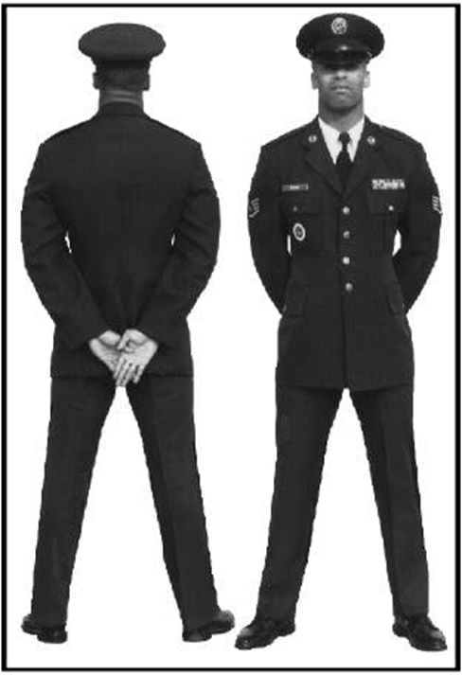
Parade Rest

SALUTING

1. Introduction: The salute, in its various forms, is considered a military greeting the world over. In many countries, as in the United States, it is a symbol of respect. Military personnel regard the salute as a respectful greeting between members. It is one of the oldest traditions binding military people together.

2. Rules: It is important that you learn the following rules of saluting:

- Cadets in uniform will salute all cadet officers of higher grades, officers of the United States Armed Forces, and the SASI. The ASI will only be saluted in “reporting” situations. Cadets not in uniform are encouraged to salute these personnel anytime they meet.
- A cadet of junior grade will salute a cadet officer of senior grade first, and will hold the salute until it is properly returned or otherwise acknowledged.
- When a cadet in uniform sees the American Flag being raised on any flagpole, he/she will assume the position of attention, render the hand salute, and hold it until the flag reaches the top of the flagpole. When the flag is being lowered, the salute will be held until the flag reaches the hands of the individuals lowering the flag.
- When a cadet is late for squadron, flight, or element formation, he/she will approach the person in charge when the formation is at a halt. He will salute and request permission to fall in. This also applies to flag raising/lowering ceremonies.
- Cadet Officers and cadet non-commissioned officers will correct saluting violations in a helpful manner on the spot. A cadet should not be placed in a degrading or embarrassing situation by public reprimand for failure to salute. Be civil and use common sense at all times. All cadets are expected to accept these corrections without resentment.
- Cases of disrespect, insolence, insubordination, or refusal to comply with corrective instructions will be reported to the SASI/ASI immediately.

3. Hand Salute. This command is used for training purposes only. The command is Hand, SALUTE, and it is performed in two counts. On the command SALUTE, the individual raises the right hand smartly in the most direct manner while at the same time extending and joining the fingers. Keep the palm flat and facing the body. Place the thumb along the forefingers, keeping the palm flat and forming a straight line between the fingertips and elbows. Tilt the palm slightly toward the face. Hold the upper arm horizontal, slightly forward of the body and parallel to the ground. Ensure the tip of the middle finger touches the right front corner of the headdress. If wearing a hat without a bill, ensure the middle finger touches the outside corner of the right eyebrow or the front corner of glasses. The rest of the body will remain at the position of attention. This is count one of the movement. To complete count two of the movement, bring the arm smoothly and smartly downward, retracing the path used to raise the arm. Cup the hand as it passes the waist, and return to the position of attention.
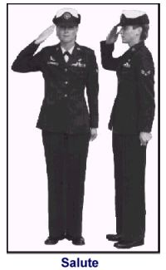
4. Saluting Areas: The mandatory saluting areas at Louisburg High School are:
- Outside: When outdoors on campus (common sense—if you can see the sky above you—salute.) This includes loading/unloading school buses.
Note: Saluting is not required at sporting events, pep rallies, outdoor assemblies or off-campus bus stops unless it involves a flag raising/lowering ceremony. NC-20054 does not have an exemption zone from saluting.
- Inside: You are only to salute inside when:
(1) When reporting to the SASI/ASI
(2) When reporting to the President of the Cadet Evaluation Board when formed.
(3) When being recognized at awards ceremonies
(4) When otherwise direct to by another Officer or Staff member
Note: When reporting to the SASI/ASI and to the cadet board president, the cadet will come to attention, salute and say, “Sir/Ma’am, Cadet (grade) Last Name, reports as ordered.” When reporting late to class, the cadet will come to attention, salute, and say, “Sir/Ma’am, Cadet (grade) Last Name, request permission to join the flight.” Hold the salute until it is returned or the salute is acknowledged.

CADET PROMOTION GUIDE

1. Promotions at Louisburg High School AFJROTC are based on academic performance, demonstrated leadership abilities, and overall contributions to the quality of the Louisburg High School AFJROTC unit. Each cadet should understand how selections for various command and staff positions are made. Promotions must be earned; they are not automatic. A cadet promotion indicates that, based on past performance, you are ready for a position of increased responsibility.

2. The promotion system is patterned after that of the active US Air Force. Cadets are considered for promotions and assignments based on their grades and participation in squadron activities.

- There are two types of grades a cadet may hold:

(1) PERMANENT GRADE: The permanent grade for the first year is Cadet Airman; for the second year, Cadet Airman First Class; for the third year, Cadet Senior Airman; and for the fourth year Cadet Staff Sergeant. Cadets serving in a temporary grade while occupying a command and staff position may revert to their permanent grade upon completion of these duties with the exception of graduating seniors in the three/four-year programs. At the discretion of the SASI or ASI, graduating seniors may retain their highest rank, regardless of course level.

(2) TEMPORARY GRADE: The grade is awarded based on the job assigned and the performance of the cadet. Since the grade is temporary, it will not be carried over from one semester to the next. Temporary grades are assigned only when they are higher than the permanent grade. Therefore, a cadet who has both a temporary grade and a permanent grade will wear the insignia of the higher grade.
- All cadet officer positions will be filled by AS-III and AS-IV cadets first, and then offered to AS-II and AS-I if cadets are not available and can prove themselves worthy. All Exceptions made must be reviewed by an Instructor.

- Cadets initially assigned to command and staff positions will normally not be awarded the highest rank authorized for the position. The SASI or ASI must approve temporary promotions and assignments. Promotion recommendation system works as follows:

(1) Cadet Commanders will recommend eligible cadets for promotion to a Cadet Evaluation Board.

(2) The cadet being considered for promotion must normally have at least 20 days time-in-grade before becoming eligible for the next grade.

(3) Normal progression for cadet promotion is as follows:
(a) AS-I: Cadet/Airman through Cadet Staff Sergeant
(b) AS-II: Cadet/Airman First Class through Cadet Master Sergeant
(c) AS-III: Cadet/Senior Airman through Cadet Colonel
(d) AS-IV: Cadet/Staff Sergeant through Cadet Colonel

(4) Cadets must meet eligibility requirements (grades and participation) to be eligible for positions and grades listed in the UMD.

(5) Eligible AS-III or AS-IV Cadets will be considered for staff positions before eligible AS-II cadets.

- No cadet will hold a grade higher than that authorized for his/her current position. Exceptions may be made for AS-III seniors and AS-IV cadets to permit them to hold the highest grade regardless of position. Such exceptions will be granted only upon approval of the SASI or ASI. In all cases where this exception in made, these cadets will be assigned to special staff functions with further assignments to special projects, advisory positions, or to positions where their special talents or qualifications can be used for the benefit of the cadet corps.

- In order for each cadet to experience an active leadership role, a rotation system will be used. Rotations may be made laterally by moving to another leadership position with the same grade. Cadets may be rotated to lower positions or lower grades to permit other cadets to have the opportunity to serve at a higher grade. In these cases, this action is NOT a demotion, but is an opportunity to share the leadership experience. Every cadet must understand and cooperate with the rotation system if we are to maximize our leadership experiences. Each cadet is expected to give his/her successor the same degree of loyalty and cooperation received when they held that position.

REQUIREMENTS FOR PROMOTION

Cadet Airman (C/AMN):
1. Regular uniform wear with a minimum average of 80% for the promotion term
2. Satisfactory progress towards learning and performing military drill.
3. No discipline problems.
4. Ability to fold the U.S. Flag and serve on the flag detail.
5. Academic grade of “C” or better in AFJROTC

Cadet Airman First Class (C/A1C):
1. Regular uniform wear with a minimum average of 80% for the promotion term
2. Satisfactory progress towards learning and performing military drill.
3. No discipline problems.
4. Ability to fold the U.S. Flag and serve on the flag detail.
5. Academic grade of “C” or better in AFJROTC

Cadet Senior Airman (C/SrA):
1. Regular uniform wear with a minimum average of 80% for the promotion term
2. Satisfactory progress towards learning and performing military drill.
3. No discipline problems.
4. Ability to fold the U.S. Flag and serve on the flag detail.
5. Academic grade of “C” or better in AFJROTC

Cadet Staff Sergeant (C/SSgt) and Cadet Technical Sergeant (C/TSgt):
1. Regular uniform wear with a minimum average of 80% for the promotion term
2. Promotion Fitness Examination score greater than an 80%.
3. Display satisfactory military bearing and knowledge of basic drill.
4. Successfully command an element during a predetermined drill sequence.
5. Demonstrate the ability to serve on a Color Guard.
6. Demonstrate the ability to serve as Flight Sergeant.
7. Academic grade of “B” or better in AFJROTC.
8. No discipline problems.

Cadet Master Sergeant (C/MSgt) through Cadet Senior Master Sergeant (C/SMSgt):
1. Regular uniform wear with a minimum average of 80% for the promotion term
2. Promotion Fitness Examination score greater than an 80%.
3. Display satisfactory military bearing and knowledge of basic drill.
4. Successfully command an element during a predetermined drill sequence.
5. Demonstrate the ability to serve on a Color Guard.
6. Demonstrate the ability to serve as Flight Sergeant.
7. Academic grade of “B” or better in AFJROTC.
8. No discipline problems.

Cadet Second Lieutenant (C/2lt) through Cadet Captain (C/Capt):
1. Regular uniform wear with a minimum average of 90% for the promotion term
2. Selection by the Cadet Promotion Board.
3. Display satisfactory military bearing and knowledge of basic drill.
4. Display the ability to teach basic military drill.
5. Successfully command an element during a predetermined drill sequence.
6. Demonstrate leadership qualities by doing the following:
a. Working well with other cadets.
B. Able to serve in Cadre positions (flight commander, staff, etc.)
c. Ability to develop basic plans and carry them out.
d. Demonstrate a willingness to accept responsibility for personal actions and the actions of those under their supervision.
7. Set an example for other cadets by meeting and enforcing standards.
8. Academic grade of “B” or better in AFJROTC and a “C” average elsewhere.
9. No discipline problems.

Cadet Major (C/Maj) through Cadet Colonel (C/Col):
1. Regular uniform wear with a minimum average of 90% for the promotion term
2. Selection by the Cadet Promotion Board.
3. Display satisfactory military bearing and knowledge of basic drill.
4. Display the ability to teach basic military drill.
5. Successfully command an element during a predetermined drill sequence.
6. Demonstrate leadership qualities by doing the following:
a. Working well with other cadets.
B. Able to serve in Cadre positions (flight commander, staff, etc.)
c. Ability to develop basic plans and carry them out.
d. Demonstrate a willingness to accept responsibility for personal actions and the actions of those under their supervision.
7. Set an example for other cadets by meeting and enforcing standards.
8. Academic grade of “B” or better in AFJROTC and a “C” average elsewhere.
9. No discipline problems for the past year.

All promotions submitted by C/Commander or Promotions board must be approved by the SASI.

UNIT MANNING DOCUMENT

COMMAND (CC):

1 Squad Commander C/Colonel
1 Deputy Commander C/Lt Colonel
1 Executive Officer C/Major
1 Senior Enlisted Advisor C/CMSgt

OPERATIONS (DO):

1 Chaplain C/Capt
1 Color Guard/Drill Team Commander C/Capt
1 Cyber Officer C/Capt

PERSONNEL (DP):

1 Personnel Officer C/2nd Lt.

RECRUITING:

1 Recruiting Officer C/Capt

LOGISTICS MANAGEMENT:

1 Logistics Officer C/2nd Lt

PUBLIC AFFAIRS (PA):

1 Public Affairs Officer C/2nd Lt
1 Historian Officer C/2nd Lt

OPERATIONS SQUADRON (OS):

6 Flight Commanders C/1st Lt
6 Flight Sergeants C/MSgt
18 Element Leaders C/SSgt
6 Guidon Bearer C/TSgt

JOB DESCRIPTIONS

Squadron Commander Authorized Grade: C/Col

- In coordination with the SASI and ASI, establishes the mission, goals, and objectives of NC-20054
- Responsible for the appearance, discipline, training, and conduct of the group as well as the accomplishment of unit goals and objectives
- Assists the SASI as necessary
- Assists in developing and recommending group goals and policies
- Conducts group staff meetings and evaluates the performance of top cadet officers
- Leads the cadet corps
- Chairs the Group Staff and is on the Honor Code Council
- Organizes summer officer training
- Meets with SASI as directed.

Deputy Squadron Commander Authorized Grade: C/Lt Col.

- Assumes all duties of the Squadron Commanders absence
- Ensures the group personnel are complying with AFJROTC and policies and procedures
- Member of Squadron staff.

Executive Officer Authorized Grade: C/Major

- Assists SASI and Group Commander in formulating unit goals and objectives
- Is a member of the Honor Code Council, Group staff, and Promotions board
- Plans special functions as directed by the SASI and/or ASI

Senior Enlisted Advisor Authorized Grade: C/CMSgt.

- Evaluating the morale of all NC-20054 enlisted JROTC cadets are reporting any issues to the cadet squadron commander and the SASI/ASI.
- Conducting periodic NCO staff meetings to insure proper support is being given to the Squadron Commander.
- Forming all parades and other squadron cocurricular activities related to drill and ceremonies.
- Preparing facilities for the weekly staff meetings.
- Performing other duties as assigned.

Color Guard/Drill Team Commander Authorized Grade: C/Capt.

- Conducting required drill team & honor guard practice.
- Appearance, efficiency and conduct of the drill team & honor guard.
- Advising the C/Commander or SASI/ASI of any problems.

Chaplain Authorized Grade: C/Capt

- Acts as the religious liaison for the corps
- Is responsible for giving invocations and benedictions at ROTC functions
- Member of Group staff and Promotions board
- Head of the Honor Code Council

Cyber Officer Authorized Grade: C/Capt.
- Maintains the ROTC web page and coordinates with PA Officer for special events.
- Coordinate Cyber Patriot issues
- Help provide information security for unit information systems
- POC for unit cyber and information technology issues

Personnel Officer Authorized Grade: C/2nd Lt.
- Assists in publishing promotion orders and ensures cadet personnel folders are maintained properly
- Receives documentation on cadet participation in co-curricular activities
- Is responsible for the standardization of cadet personnel folders and works with the ASI on updating the WINGS inventory management system

Recruiting Officer Authorized Grade: C/Capt
- Is responsible for all of the including:
    - Finding new cadets interested in joining the core
    - Keeping accurate records of all interested
    - Organizing recruiting trips to middle schools and other recruiting trips.

Public Affairs Officer Authorized grade: C/2nd Lt
- Coordinates all public affairs matters to include:
  - Preparing news releases and distributing pictures to school year book and newspaper.
  - Manages invitations to NC-20054 public activities
- Responsible for posting current events on the bulletin board and pictures of the chain of command and cadet of the month
- Is responsible for maintaining the currency of the Outstanding Flight Competition
- A member of Group staff, promotions board, and Honor Code Council.

Historian Authorized Grade: C/2nd Lt
- Coordinates with Public Affairs Officer to ensure all cadet activities are photographed
- Maintains a scrapbook/photo album of all activities
- Maintain records of all SASIs, ASIs and students who have held the commander position at LHS

Flight Commanders Authorized Grade: C/1st Lt

- Are responsible for the leadership, training, and discipline of their flights
- Assists the ASI with record-keeping (activity sheets, awards and personal records)
- Drill and administer the flight
- Counsel flight members when required to correct deficiencies
- Coordinate with the Chaplain’s “Ace of Aces” program
- is responsible for verifying the qualifications of cadets receiving awards by initialing the events.
- Initiate Monthly ribbon order for all members of the flight on the last Tuesday of the month.

Flight Sergeants Authorized Grade: C/MSgt
- Assume command of the flight in the absence of the flight commander
- Assist the flight commander in drill, during inspections, and in the maintenance of personnel records
- Take attendance and report absentees
- Start class by posting the Flight Guidon

Uniform Grading Criteria

The normal grading of all cadets in uniform goes as follows:

Infraction Maximum Points Deducted
Hair 15
Facial Hair 15
Jewelry/Cosmetics 15
Belt 5
Flight Cap 5
Lint/Strings 5
Rank 5
T-Shirt 5
Ribbons/Badges/Cord/Name Tag 5
Socks 10
Shoes 15

GRADING CRITERIA

Aerospace Science
Classroom assignments will account for 10% of your total grade. All chapter tests will account for 30% of your grade. In total, the academic portion will account for 40% of your grade.

Leadership Education
Quizzes, classroom and homework assignments and drill participation will account for 10% of your total grade. Uniform wear/inspection will account for 30% of your grade. This leadership grade will account for 40% of your total grade.

Wellness Program
Grades are derived from participation (10%) and wearing the required PT gear (10%)for class on Fridays. This PFT grade will count 20% of your total grade.

CHAIN OF COMMAND

In all military units authority is distributed according to rank, position held, and level of responsibility. This distribution of authority is called the chain of command and is absolutely necessary for a smooth running unit. The lines of this chain can be drawn from the lowest ranking individual to the Commander-In-Chief of the US Armed Forces, the President of the United States. In order for our Cadet Corp to be successful every member must understand the chain of command and know how to use it to accomplish our objectives and solve problems.

Commander in Chief: Donald Trump

Secretary of Defense: Mark Esper

Secretary of the Air Force: Barbara Barrett

Chief of Staff of the Air Force: Gen David L. Goldfein

Air Education and Training Command Commander Lt Gen Marshall B. “Brad” Webb

Air University Commander Lt Gen Anthony J. Cotton

Holms Center Commander: Brig Gen Christopher J. Niemi

Air Force Junior ROTC Director: Col Stephen T. Sanders

AFJROTC Region 2 Director: Robert G. Atkins

Local Chain of Command

PRINCIPAL Mrs. Melissa Thomas

SASI: Major (Ret) Anthony Bond

ASI: MSgt (Ret) James Goodine

Squadron Commander: _____________________________________

Deputy Commander: _____________________________________

Senior Enlisted Advisor _____________________________________

Flight Commander/Sergeant:

1st Semester | 2nd Semester
A Ft Commander-  First Sergeant- | A Ft Commander-  First Sergeant-
B Ft Commander-  First Sergeant- | B Ft Commander-  First Sergeant-
C Ft Commander-  First Sergeant- | C Ft Commander-  First Sergeant-

CURRICULUM-IN-ACTION

Curriculum-In-Action or Field Trips are an important part of the AFJROTC program. The SASI/ASI work hard to plan these trips. Every trip will be interesting and exciting. Our unit will visit Air Force bases, museums, other JROTC units, college ROTC units, and other points of interest.

Participation in field trips is a privilege, not a right. Therefore, not all cadets may be eligible to participate in every field trip. Cadet eligibility includes the following:

- Must be passing all current subjects: AFJROTC and other school courses

- Must not be suspended (ISS or OSS) on the day of the event. If the event is on the weekend, you are ineligible if suspended on the previous Friday.

LEADERSHIP DEVELOPMENT REQUIREEMNTS (LDRs)

LDRs (aka: Co-curricular) are activities which are a critical component of AFJROTC. Cadets are high encouraged to participate in LDRs through the school year. Students must be in good standing in AFJROTC and at Louisburg High School to participate. The following are LDRs that are offered at LHS. More will be incorporated as interests develops.

COLOR GUARD TEAM
Cadets will present the United States, North Carolina and (when appropriate) the Louisburg High School flag. Cadets will wear special clothing when presenting the colors and will maintain outstanding dress and appearance.

CYBER PATRIOT TEAM
Cyber Patriot is a National High School Cyber Defense Competition sponsored by the Air Force Association (AFA) and in conjunction with the USAF. This competition exposes students to careers in cyber defense and other STEM related disciplines while bringing cyber security awareness to cadets.
FLAG DETAIL TEAM
This team of cadet are primarily responsible for the raising/lowering of the school flags. They must be versed in proper care of the flags and display including special occasions when they are flown at half-staff. Participating in 10 flag details will earn a cadet a Patriotic ribbon.

MARQUEE TEAM
Cadets will coordinate with the principal and SASI to update the marquee if front of the school as needed. The marquee is vital to updating students, parents and the community of the school’s activities and important dates on the school’s calendar.

CADET AWARDS GUIDELINES

Attendance Ribbon. To receive the attendance ribbon, a cadet can miss no more than two (2) days (excused or unexcused) during the semester. Three tardies equals one absence.

Dress and Appearance. To receive the Dress and Attendance ribbon, a cadet must wear the uniform 90% of the time and have no less than a 93 on their uniform grade.

Shoulder Cords. Color Guard/Drill Team cadets may wear a silver shoulder cord on the left shoulder. Cadet staff (Cadet Commander, Cadet Vice Commander, Cadet Executive Officer, and Cadet Senior Enlisted Advisor) is authorized to wear a white shoulder cord. You may wear the shoulder cord on the light blue shirt and the service dress coat. On the service dress coat, cords should be pinned to the shoulder with the pin hidden beneath the cord.

Color Guard/Drill Team Ribbon. Cadets may wear the Color Guard and Drill Team Ribbons when they have completed three events. After the first ribbon, the cadet is entitled to a device after three events.

Service Ribbon. Cadets may wear the Service Ribbon when they have completed at least 5 service hours. After the first ribbon, the cadet is entitled to a device after five additional hours.

Patriotic Flag Ribbon – To receive the Patriotic Flag Ribbon, a cadet must participate in a non-color guard event specifically designed to honor our nation’s flag. Such events such as flag raising ceremonies, flag retirements ceremonies, flag folding ceremonies, and historical flag demonstrations are examples. Students raising or lowering the flag 10 times are eligible for the ribbon and will receive a device after an additional 10 times.

CADET APPEARANCE AND GROOMING STANDARDS

Appearance and Grooming. When a cadet wears the uniform, he/she is responsible for presenting a neat, clean, and professional military image. Appearance and grooming standards help cadets present the image of disciplined cadets who can be relied upon to do the job they are called on to do. A professional military image has no room for the extreme, the unusual, or the faddish. The standards for wearing the uniform consist of five elements: neatness, cleanliness, safety, uniformity and military image. The first four are absolute, objective criteria for the efficiency, health, and well- being of the force. The fifth standard, military image is also very important, military appearance is subjective, but necessary. People, both military and civilian, draw conclusions as to the military effectiveness of the Air Force by how they perceive those in uniform.

Jewelry. While in uniform will be plain and conservative (moderate, being within reasonable limits; not excessive or extreme) as determined by the SASI.

Rings. Cadets may wear a total of no more than three rings; wedding sets count as one ring when worn as a set. Rings will be worn at the base of the finger, and will not be worn on the thumb.

Necklaces. Will not be visible at any time. If worn, will be concealed under a collar or undershirt.

Bracelets. Ankle bracelets are not authorized. Cadets may wear one bracelet around their wrist. If worn, the bracelet will be conservative (moderate, being within reasonable limits; not excessive or extreme) (which is defined as plain, not drawing attention or faddish) in design, no wider than ½ inch, gold or silver in color, and will not have any inappropriate pictures or writing. Medical alert/identification bracelets are authorized; however, if worn, they will be conservative (moderate, being within reasonable limits; not excessive or extreme) (which is defined as plain, not drawing inappropriate attention or faddish). Bracelets espousing support for cause, philosophy, individual or group are not authorized (Exception: Traditional metal POW/MIA/KIA bracelets, which come in colors besides silver, bronze, or gold, remain authorized). Colored/rubber bracelets that support a cause are not allowed to be worn in uniform.

Eyeglasses or Sunglasses. If you wear glasses, they must not have any ornaments on the frames or lenses. Eyeglass lenses that are conservative, clear, slightly tinted, or have photosensitive lenses may be worn in uniform while indoors or while in military formation. When outdoors and in uniform, sunglasses and eyeglasses must have lenses and frames that are conservative; faddish or mirrored lenses are prohibited. Sunglasses are not allowed while in a military formation. Neither eyeglasses nor sunglasses can be worn around the neck while in uniform.

Tattoos or Brands. Whether you are in or out of uniform, tattoos or brands anywhere on the body are not allowed if they are obscene or if they advocate sexual, racial, ethnic, or religious discrimination. Tattoos or brands that might harm good order and discipline or bring discredit upon the Air Force are also barred, whether you are in or out of uniform. The SASI may exercise discretion if a new cadet arrives with a tattoo that may not be in full compliance with the above guidance.

Body Piercing. Cadets in uniform are not allowed to attach or display objects, articles, jewelry, or ornamentation to or through the ear, nose, tongue, or any exposed body part (including anything that might be visible through the uniform). Cadets may not cover any of these articles with make-up, band aids, or wearing clear post pins to hide body piercings.

Back Packs. Cadets may wear a back pack on the left shoulder or both shoulders (not to interfere with rendering the proper salute).

Wear/use of an earpiece, any blue tooth technology or headphones, while in uniform, indoors or outdoors, is prohibited, unless specifically authorized for the execution of official duties. Exception: Headphones and earphones [iPods, MP3-type players, etc.] are authorized during travel on public transportation i.e., bus, train or air travel.

Specific Female Cadet Grooming Guidelines.


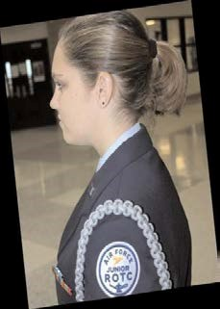
Hair-Female. Figure 3.2. There is no minimum hair length, to a maximum bulk of 3 ½ inches from scalp and allows proper wear of headgear. Hair will end above the bottom edge of collar and will not extend below an invisible line drawn parallel to the ground, both front to back and side to side. Bangs, or sideswiped hair will not touch either eyebrow, to include an invisible line drawn across eyebrows and parallel to the ground. See Figure 3.4. When in doubt, assess correct length of hair with Cadet standing in the position of attention. Exception: While wearing the Physical Training Uniform (PTU), long hair will be secured but may have loose ends and may extend below the bottom edge of the collar.

Hair color, highlights, lowlights, and frosting will not be faddish or extreme and will be natural looking hair color, similar to the individual’s hair color (e.g. black, brunette, blond, natural red, and grey).

Hair accessories. If worn, black hair accessories (e.g., fabric scrunchies, hairpins, combs, clips, headbands, elastic bands, barrettes, etc.) are authorized regardless of hair color. Headbands or fabric scrunchies will not exceed one-inch in width. Ornaments are not authorized (i.e., ribbons, beads, jeweled pins). See Figure 3.4 (photo of scrunchie)

Locs, braids, twists, micro-braids, french braids, dutch braids and cornrows are authorized. Locs are defined as portions of hair that have been intentionally or unintentionally fused together to form a loc or locs. A braid or twist is two or more portions of interwoven hair. If adding additional hair, it must be a natural-looking color, similar to the individual's hair color. It must be conservative (moderate, being within reasonable limits; not excessive or extreme) and not present a faddish appearance. Hair must not exceed bulk and length standards and must not extend below the bottom of the collar (see figure 3.2). Headgear must fit properly.

All locs braids/twists, when worn will be of uniform dimension, no wider than one inch, with natural spacing between the locs, braids/twists and must be tightly interwoven to present a neat, professional and well-groomed appearance. When worn, multiple locs/braids shall be of uniform dimension, small in diameter (approx. ¼ inches), show no more than ¼ inch of scalp between the braids and must be tightly fused/interwoven to present a neat, professional appearance. A loc, braid/twist must continue to the end of the hair without design and following the contour of the head, and may be worn loose or in a secured style within hair standards in paragraph 7.9.3 above. Exception: Micro-braids or twists are not required to continue to the end of the hair.

Unauthorized: Mohawk, mullet or etched design. See Figure 3.5 (photos of unauthorized female hair styles)

Fingernails. Fingernail polish, if worn by female cadets, will be a single color that does not distinctly contrast with the female cadet’s complexion, detract from the uniform, or be extreme colors. Some examples of extreme colors included, but are not limited to, purple, gold, blue, black, bright (fire engine) red and florescent colors. Do not apply designs to nails or apply two-tone or multi-tone colors. However, white-tip French manicures are authorized. Fingernails must not exceed ¼ inch in length beyond the tip of the finger and must be clean and well groomed.

Skirts. The length of your skirt may not vary beyond the top and bottom of the kneecap. Your skirt will fit smoothly, hang naturally, and must not be excessively tight. You must wear hosiery with the skirt. Choose a sheer nylon in a neutral dark brown, black, off-black, or dark blue shade that complements the uniform and your skin tone.

Earrings. Female cadets may wear small round or square white diamond, gold, white pearl, or silver earrings. If member has multiple holes, only one set of earrings are authorized to be worn in uniform and will be worn in the lower earlobes. Earrings will match and fit tightly without extending below the earlobe unless the piece extending is the connecting band on clip earrings.

Figure 3.2. Authorized Women’s Hair Styles

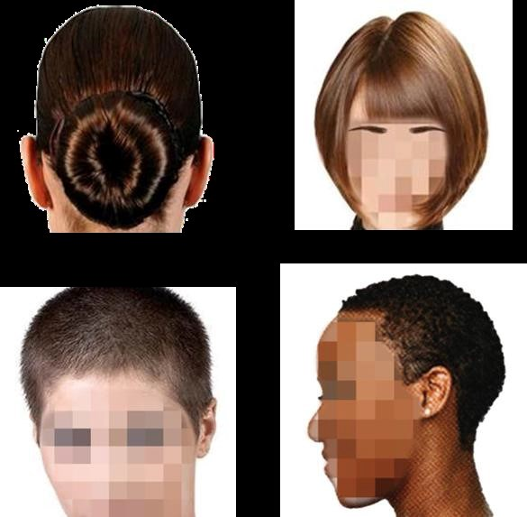

3.3. Authorized Braids

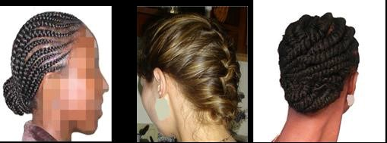

Figure 3.4. Example Authorized Scrunchie

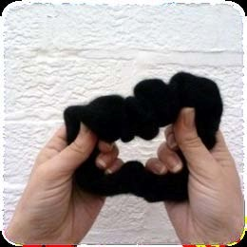

Figure 3.5. Unauthorized Female Hair Styles

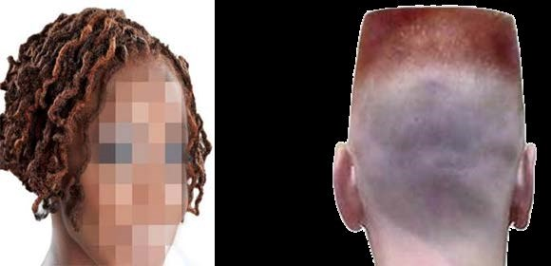

Specific Male Cadet Grooming Guidelines. (See Figure 3-1)

Men’s Hair. Keep your hair clean, neat, and trimmed. It must not contain large amounts of grooming aids such as greasy creams, oils, and sprays that remain visible in the hair.

Men’s Hair will be tapered appearance on both sides and the back of the head, both with and without headgear. A tapered appearance is one that when viewed from any angle outlines the member's hair so that it conforms to the shape of the head, curving inward to the natural termination point without eccentric directional flow, twists or spiking. A block-cut is permitted with tapered appearance. Hair will not exceed 1¼ inch in bulk, regardless of length and ¼ inch at natural termination point; allowing only closely cut or shaved hair on the back of the neck to touch the collar. Hair will not touch the ears or protrude under the front band of headgear. Cleanly shaven heads, military high-and-tight or flat-top cuts are authorized. Prohibited examples (not all inclusive) are Mohawk, mullet, cornrows, dreadlocks or etched design. Men are not authorized hair extensions.

Sideburns. If worn, sideburns will be straight and even width (not flared), and will not extend below the bottom of the orifice of the ear opening. Sideburns will end in a clean shaven horizontal line. See Figure 3-1, orifice of the ear opening is at reference point A.

Mustaches. Male cadets may have mustaches; however they will be conservative (moderate, being within reasonable limits; not excessive or extreme) and will not extend downward beyond the lip line of the upper lip or extend sideways beyond a vertical line drawn upward from both corners of the mouth. See Figure 3-1, reference points B, C, and D.

Beards. Beards are not authorized unless for medical reasons, when authorized by a SASI on the advice of a medical official. SASI will submit waiver request in WINGS for review by HQ AFJROTC Waiver Review board. Members will keep all facial hair trimmed not to exceed ¼ inch in length. Individuals granted a shaving waiver will not shave or trim any facial hair in such a manner as to give a sculptured appearance.

Fingernails. Male cadets are not authorized to wear nail polish.

Earrings. Male cadets in uniform may not wear earrings or any other type of facial piercings.

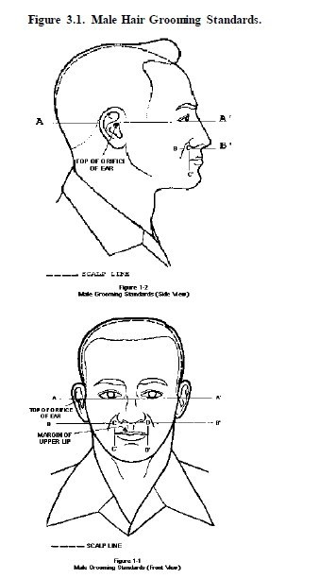

A

Bottom of ear orifice

A



