2.1 Assignment: Solving systems by Substitution
Part 1: Matching: Solve each system of equations using the substitution method. Show all work on your notebook paper. Once you solve each system, record the letter that corresponds to the answer in the blank provided. Each answer will only be used once.
Answers A: (12, 17) B: (4, 1) C: (2, 3) D: (6,0) E: (24, 3) F: (2, 1) G: (3, 5) H: (8, 4)
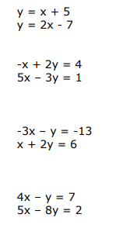
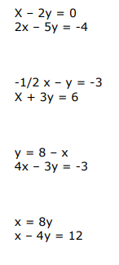
- Answer: _________ 5) Answer: _________

- Answer: _________ 6) Answer: _________

- Answer: _________ 7) Answer: _________

- Answer: _________ 8) Answer: _________

Part 2: Solve using a graphing calculator. Show the work of solving each equation for y on your paper. Then record the solution as an ordered pair.
9) $\left\{\begin{aligned}-3x+y=10 \\ -x+2y=0\end{aligned}\right.$ Solution: ( , ) 10) $\left\{\begin{aligned}-4x+3y=10 \\ 7x+y=20\end{aligned}\right.$ Solution: ( , )

2.1 Assignment: Solving systems by Substitution
Part 1: Matching: Solve each system of equations using the substitution method. Show all work on your notebook paper. Once you solve each system, record the letter that corresponds to the answer in the blank provided. Each answer will only be used once.
Answers A: (12, 17) B: (4, 1) C: (2, 3) D: (6,0) E: (24, 3) F: (2, 1) G: (3, 5) H: (8, 4)
- Answer: _________ 5) Answer: _________

- Answer: _________ 6) Answer: _________

- Answer: _________ 7) Answer: _________

- Answer: _________ 8) Answer: _________

Part 2: Solve using a graphing calculator. Show the work of solving each equation for y on your paper. Then record the solution as an ordered pair.
9) $\left\{\begin{aligned}-3x+y=10 \\ -x+2y=0\end{aligned}\right.$ Solution: ( , ) 10) $\left\{\begin{aligned}-4x+3y=10 \\ 7x+y=20\end{aligned}\right.$ Solution: ( , )

