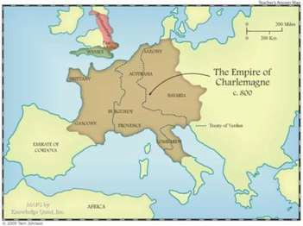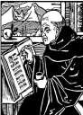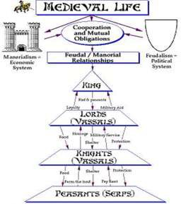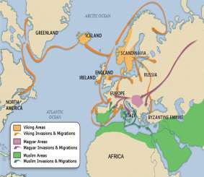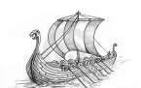Influence of Christianity

Age of Faith
- As Secular authority declined, Church authority grew
- Monasteries preserve Greco-Roman cultural achievements
  - St. Benedict – Benedictine Monks
  - Sister – Scholastica – creates women’s order
- Missionaries carry Christianity to Germanic tribes
  - Patrick – Ireland
- Pope anoints Charlemagne Emperor
- Parish priests see to the needs of the people
- Church controls Papal States – territories in Italy

Vikings
- Originate in Scandinavia
- Use Longboats to navigate Rivers/Seas
- Create settlements in Ireland & Iceland
- Eric the Red
  - 1st European in Greenland
- Leif Ericson
  - 1st European to land in North America

Charlemagne & the Frankish Kingdom

- 2 Dynasties – Merovingian & Carolingian
- Clovis converts to Christianity
- Charles Martel stops Muslim onslaught at Battle of Tours
- Pepin the Short expands Frankish kingdom
- Charlemagne crowned Holy Roman Emperor – Christmas Day, 800 CE
- Age of Charlemagne –revives Education,
Roman culture
o Missi Dominici – Court officials
- Treaty of Verdun splits Charlemagne’s empire among 3 grandsons
Europe
Early Medieval Period

Other Invaders
- Magyars
  - Originate Central Asia, settle Hungary
- Muslims
  - Impact Sea Trade
- Angles, Saxons, Jutes
  - Migrate to British Isles

Feudalism & Manorialism

Solution to new invasions

