Lesson 1 The Roman Way of Life

ESSENTIAL QUESTION
What makes a culture unique?

GUIDING QUESTIONS
- What was daily life like for the Romans?
- How did the Greeks influence Roman culture?
Terms to Know
gladiator a person who fought people and animals for public entertainment
satire writing that pokes fun at human weaknesses
ode poem that expresses strong emotions about life
vault a curved ceiling
anatomy the study of the body’s structure

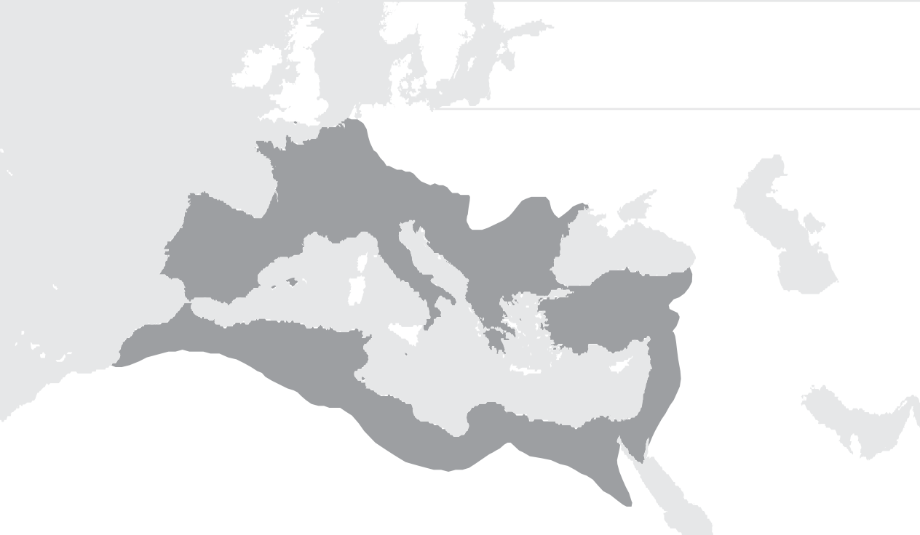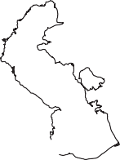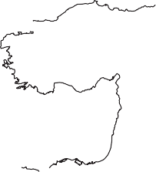Where in the world?
KEY
Roman Empire
ATLANTIC OCEAN
EUROPE
ASIA
Medi t e r r anean Se a
0 400 miles
0 400 km
Lambert Azimuthal Equal-Area projection
AFRICA

When did it happen?
Copyright by The McGraw-Hill Companies.

300 B.C.
A.D. 100
A.D. 300
A.D. 500
A.D. 700
A.D. 100 Emperors begin ruling the Roman Empire
A.D. 80 You Are Colosseum Here in finished History
A.D. 476 A.D. 550 The city of Western Rome falls Empire falls

Lesson 1 The Roman Way of Life, Continued

Explaining
- What did politicians do to make people like them?

Listing
- List three activities that wealthy women could do that poorer women could not.

Marking the Text
- Underline the phrase that explains why wives of wealthy men had time for study and entertainment.
Copyright by The McGraw-Hill Companies.

Daily Life
Rome was one of the largest and most carefully planned cities in the ancient world. More than a million people lived in Rome by about A.D. 1. It had a public square called the Forum. Romans shopped, conducted business, played games, and visited with friends in this area.
Wealthy people lived in big houses built around courtyards. Most Romans were poor and did unskilled labor. They lived in apartment buildings. Those neighborhoods were crowded, noisy, and dirty.
Politicians offered free food and entertainment to gain the support of the poor. People watched chariot races.
They also watched gladiators fight. Gladiators fought each other or even wild animals to entertain the crowds.

Roman Men
- Heads of household
- Responsible for their children’s education
- Responsible for the family business
- Could work outside the home
- Could own property
Roman Women
- Not full citizens
- Had strong influence on their families
- Did the housework
- Could work in the family’s business
- Few worked outside their homes

Roman families were large. Fathers had control over their families. They could even sell their children into slavery. Children of wealthy families received an education. Sons went to school to learn reading, writing, math, and rhetoric, or public speaking. Children of poor families could not afford to go to school. Poor people learned just enough reading, writing, and math to help them conduct business.
Wives of wealthy, powerful men had more freedom than those with less money. They could own land. They could hire enslaved people to do their housework, so they had free time to study art and literature, and go out for entertainment. Women with little money generally worked in the family business and took care of their households.
The use of enslaved persons in Rome became more common as the empire grew larger. Most enslaved people were prisoners of war. They worked in homes and on farms. They also helped build roads, bridges, and buildings.
Romans believed that gods and spirits controlled all parts of life. Greek gods and goddesses were popular in

Lesson 1 The Roman Way of Life, Continued
Reading
Check
4. Why was the family important in Roman society?
Listing
5. Cut a two-tab Foldable in half to
make four tabs. On
the anchor tab, write Romans Borrowed from Greeks. Label the four tabs Religion and Culture, Art, Science, and Architecture.
Use both sides of the tabs to list examples of each category.
Contrasting
6. How were satires different from odes?

Rome, but the Romans gave them new names. The Roman Senate declared that the emperors were gods. The Romans worshiped their gods by praying and offering food to them.
Romans borrowed ideas such as Stoicism from the Greeks and changed them to fit their culture. For Greeks, Stoicism meant finding happiness through reason. For the Romans, it meant living in a practical way. Roman Stoics urged people to do their civic duty and participate in government. These ideas are still important to us today.
Glue Foldable here

Science and Art
The Romans used many features of Greek writing, art, and architecture, but changed them to fit Roman style. Like the Greeks, Roman artists created statues. Greek statues showed perfect and beautiful people. Roman statues, on the other hand, showed people that looked more realistic.

Greeks
Romans
Greeks believed in gods and goddesses.
Romans gave Greek gods and goddesses new names.
Stoicism taught people to find happiness through reason.
Stoicism taught people to do their duties as citizens and participate in government.
Statues made people look perfect and beautiful.
Realistic statues showed details like warts and wrinkles.
Writers honored their gods and praised their generals’ successes.
Writers wrote comedies about their gods’ mistakes. Writers also wrote about the failures of their generals.

Some Roman writers based their work on Greek models. The Roman poet Virgil borrowed some of the ideas for his poem the Aeneid from the Greek poem called the Odyssey. The poet Horace based his satires and odes on Greek works. Satires poke fun at human weakness, like comedians do today. Odes are poems that express strong emotions about life.
Copyright by The McGraw-Hill Companies.
Other Romans wrote plays. Unlike the Greeks, however, Romans wrote comedies about their gods as well as plays that honored them.

Lesson 1 The Roman Way of Life, Continued

Explaining
- How did engineers change and improve the lives of people throughout the empire?

Reading Check
- Describe Roman improvements to Greek architecture.

- Place a one-tab Foldable to cover the Check for Understanding. Label the anchor tab Culture and Influences. In the center of the Foldable, write Roman Daily Life.
Make a memory map by drawing five arrows out from the title. Write five words or phrases about Roman daily life. Use your notes to help you with the lists under the tab.
Copyright by The McGraw-Hill Companies.

Romans added new ideas to architecture. Architecture is the art of making structures, such as buildings. Romans built with concrete. They added arches. By putting many arches together, they could form a vault, or curved ceiling. Curved ceilings created beautiful domes. Using domes, the Romans were able to build large, open rooms.

Concrete
hard substance used
for roads, bridges, and buildings
Arch curved part of a structure that supports ceilings and walls
Dome round ceiling that is shaped like half of a ball

Romans also learned science from the Greeks. They studied the work of a Greek doctor named Galen. Galen studied anatomy to learn about the body’s structure.
Roman engineers built practical things such as bridges, buildings, and roads. Roads connected the city of Rome to every part of the empire. This allowed soldiers to travel quickly. Traders used the roads so trade grew. The Romans also built aqueducts that carried fresh water into the cities.
The Romans influenced future generations. Concrete and other elements of Roman architecture are still used today. Until about A.D. 1500, Latin, the language of the Romans, was the official language of European government, trade, and learning. It is the basis of many modern languages, such as Italian, French, and Spanish.

Check for Understanding
List two facts that describe what life was like for the Romans.
1.
2. List two things the Romans borrowed from the
Greeks and then adapted to meet their needs.
3.

4.
Glue Foldable here

Lesson 2 Rome’s Decline

ESSENTIAL QUESTION
Why do civilizations rise and fall?

GUIDING QUESTIONS
- What problems led to Rome’s decline?
- What effect did Germanic invaders have on the Roman Empire?
- What are the key achievements and contributions of Roman civilization?
Term to Know
reforms political changes to bring about improvement

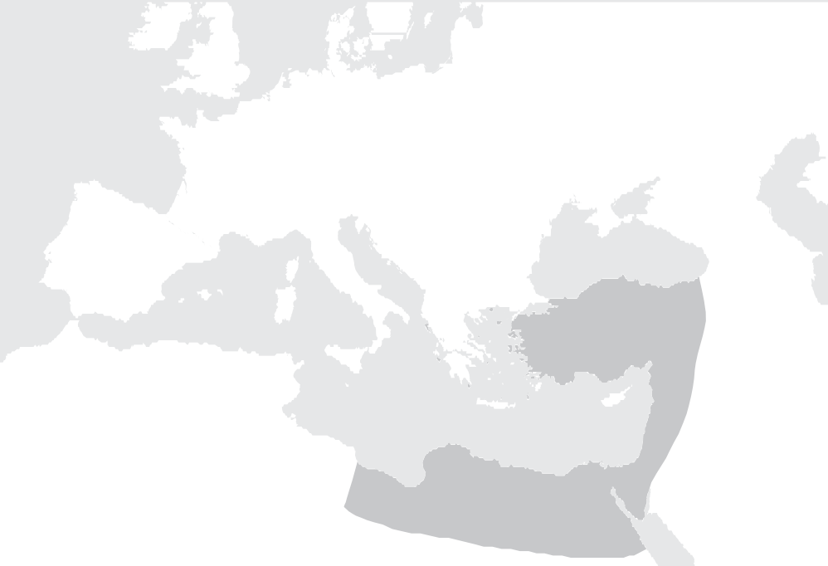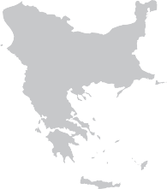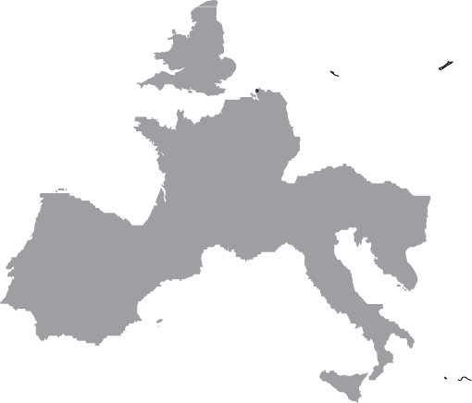Where in the world?
KEY
Western Roman Empire Eastern Roman Empire Huns
Vandals
Visigoths
North Sea
BRITAIN
ATLANTIC
OCEAN
GAUL
Black Sea
SPAIN
.
Rome
ITALY
Constantinople
ASIA MINOR
GREECE
Medit e r r anean Se a
0
AFRICA

400 miles
0 400 km
Alexandria
EGYPT
Lambert Azimuthal
Equal-Area projection

When did it happen?
Copyright by The McGraw-Hill Companies.

A.D. 100
A.D. 200
A.D. 300
A.D. 400
A.D. 500
A.D. 200s The Roman Empire begins its decline

A.D. 284 Diocletian A.D. 330 Constantine becomes emperor; moves the capital to begins reforms Byzantium
A.D. 476 The city of Rome falls

Lesson 2 Rome’s Decline, Continued

Explaining
- Place a two-tab Foldable along the dotted line. On the anchor tab, write Roman Empire. Label the left tab Western and write Rome below it. Label the right tab Eastern and write Constantinople below it.
Draw arrows from the anchor tab to each label on the tabs. Write facts about both halves of the Roman Empire.

Marking the Chart
- Place a dollar sign to the left of the three reforms that Diocletian made to help Rome’s economy.

Reading Check
- How did Diocletian try to improve Rome's economy?
Copyright by The McGraw-Hill Companies.

A Troubled Empire
Glue Foldable here
The peace of the Pax Romana was followed by a century of confusion and violence. Roman government grew weak while the army grew strong and independent. The legions of the army fought each other to put new emperors on the throne. Rome had 22 emperors in a period of 50 years.
This period of civil war caused great suffering, including:
- Food shortages
- High prices
- Decreased support for education
- Unpaid taxes
The government tried to fix the economy by making more new coins. These new coins had less value, so it cost more to buy goods. This is called inflation. Inflation happens when prices go up and money is worth less.
People began to barter. Instead of using money, they traded one product or service for another.
As Rome struggled, Germanic tribes began to attack the empire. The Romans built walls around their cities for protection. The Roman government hired Germanic soldiers for the army, but these soldiers had no loyalty to Rome.
In A.D. 284, a general named Diocletian became emperor.
He tried to strengthen the empire by making many
reforms, or changes to make things better.

Diocletian’s Reforms | Reasons
Built forts on borders | for defense
Split empire into four parts | to make it easier to rule
Set prices for goods and wages | to stop inflation
Ordered workers to keep their jobs until they died | to improve the amount of goods being made
Made officials responsible for local taxes | to make sure taxes were paid
He built forts along the borders. He set prices for goods and wages. This was to keep prices from rising even more. People paid no attention to his rules. Diocletian was not strong enough to enforce them, so his reforms did not work.

Lesson 2 Rome’s Decline, Continued

Identifying
- Which phrase tells what Constantine finally did when his reforms failed to help Rome?

Explaining
- Why did some Germanic tribes want land?

Drawing Conclusions
- Why did the Visigoths rebel?

Reading Check
- Why do historians consider A.D. 476 an important date?

The Fall of Rome
The next emperor was Constantine. He tried to make Diocletian’s reforms work so the empire would grow strong again. Constantine made the military stronger. Nothing seemed to help Rome improve. In A.D. 330, he moved the capital from Rome to Byzantium in the east. Then he changed the name of the new capital to Constantinople.
That name lasted many years. Today the city is known as Istanbul in present-day Turkey. Constantine’s reforms helped the empire, but not enough.
After Constantine died, Theodosius took power. He realized that the empire had grown too big to rule. When Theodosius died, he left a will that instructed the Romans to divide the empire into eastern and western parts. When the Romans divided the empire, they also divided the army. The western half of the empire was now too weak to stop invaders.

The Two Roman Empires

Eastern capital—Constantinople Western capital—Rome

In the A.D. 300s and A.D. 400s, many Germanic tribes took over Roman land. Some wanted better land for raising crops and farm animals. Many were running away from the Huns, a fierce group of warriors. A tribe called the Visigoths asked Rome for protection. The Romans let the Visigoths live just inside the empire's border. Later, the Romans treated the Visigoths badly so the tribe fought back. The Visigoths captured Rome in A.D. 410.
Copyright by The McGraw-Hill Companies.
Then, another Germanic tribe, the Vandals, invaded the Western Roman Empire. They burned buildings and took valuable things. The Germanic people now had entered every part of Roman society. Many held high government positions.
The last Western Roman emperor was a 14-year old boy name Romulus Augustulus. He did not have strong power or support.
In A.D. 476, a Germanic general named Odoacer overthrew the emperor. He took control of Rome. No Roman emperor ever again ruled from Rome. This is considered the end of the Western Roman Empire.

Lesson 2 Rome’s Decline, Continued

Marking the Text
- Underline the Roman ideas that tell how the language of the Romans influenced languages used today.

Reading Check
- What Roman contributions still influence our lives today?

- Place a one-tab Foldable along the dotted line to cover the Check for Understanding. Label the anchor tab Positive and Negative Aspects. Write The Roman Empire in the center.
Make a memory map by drawing five arrows around the title and writing words about Rome. Use your map to list the information in the Check for Understanding.
Copyright by The McGraw-Hill Companies.

Rome’s Legacies
Roman ideas still influence our lives in the United States today. We read Roman literature. Modern buildings use Roman arches, domes, and concrete.
We share Roman ideas about justice and the law. Like the Romans, we believe that everyone is equal under the law and that a person is considered innocent until proven guilty. We also require judges to decide court cases fairly.
Our government, too, is similar to the Roman republic. In a republic, citizens elect their leaders. As in Rome, our republic works best when citizens get involved.
The Romans also influenced how we speak. The Italian, French, Spanish, Portuguese, and Romanian languages come from Latin. Many English words have Latin roots. We use the Latin alphabet. Doctors, lawyers, and scientists use Latin phrases in their work. All plant and animal species have Latin names.
Some of our architecture and construction comes from the Romans. Government buildings and state capitols often use domes and arches. Concrete, developed by the Romans, is an important building material today.
One of the world’s major religions, Christianity, began in the Roman Empire. It spread with the help of the Roman road system. When Roman emperors adopted Christianity in the A.D. 300s, they also helped spread the new religion.

Check for Understanding
List four contributions or achievements of Roman civilization that influence our lives today.
1.

2.

3.

4.
Glue Foldable here

Lesson 3 The Byzantine Empire

ESSENTIAL QUESTION
How does geography influence the way people live?

GUIDING QUESTIONS
- How did the Byzantine Empire become rich and powerful?
- How did Emperor Justinian and Empress Theodora strengthen the Byzantine Empire?
Terms to Know
mosaics patterns or pictures made from small pieces of colored glass or stone saints Christian holy people

When did it happen?

A.D. 350
A.D. 400
A.D. 450
A.D. 500
A.D. 550
A.D. 600
A.D. 396 Roman Empire divided into Eastern and Western Empires
A.D. 476 The city of Rome falls
A.D. 532
Justinian stops taxpayer rebellion
A.D. 590 "Justinian’s Plague" kills millions
A.D. 527–A.D. 565 Emperor Justinian rules Byzantine Empire

What do you know?
In the K column, list what you already know about the Byzantine Empire. In the W column, list what you want to know. After reading the lesson, fill in the L column with the information that you learned.
Copyright by The McGraw-Hill Companies.

K | W | L

Lesson 3 The Byzantine Empire, Continued

Visualizing
- On the time line for this lesson, shade in the hundred-year period when the Byzantine Empire was strongest.

Identifying
- What language did Byzantine officials and emperors learn to speak and why?

Reading Check
- Why was Constantinople important to the Byzantine Empire?
Copyright by The McGraw-Hill Companies.

The New Rome
The Eastern Roman Empire became known as the Byzantine Empire. It was its most powerful in the A.D. 500s. The empire stretched east to Arabia, south to Egypt, and west to Italy.
Constantinople was the capital of the empire. The location of the city gave it special advantages. The city sat on a peninsula between the Black Sea and the Aegean Sea. It was surrounded on three sides by water. This made the city easy to defend. Because the city sat between Europe and Asia, it became a crossroads for trade. Merchants from far away did business there and trade grew. Constantinople became the wealthiest part of the Roman Empire.

Advantages of Constantinople’s Location
- Fishing boats, trading ships, and warships could use its harbors.
- The seas around it made it easy to defend.
- Two major trade routes crossed through it, so traders from Asia to Europe sold goods there.

People called Constantinople the “New Rome.” Many wealthy Romans moved there. The city had many Roman- style buildings, including an outdoor arena for sporting events. It was called the Hippodrome. Like Rome, officials gave free food and entertainment to the poor.
People from many lands settled in the Byzantine Empire.
Their different customs blended together to form a new culture. Over time, the empire became less Roman and more Greek. Most Byzantines spoke Greek, so officials and emperors learned to speak Greek too. Between A.D. 500 and A.D. 1200, the Byzantines developed one of the most advanced civilizations in the world.

Byzantine Achievements
A.D. 500 to A.D. 1200
- Passed on Greek culture and Roman law to other peoples
- Brought Christianity to people in Eastern Europe

Lesson 3 The Byzantine Empire, Continued
Analyzing
4. Why was Theodora an important part of Justinian's rule?
Making
Connections
- Place a two-tab Foldable along the dotted line. On the anchor tab, write Byzantine Empire. Label the first tab Emperor Justinian and the second tab Empress Theodora.
On the back sides, explain how the contributions of each have influenced life today.

Critical Thinking
- Why do you think so many countries have used the Justinian Code as the basis of their laws?

Justinian’s Rule
Emperor Justinian ruled the Byzantine Empire when it was at its most powerful. He was a skilled general and a strong leader. He controlled the military and made the laws.
Justinian was married to Empress Theodora. She helped Justinian rule the empire. Theodora helped her husband choose government officials. She helped women gain more legal rights. She urged Justinian to grant women the right to own land. This reform helped widowed women earn money to take care of their children.
When angry taxpayers rebelled in A.D. 532, Empress Theodora's wisdom helped stop the crisis. The people threatened the government. Justinian's advisers told him he should leave the city to be safe. Theodora told him he would not like his life if he ran away. She said he should stay and fight to protect the empire. He took her advice and stayed. Justinian's army stopped the riot and brought order back to the capital. This victory made him a more powerful ruler.
One of the most important things Justinian did was in the area of law. He ordered a group of scholars to organize the laws and make them simpler and better. The new laws were easier for people to understand and follow. The Justinian Code is still the basis of legal systems in many countries today.
Glue Foldable here

Justinian’s Contributions
- Improved women’s rights
- Created the Justinian Code
- Constructed the Hagia Sophia
Many Byzantine emperors ordered workers to build forts, government buildings, and churches all over the empire.
Copyright by The McGraw-Hill Companies.
The emperors supported the work of artists and architects. Justinian ordered the building of a church called the Hagia Sophia. The Hagia Sophia has gold and silver decoration inside. It is also decorated with mosaics, pictures or patterns made from small pieces of colored glass or stone. This church became the religious center of the empire. It still stands today as a museum.
The Byzantines also became famous for their mosaics.
This Byzantine art usually showed figures of saints. Saints are Christian holy people.

Lesson 3 The Byzantine Empire, Continued

Explaining
- Why did Justinian make his army stronger?

Reading Check
- What effect did Theodora have on Justinian's rule?

- Cut a two-tab Foldable to make four tabs. Place the Foldable over the Check for Understanding. Label the four tabs Who, What, When, Where.
On both sides of
the tabs, write facts about Emperor Justinian: what he did, when he did it, and where. Use your notes to help you list his accomplishments under the tabs.
Copyright by The McGraw-Hill Companies.

Justinian’s Military Conquests
- Began using a cavalry in the army
- Conquered Italy and parts of Spain and northern Africa
- Protected the eastern border from Persia
Justinian knew the empire had once been much larger. He wanted his army to be strong so they could take back the lands that had once been part of the empire. He wanted his army to protect the borders of the empire.
A general named Belisarius reorganized the Byzantine army and made it stronger. He created cavalry—groups of soldiers on horses. The cavalry wore armor and carried bows and long spears.
Justinian’s army fought in Italy, Spain, and northern Africa. It conquered the invaders who had taken lands from the Western Roman Empire. The army also defeated the Persians. It was able to secure the eastern border again.
However, these conquests did not last long. A deadly disease, known as "Justinian's Plague," moved through Asia and Europe. It killed millions of people, including Roman soldiers. There were not enough soldiers to protect the large empire. There also was not enough money to pay them. After Justinian died, the empire again lost control over most of the western lands.

Check for Understanding

List five of Justinian’s accomplishments.
Glue Foldable here
1.

2.

3.

4.

5.

