Philip II

- 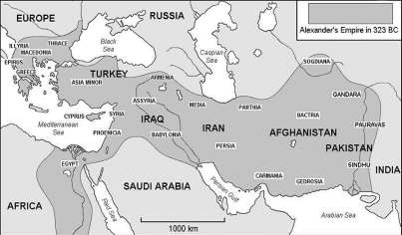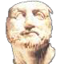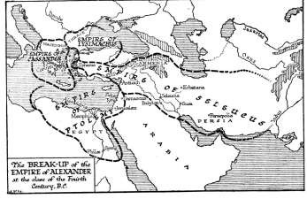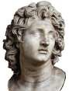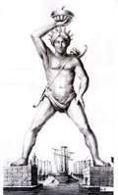Father to Alexander the Great
- Recognizes Greece’s weakened state after the Peloponnesian War – Captures most of the Greek city- states.
- Raises Alexander to appreciate all
things Greek.
- Assassinated at Daughter’s Wedding Celebration

Hellenistic Culture

Blending of Greek and Persian, Egyptian,
Indian (Oriental) cultures.

Exposure to others’ ideas leads to an explosion of creativity & scientific achievement.

Science:
- Aristarchus
- Ptolemy
- Eratosthenes

Mathematics:

- Euclid
- Archimedes
- Pythagoras

Alexander the Great & Hellenistic Culture

After Alexander
- No clear successor after Alexander’s Death
- Fighting among generals splits the Empire.

Empire
- Alexander completes takeover of Greece.
- Captures Anatolia Peninsula from Persia
- Proclaimed Pharaoh in Egypt.
- Completes defeat of Persian Empire
- Stretches Empire to Indus River Valley in the East

