## Geography

* Mountainous terrain
* Lack of arable land
* Located on Balkan Peninsula
* Aegean Sea at heart of civilization
* Black & Med. Seas –

***colonization***

* Dardanelles – access to the Black Sea

Governments

* Individual cities = Individual Governments
* Monarchy: Aristocracy: Tyranny
* Oligarchy – Sparta
* Direct Democracy - Athens

# Ancient

Greece

City-States

**The *Polis***

* Athens
  + Education
  + Government
  + Economy
  + Democracy
* Sparta
  + Militaristic
  + Oligarchy

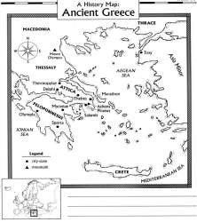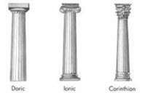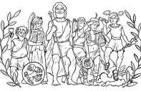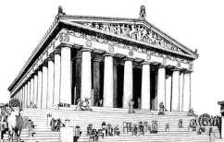

### Religion

|  |  |  |
| --- | --- | --- |
|  | Greek Golden Age |  |
| **Hellenic Culture**  **“Golden Age of Pericles”**   * **Drama:** Aeschylus, Sophocles * **Poetry:** Homer   o *Iliad, Odyssey*   * **History:** Herodotus, Thucydides * **Sculpture:** Phidias * **Philosophy:** Socrates, Plato, Aristotle * **Medicine:** Hippocrates | | |

Greek Wars

The Parthenon

### Roots of Democracy

“*United we stand, divided we fall*”

Persian Wars

* Greek city-states united
* Battles
  + Marathon
  + Salamis
* Athens becomes dominant city-state

Peloponnesian Wars

* Greek Civil War
* Delian League vs. Peloponnesian League
* Sparta victorious
* Weakens Greek City-states

* **Polytheistic**
* **Explained natural phenomena**
* **Expressed human**

**frailties/emotions**



* **Tyrant Reformers**
  + **Draco – Law Code**
  + **Solon – Outlaws debt slavery**
* **Pericles – extends citizenship**
* **Citizens**
  + **Male-landowners**

o **Responsibility of civic participation**

**DIRECT DEMOCRACY**