Biology
Name ___________________________________ Date _____________________

- Which is an example of osmosis?
A potassium ions moving in and out of an animal cell
B carbon dioxide moving into the leaf cells of a plant
C oxygen moving into the bloodstream from the lungs
D water moving into the root cells of a plant

- A scientist treats a cell with a chemical that destroys the ribosomes. As a result, which cell process will be stopped?
A osmosis B photosynthesis C protein synthesis D respiration

This diagram shows an enzyme-substrate complex.
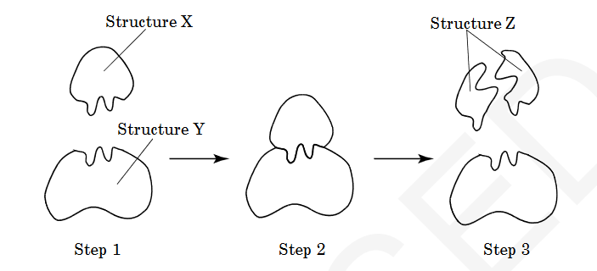
- Which is represented by Structure X?
A substrate B product C enzyme D complex

- Two different species of bacteria are examined. Scientists find that Species X always produces 2CO and 2HO during cellular respiration. Species Y always produces ethyl alcohol and 2CO . Which conclusion can be made from these observations?
A Only Species Y is aerobic. B Only Species Y is anaerobic.
C Both Species X and Y are aerobic. D Both Species X and Y are anaerobic.

- Which types of organisms developed first due to the early environmental conditions on Earth?
A prokaryotic and aerobic B prokaryotic and anaerobic
C eukaryotic and aerobic D eukaryotic and anaerobic

- What kingdoms did Carolus Linnaeus originally use for his classification system?
A Fungi and Protista B Fungi and Animalia
C Plantae and Protista D Plantae and Animalia

- Which is the most likely function of a group of cells that contains a high number of chloroplasts?
A respiration B transpiration C fermentation D photosynthesis

- A sugar, a phosphate group, and a nitrogen base form the building blocks of which organic compound?
A carbohydrate B lipids C nucleic acids D proteins

- What will most likely happen if an appropriate enzyme is added to a chemical reaction?
A The reaction rate will increase. B The equilibrium of the reaction will be maintained.
C The reaction rate will decrease. D The reaction will stop.

- In which way are photosynthesis and cellular respiration different?
A Cellular respiration stores ATP, while photosynthesis releases ATP.
B Cellular respiration produces oxygen, while photosynthesis uses oxygen.
C Photosynthesis releases energy, while cellular respiration stores energy.
D Photosynthesis uses carbon dioxide, while cellular respiration produces carbon dioxide.

- According to fossil records, the horses that lived 50 million years ago were much smaller, weaker, and slower than modern horses. Which process is most likely responsible for the
changes that have led to the increased size, strength, and speed in horses?
A commensalism B inbreeding C migration D natural selection

- Which kingdoms have photosynthetic
organisms?
A fungi and plants B fungi and protists C protists and plants D plants and animals

- An iodine solution is placed on the cut side of a potato. Within seconds, a blue-black color appears. What is most likely occurring?
A a positive test for proteins B a positive test for starches
C a negative test for proteins D a negative test for starches

- A person with swollen gums rinses his mouth with warm salt water, and the swelling decreases. Which has occurred?
A The swollen gums have absorbed the saltwater solution.
B The saltwater solution lowers the temperature of the water in the gums.
C The salt in the solution has moved against the concentration gradient.
D The water in the gums has moved from a high to a low concentration of water

This diagram represents a cell.
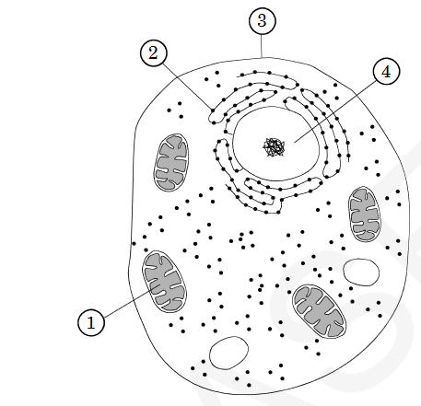
- Which organelle is the site where amino acids are synthesized into proteins?
A 1 B 2 C 3 D 4
- What will most likely be the result if all of the mitochondria are removed from a plant cell?
A It will be unable to carry out respiration. B It will lose water through osmosis.
C It will break down the ribosomes in the cell. D It will be unable to photosynthesize.

- What process best explains how a nerve cell and a muscle cell can both develop from the same fertilized egg?
A differentiation B natural selection C selective breeding D genetic engineering

- During strenuous exercise, body temperature increases. The body responds to the increase in temperature by sweating, which helps to reduce the body temperature. Which is demonstrated in this situation?
A excretion B metabolism C homeostasis D synthesis

- What is the function of autotrophs in the carbon cycle?
A to use oxygen to produce glucose B to take in excess water
C to use carbon dioxide to produce glucose D to feed on herbivores

- What type of organic molecules are enzymes?
A carbohydrates B lipids C nucleic acids D proteins

- What are the subunits of DNA and their function?
A nucleotide that store information
B monosaccharides that provide quick energy for the cell
C lipids that store energy and provide insulation
D proteins that provide the building blocks for the structural components of organisms

- How does the amount of energy resulting from fermentation compare with that of aerobic respiration?
A Aerobic respiration results in less energy.
B Aerobic respiration results in more energy.
C Each process results in equal amounts of energy.
D Each process results in variable amounts of energy.

- This diagram shows a plant cell. Which structure is found in a plant cell but is absent in an animal cell?
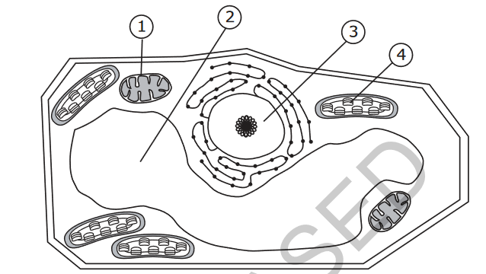

A 1 B 2 C 3 D 4

- Which best explains why muscle cells are different from blood cells?
A A mutation occurs during the development of muscle cells but not in blood cells.
B Different genes are activated in muscle cells than in blood cells.
C Muscles cells experience different environmental influences than blood cells.
D Muscle cells are produced by the brain, but blood cells are produced by the heart.

- A freshwater plant is placed in a container of saltwater. What will most likely happen to the cells of the plant?
A They will swell because water will move into them.
B They will swell because salt will move into them.
C They will shrink because water will move out of them.
D They will shrink because salt will move out of them.

This diagram shows a cladogram of six species based on amino acid similarities.
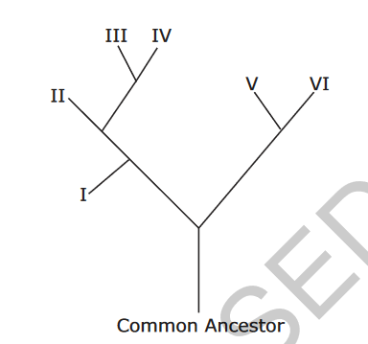
- Which two species are the most closely related?
A I and II B II and IV C I and V D V and VI

- Which type of molecule do whales use for energy storage and insulation?
A DNA B glucose C fat D starch

- Which most directly controls the rate at which food is broken down to release energy?
A enzymes B hormones C nucleic acids D vitamins

- If energy is needed to move materials into or out of a cell, what is most likely
occurring?
A active transport B passive transport C osmosis D diffusion

- How are prokaryotic and eukaryotic cells similar?
A Both contain a nucleus. B Both contain ribosomes.
C Both contain membrane-bound organelles. D Both contain cell walls.

These diagrams represent a Euglena and a Paramecium.
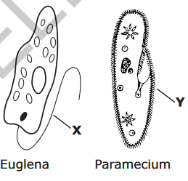
- Which function do structures X and Y have in common?
A digestion B gathering food C movement D reproduction

- What is the best explanation for the continual change s in the classification system of organisms?
A All organisms struggle for existence and become extinct.
B All organisms compete to be at the top of the food chain.
C Technological advances have allowed scientists to better compare organisms.
D More species have been discovered, but scientists have not analyzed all the data.

33. Which invention from the 17th century allowed for the development of modern cell theory?
A. X-rays B. computers C. the light microscope D. the scanning electron microscope

34. A plant and an animal are both living things. According to the Cell Theory, what can you conclude about these two very different organisms?
A. Plants have cells but animals do not.
B. They are both made of one or more cells.
C. They both come from the same kind of cell.
D. They both come from a non-living organism.

35. The combined observations of Mattias Schleiden, Theodor Schwann and Rudolph Virchow resulted in the formation of the cell theory. Which of the following is not part of the cell theory?
A. All cells contain a nucleus.
B. All cells come from other living cells.
B. All living organisms are made of one or more cells.
C. Cells are the basic unit of structure and function of all living things

36. There are some similarities between prokaryotic and eukaryotic cells. Which of the following structures is found in both prokaryotic and eukaryotic cells?
A. lysosome B. mitochondrion C. nucleus D. ribosome

Look at the cross section of a cell membrane of a eukaryotic cell. H+ ions are being pumped from a low concentration to a high concentration.

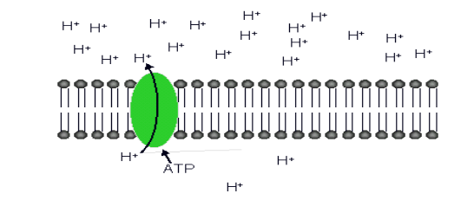
37. How do you describe this type of transport across the cell membrane?
A. active transport B. passive transport C. facilitated diffusion D. co-transport

38. Which type(s) of cells have genetic material that is contained in a nucleus?
A. bacteria B. plants only C. animals only D. both plant and animal cells

39. Which characteristic do most plants have in common?
A. they are unicellular B. they are prokaryotic
C. they produce seeds D. they are autotrophic

40. Which cell structure is correctly paired with its primary function?
A. ribosome -protein synthesis B. mitochondrion -movement
C. vacuole - cell division D. nucleus -storage of nutrients

Joy took the notes shown below while learning about cells.
•Forms boundary between a cell and the outside environment
•Controls the movement of materials into and out of the cell
•Consists of double layer of phospholipids
She forgot to write the name of the cell structure that her class was studying that day. 41. What structure is described in her notes?
A. endoplasmic reticulum B. cell membrane C. cell wall D. nucleus

Look at the diagram of a cross-section of a cell membrane below.
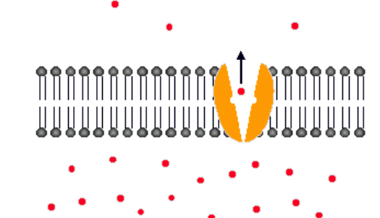
42. The cell membrane controls movement of materials into and out of the cell. The following particles are moving from high concentration to low concentration and are using a carrier protein. How would you describe this type of movement across the membrane?
A. simple osmosis B. active transport C. simple diffusion D. facilitated diffusion

43. The cell membrane of the red blood cell will allow water, oxygen, and carbon dioxide to pass through. Because other substances are blocked from entering, this membrane is called
A. perforated B. semi-permeable C. non-conductive D. permeable

44. Muscle cells are responsible for obtaining energy so the body can perform voluntary and involuntary movement. Using your knowledge about organelles and muscles, how would a muscle cell differ from other types of animal cells?
A. The muscle cell would have larger centrioles than the other types of animal cells.
B. The muscle cell would have more mitochondria than the other types of animal cells.
C. The muscle cell would have a larger golgi apparatus than other types of animal cells.
D. The muscle cell would have more endoplasmic reticulum than the other types of animal cells.

45. A specific type of cell is being studied by a scientist. She notices the cell contains a nucleus, lysosomes, a cell membrane and cell wall. What is the correct classification of this cell?
A. A prokaryotic animal cell B. A prokaryotic plant cell
C. A eukaryotic animal cell D. A eukaryotic plant cell

Look at the cell membrane model below:
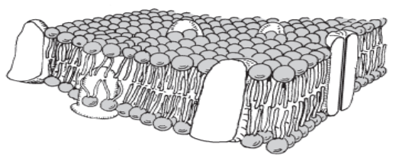
46. What is the name of the macromolecule that makes up the majority of the cell membrane?
A. nucleotide B. lipid C. carbohydrate D. protein

The diagram below shows the relationship between photosynthesis and cellular respiration and the organelles in which they occur.
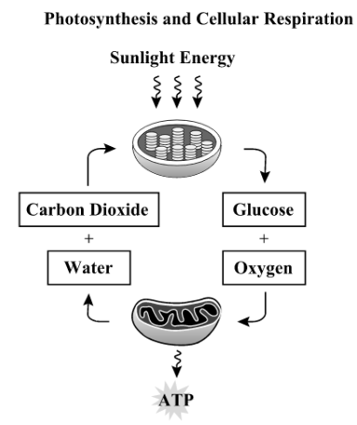
47. Which statement describes how photosynthesis and cellular respiration are interrelated?
A Oxygen is produced during cellular respiration and stored during photosynthesis.
B Carbon Dioxide and water released by cellular respiration are used in photosynthesis.
C Photosynthesis releases the energy that is stored during the process of cellular respiration.
D Glucose is used during cellular respiration to produce food that is broken down during photosynthesis.

