DNA

DNA stands for deoxyribonucleic acid DNA is responsible for storing & transferring genetic information from one generation to the next.

- The DNA Structure.
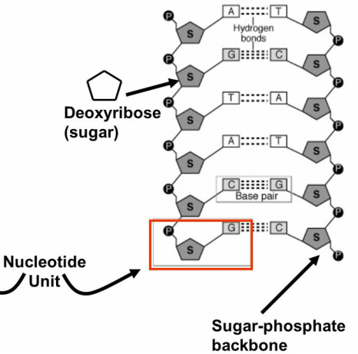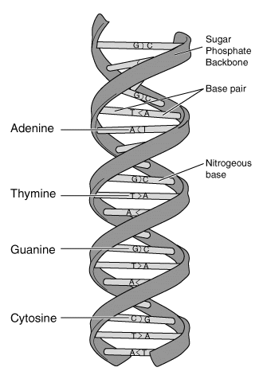
DNA is made from many nucleotides joined together The shape of each DNA looks like a ladder that has been twisted This shape is called a double helix. The shape was discovered by two scientists: Crick & Watson

Each nucleotide is made up of 3 parts
- deoxyribose – a 5 carbon sugar
- A phosphate group
- A nitrogenous base (contains nitrogen)
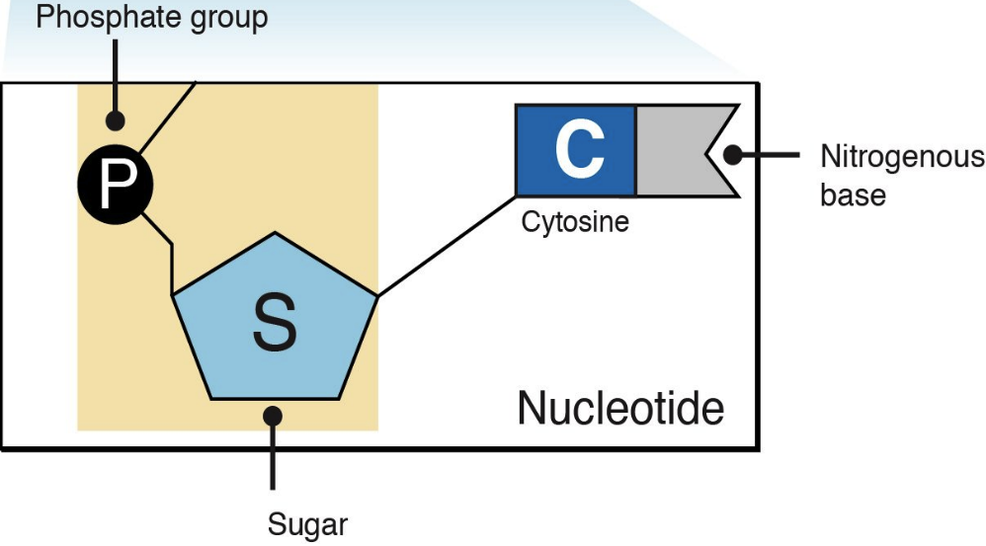
- Nitrogenous Bases.
There are 4 nitrogenous bases:
- (G) Guanine (A) Adenine (C) Cytosine (T) Thymine

Base pairing is t two nitrogenous bases that produces a force that holds the two strands of DNA together. The base pairing rule states that:
- ADENINE will always pair with THYMINE

- CYTOSINE will always pair with GUANINE

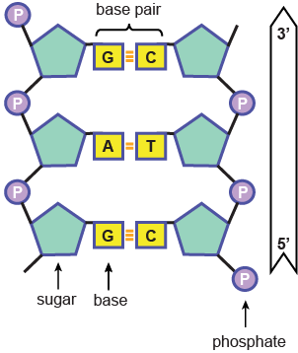
Bond Types
The base pairs in the double helix are held together by weak hydrogen bonds. The backbone of DNA is made up of alternating (D) deoxyribose and (P) phosphate molecules which are held together by strong covalent bonds.

When the DNA molecule is split in half, each side becomes a template for a new DNA molecule. By attaching the complementary base to each nucleotide, two new strands of DNA may be created. Before a cell divides to become two cells, the DNA must replicate (copy) itself so that each cell will have a copy of the same genetic code. This copying process is called replication. An enzyme (helicase) comes in and breaks the hydrogen bonds between the base pairs which causes the strand of DNA to split or “unzips” (what is left looks like a ladder cut in two). A second enzyme called DNA polymerase matches up the appropriate complementary bases. Then alternating sugar & phosphate molecules are then attached (the sides of the ladder). What you are left with is two identical strands of DNA – the cell can now divide.

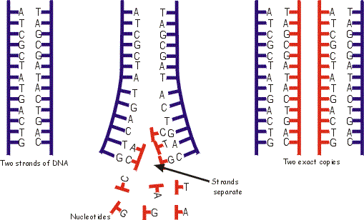

RNA

RNA – ribonucleic acid RNA is a messenger between the DNA and the ribosome.
Its job is to help in the process of making proteins!
RNA structure
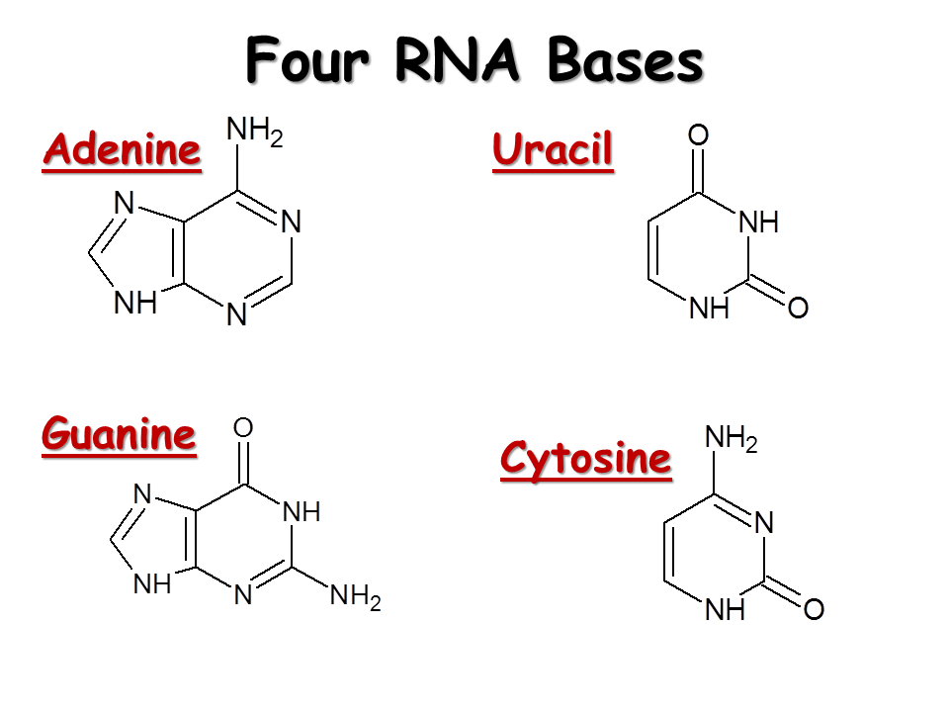
RNA like DNA is made up of a long chain of nucleotides. Each nucleotide is made up of 3 parts:
1. Ribose – a 5 carbon sugar
2. A phosphate group
3. A nitrogenous base

Transcription – the process in which a molecule of DNA is copied into a complementary strand of RNA. The result is a single stand of RNA Therefore, it is not an exact copy of DNA. Very much like replication, but instead of making DNA, RNA is made.

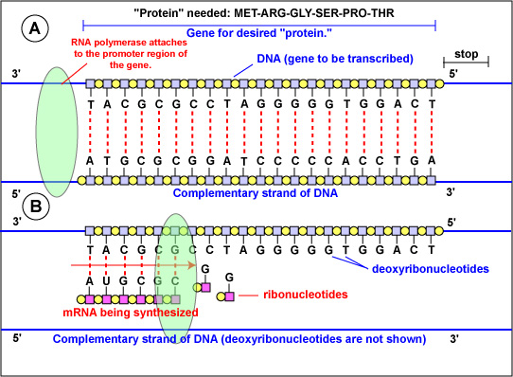
Messenger RNA (mRNA)
The carrier of the genetic information from the DNA in the nucleus to the ribosomes in the cytoplasm. DNA cannot leave the nucleus; therefore, something has to deliver the genetic code to the ribosomes (like the mailman)

Ribosomal RNA (rRNA)
Combines with proteins to make up the ribosome. Made up of two subunits that snap together around the mRNA.

Transfer RNA (tRNA)
Is the complement to the mRNA. Its job is to translate a recipe for a protein from one language (nucleic acid or RNA) into another (amino acids).

Protein Synthesis

What is Protein synthesis
Protein Synthesis is the joining of amino acids in a specific sequence in order to form a protein or polypeptide. Protein Synthesis requires transcription and translation in order for proteins to be made.

Amino Acids
There are only 20 different amino acids normally found in most humans. Proteins can be hundreds to thousands of amino acids long. The order of the amino acids also affects which protein is made.

Protein Synthesis
The DNA (through the mRNA) will tell the ribosome exactly what protein must be made. If there is a mistake in the DNA, called a mutation, then it is likely that there will be a problem with the protein that it wants to produce.

Transcription

The first step in protein synthesis is transcription. The first step occurs in the nucleus. A complementary strand of RNA (mRNA) is formed from a strand of DNA.

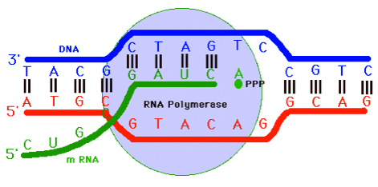

Translation

The second step of protein synthesis is translation. The second step happens in the cytoplasm at the ribosome. At the ribosome, the mRNA is “read” in groups of three bases which is also known as a codon. Since the ribosome doesn’t understand the message sent from the DNA, it requires a translator (tRNA).

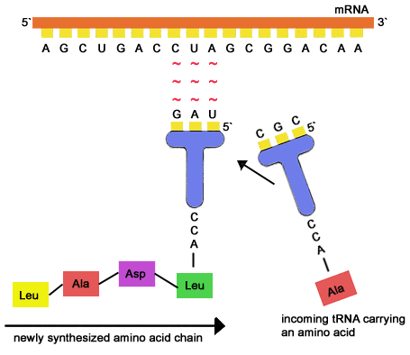
Translation

The tRNA translates the message of the mRNA into a chain of amino acids. Each tRNA caries one amino acid to the ribosome. To be able to drop off the amino acid, part of the tRNA must be able to match up with the mRNA that is being read. The three tRNA letters that matches up with the mRNA codon is called an anticodon. The mRNA continues to be translated until the ribosome reaches a stop codon.

