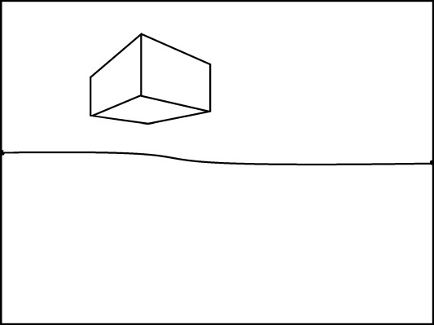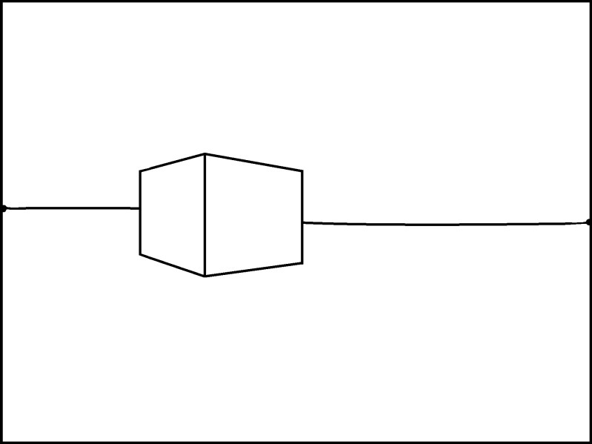

2 Point Perspective

How to Draw a Box above, on,
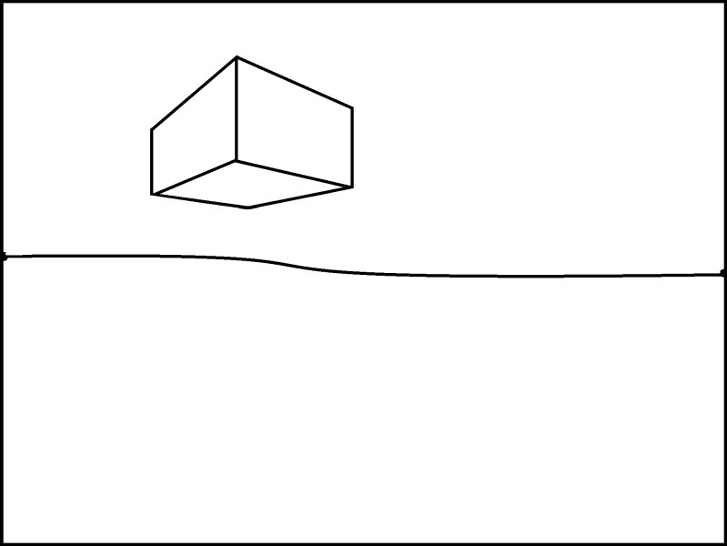
and below the Horizon Line

Created by Klaire Pearson

2 Point Perspective

How to Draw a Box above the Horizon Line

- Draw a horizon line across your paper. Don’t use a ruler.

- Add vanishing points on the edges of the horizon line.

- Draw a vertical transversal line above the horizon line. Line up your ruler with the edge of the paper to make sure your line is perfectly vertical.

- Connect the top and bottom of the vertical line with orthogonal lines that connect to the left vanishing point.

- Connect the transversal line to the right vanishing point with two orthogonal lines.

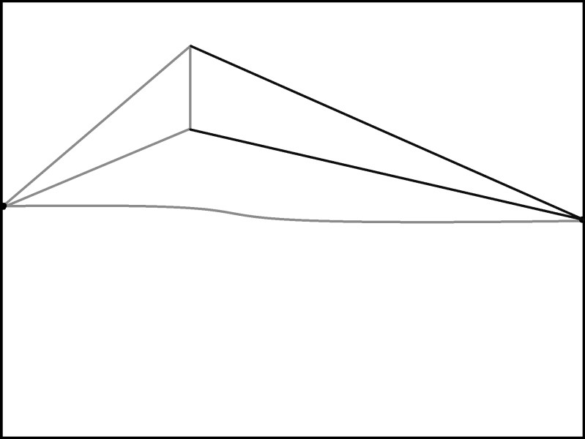

- Draw a vertical line to show the edge of the box between the first transversal line and the vanishing point.

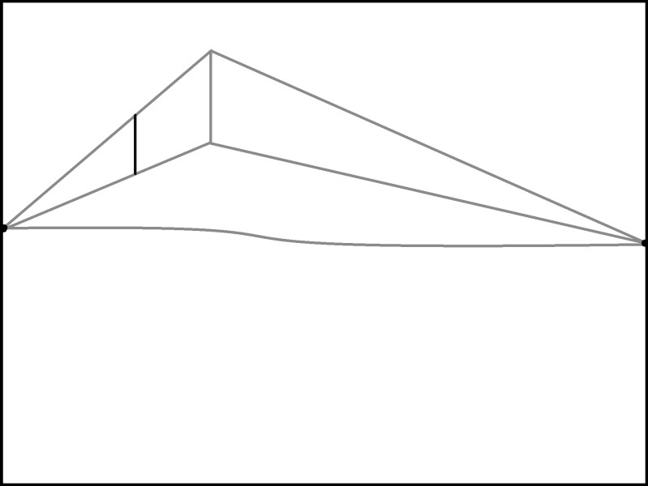

- Connect the bottom of the new transversal line to the right vanishing point.

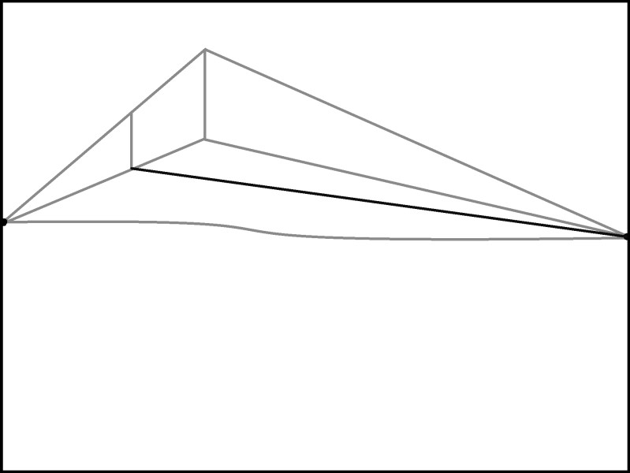

- Create another edge of the box with a transversal line.

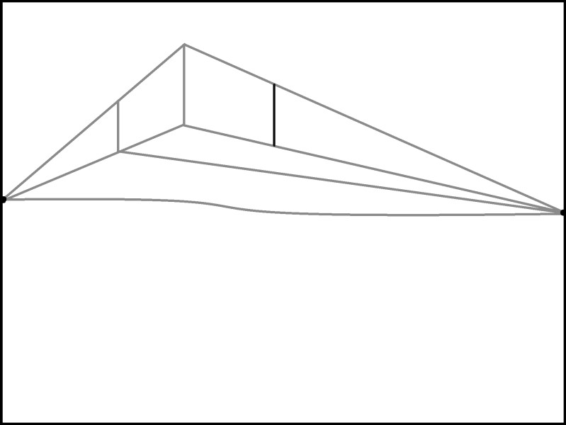

- Connect the bottom of that transversal line to the left vanishing point.
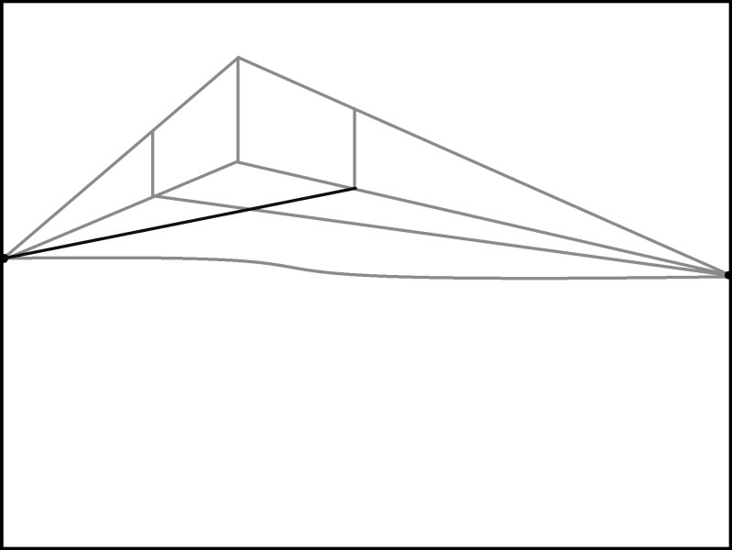

- Erase all of the connecting lines.

- Make another box above the horizon line on the other side of the paper.

2 Point Perspective
How to Draw a Box on the Horizon Line

- Draw a horizon line across your paper. Don’t use a ruler.

- Add vanishing points on the ends of the horizon lines.

- Add a vertical transversal line that goes above and below the horizon line. Line up your ruler with the edge of the paper to make sure your line is perfectly vertical.

- Connect the transversal line back to the left vanishing point with two orthogonal lines.

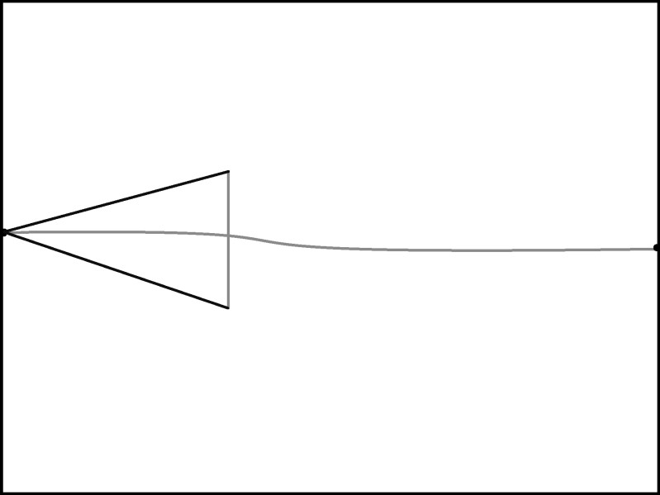

- Connect two orthogonal lines to the right vanishing point.

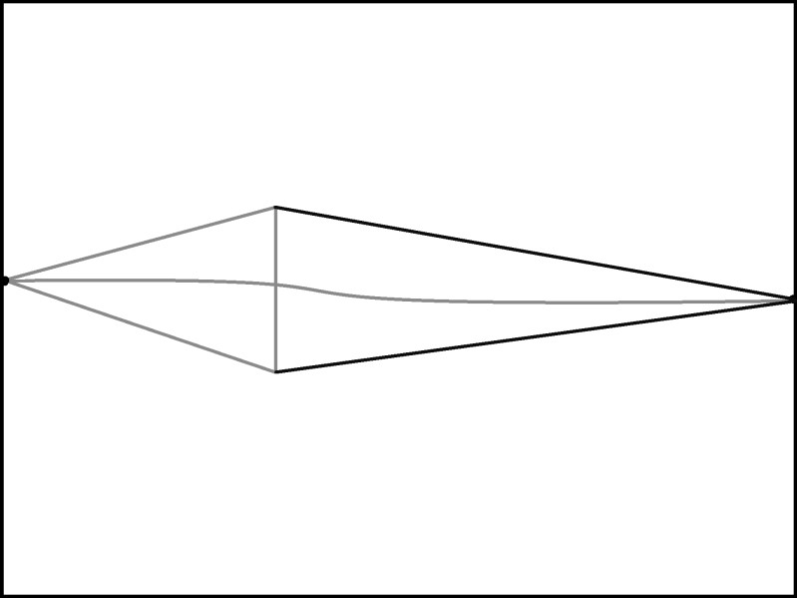

- Make the edge of the box with a vertical line.

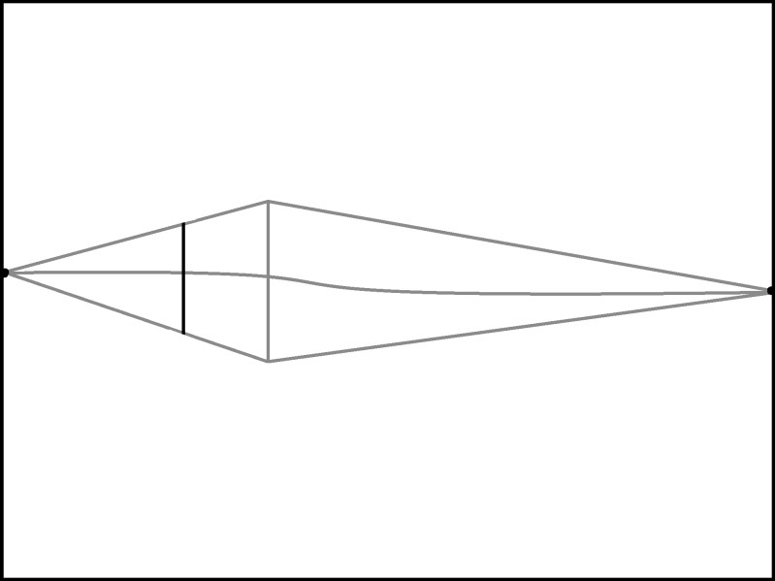

- Erase the extra lines.

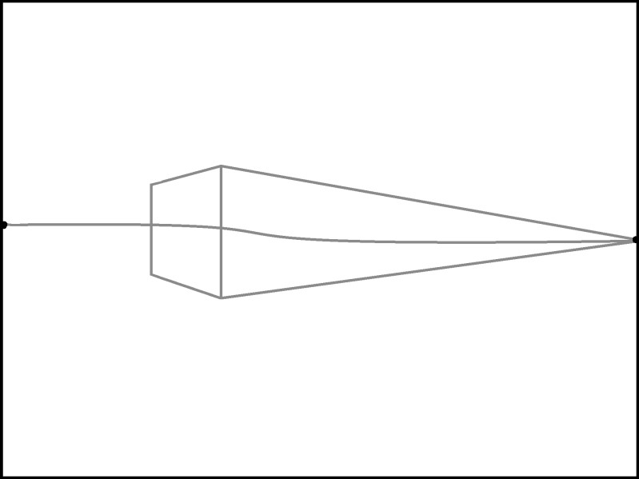

- Draw the cutoff transversal line on the right.

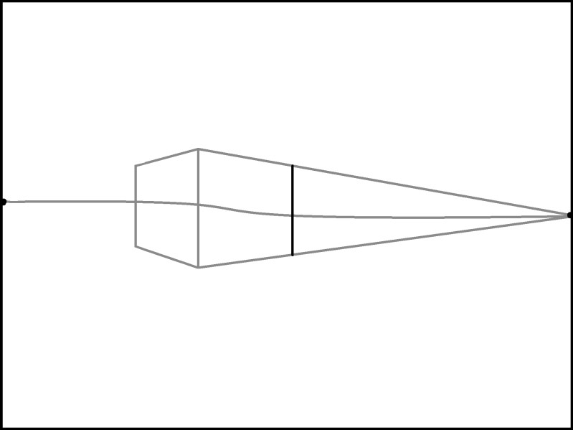

- Erase the extra lines.

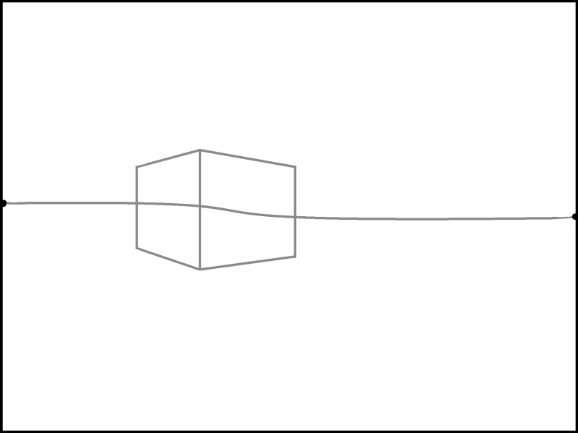

- Erase the part of the horizon line that was visible through the box.

- Draw another box on the horizon line.

2 Point Perspective

How to Draw a Box below the Horizon Line

- Draw a horizon line across your paper. Don’t use a ruler.

- Add vanishing points on the edges of the horizon line.

- Draw a vertical transversal line below the horizon line. Line up your ruler with the edge of the paper to make sure your line is perfectly vertical.

- Connect the top and bottom of the vertical line with orthogonal lines that connect to the left vanishing point.

- Connect the transversal line to the right vanishing point with two orthogonal lines.

- Draw a vertical line to show the edge of the box between the first transversal line and the vanishing point.

- Connect the bottom of the new transversal line to the right vanishing point.

- Create another edge of the box with a transversal line.

- Connect the bottom of that transversal line to the left vanishing point.

- Erase all of the connecting lines.

- Make another box below the horizon line on the other side of the paper.

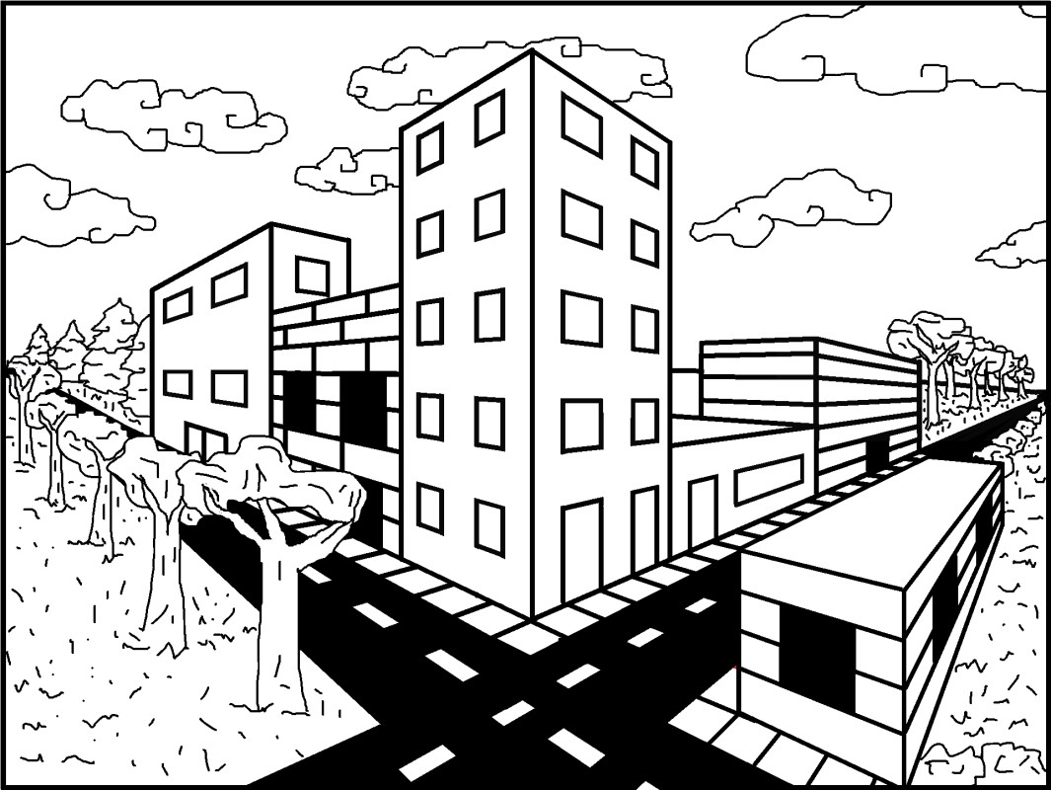

2 Point Perspective

How to Draw a City

Created by Klaire Pearson

2 Point Perspective
How to Draw a City

- Begin with a horizon line and add two small vanishing points on the edges of the line.

- Draw a tall transversal line that intersects the horizon line. Use a ruler to assure that it is perfectly vertical.

- Connect the top and bottom of the transversal line to the vanishing points with orthogonal lines.

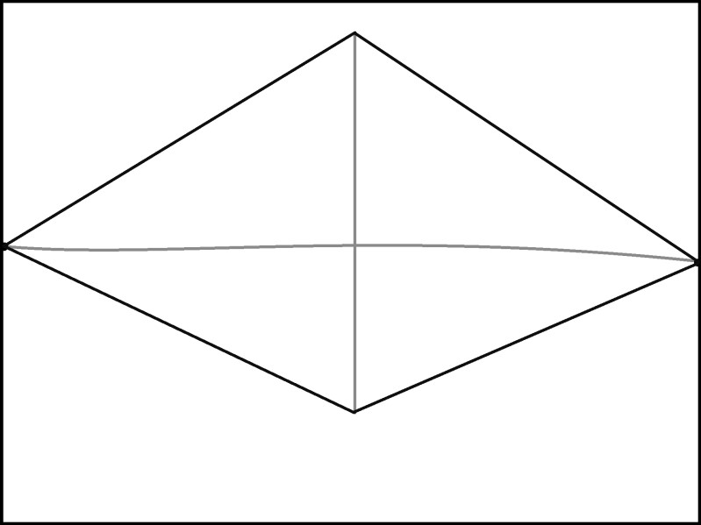

- Draw two vertical lines to illustrate the edges of the first building.

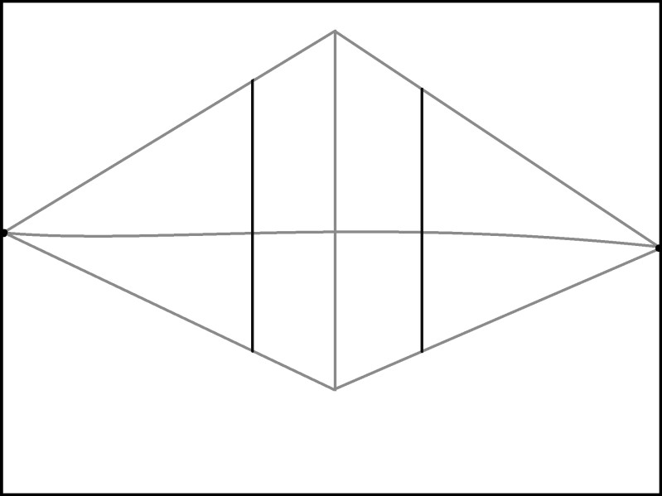

- Erase the extra lines on the top, but leave the bottom lines connected. Remove the part of the horizon line that is inside of the building.

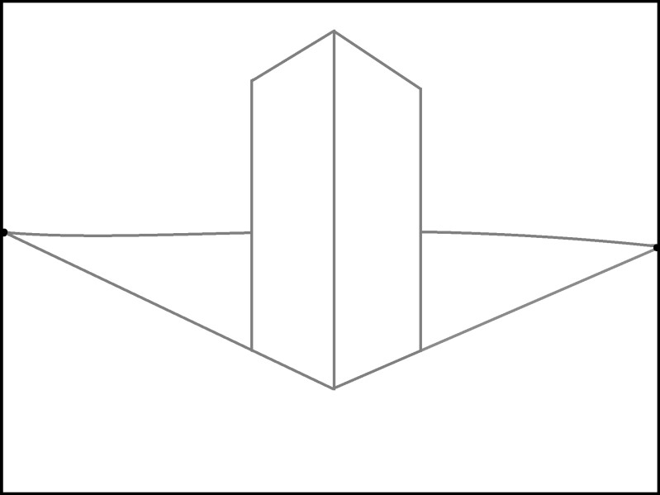

- Erase the horizon line out of the first building, and add a second building to the left side. Make it shorter than the first building. Begin with a vertical line, and draw the top by connecting the line to the left vanishing point.

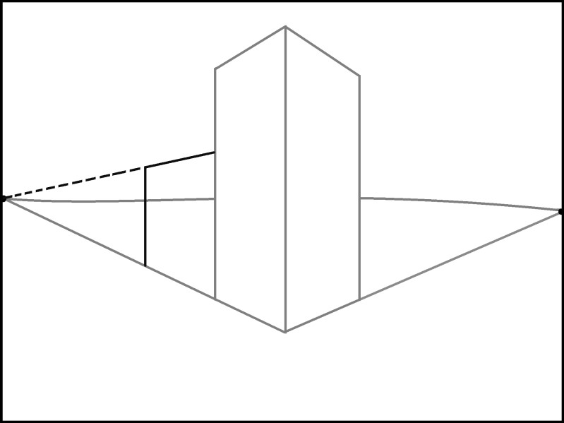

- Erase the horizon line that remained inside of the new building.

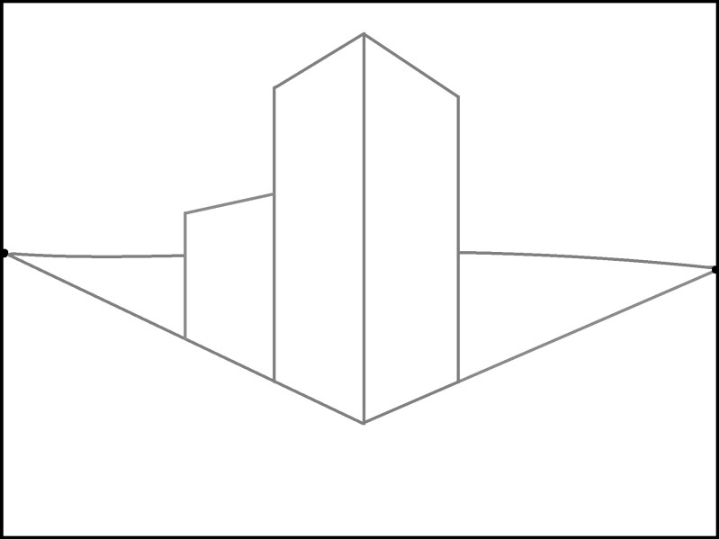

- Extend the transversal line on the left side of the small building.

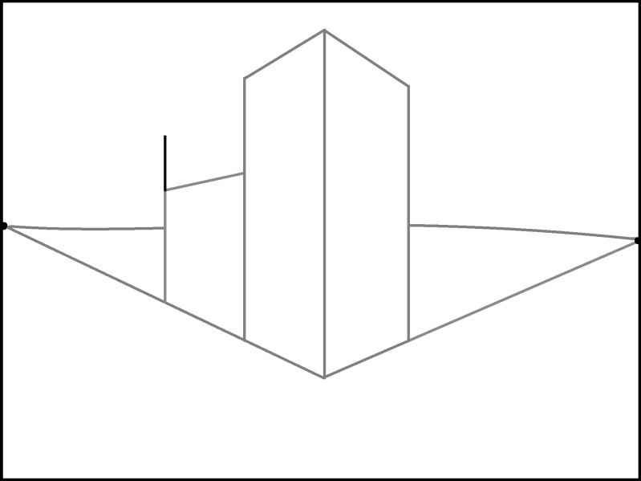
- Connect that tall line to the left vanishing point, and then create a cutoff line for the building with a vertical line. Make sure the roof of this new building connects to the vanishing point.

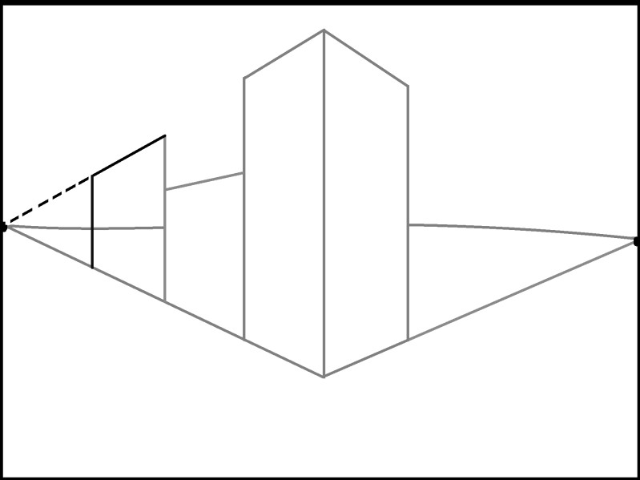

- Erase the extra lines, including the horizon line.

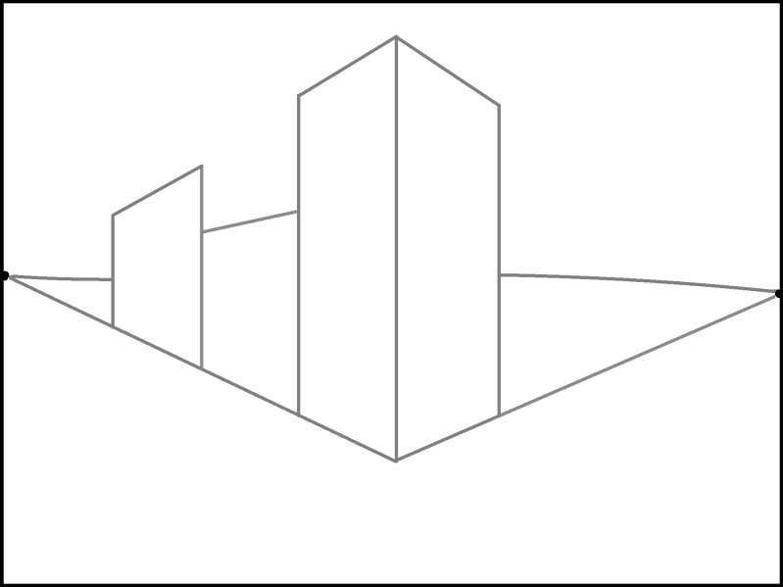

- Since this building is taller than last building, the side will be visible. Connect the corner to the right vanishing point.

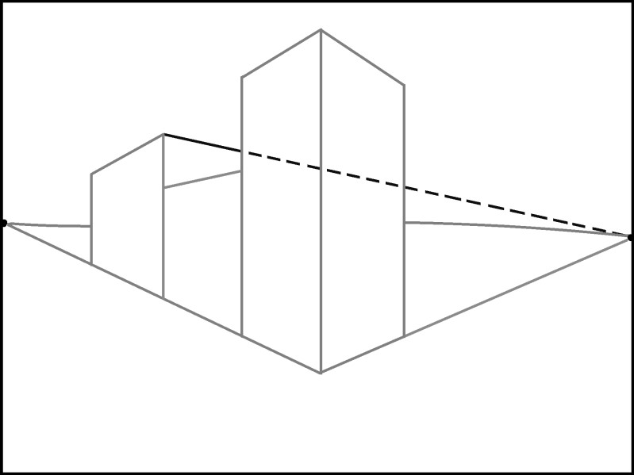

- Draw a transversal line to show the edge of the left building.

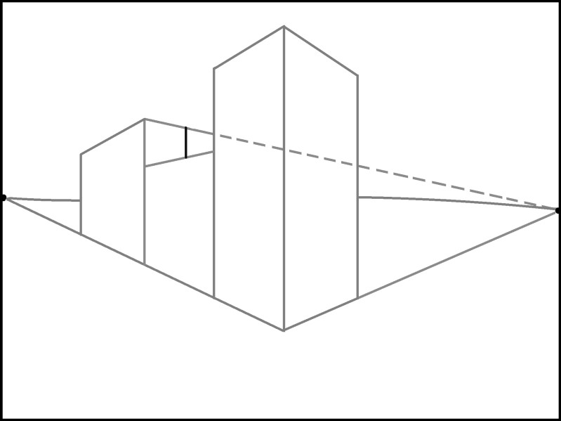
- Erase the extra orthogonal line.

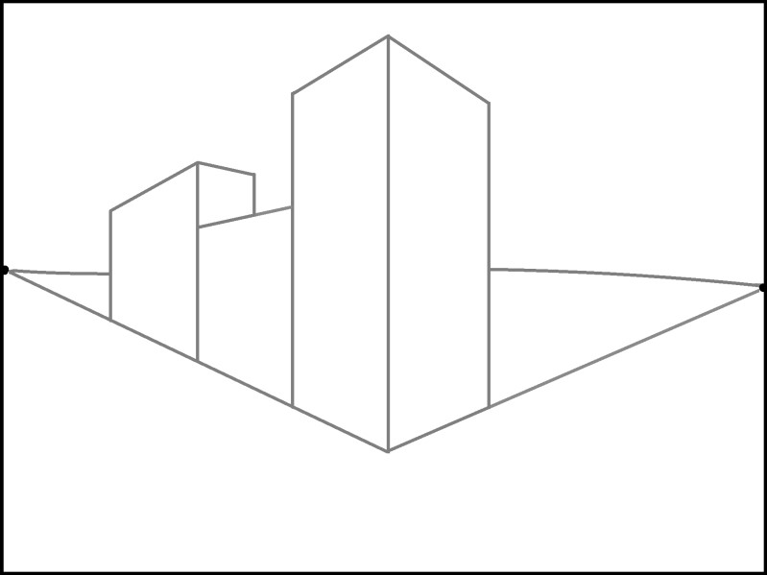

- On the right side, make a small transversal line that is below the horizon line.

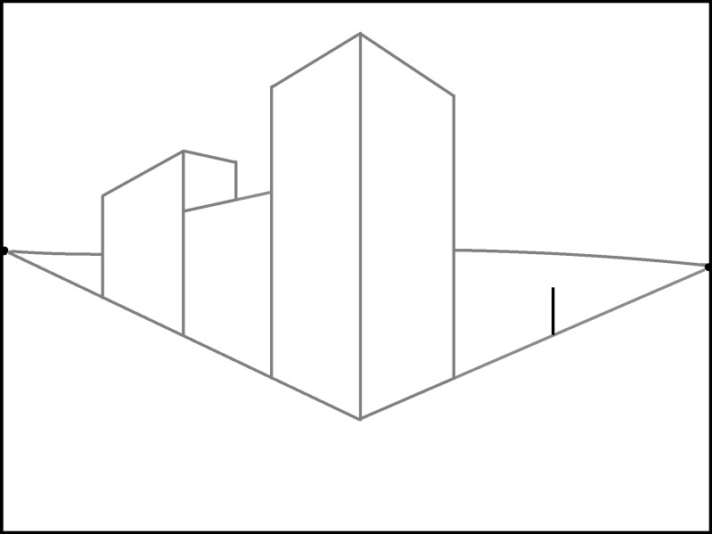
- Connect that short line to the right vanishing point with an orthogonal line.

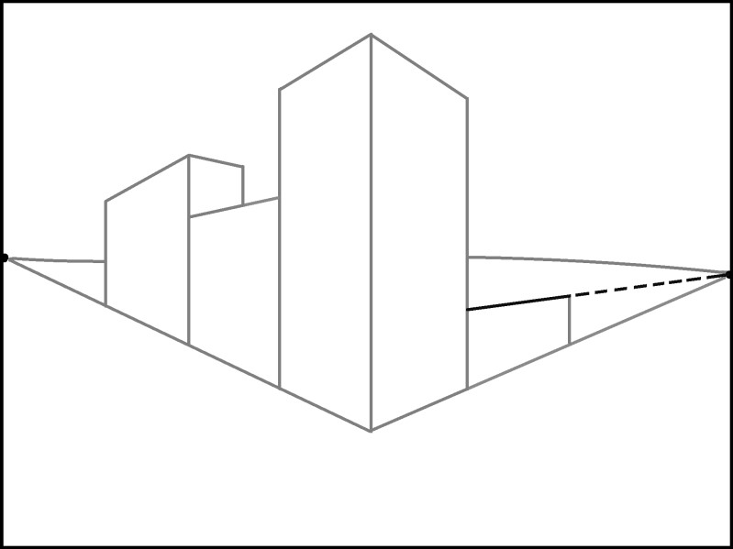

- Erase the extra orthogonal line on the right. Since this building’s roof is visible, connect the corner to the left vanishing point.

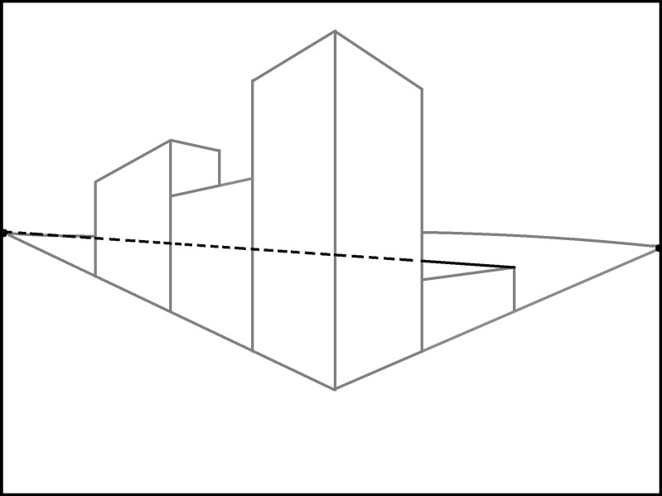
- Erase the extra lines. Extend the right transversal line so it goes above the horizon line, and then connect it to the right vanishing point.

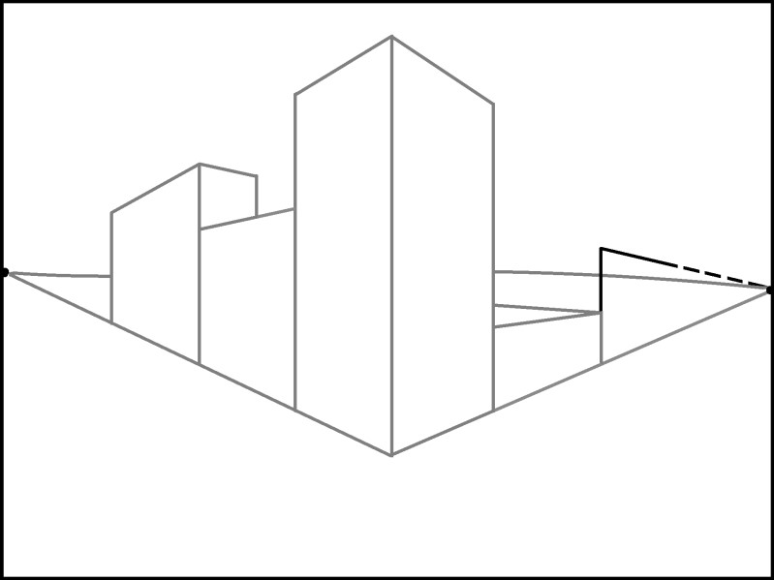

- Create the side of the building with a transversal line on the right. Erase the extra lines, including the horizon line in the building.

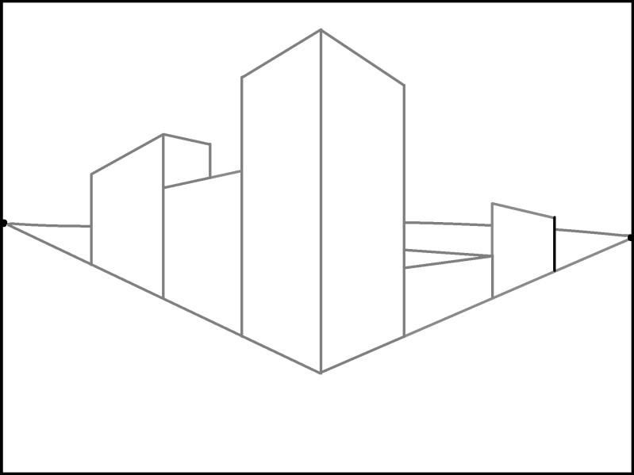
- Connect the corner to the left vanishing point with an orthogonal line. Show the edge of the building with a transversal line.

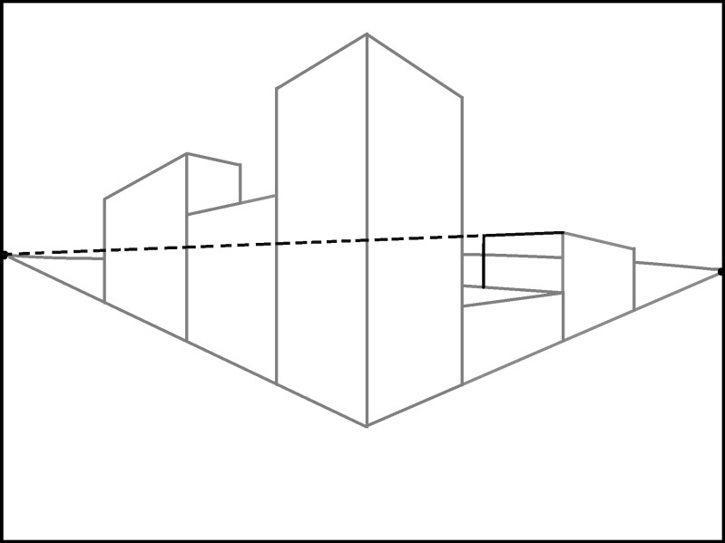

- Erase the excess lines.

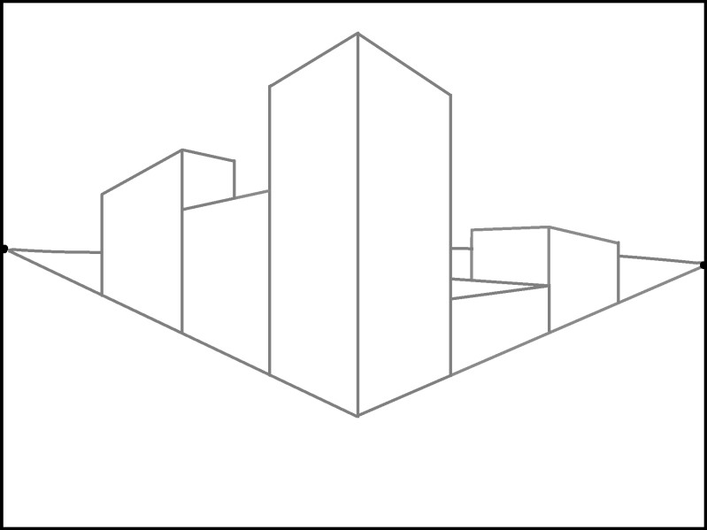
- Extend the orthogonal line on the ground by lining it up with the right vanishing point.

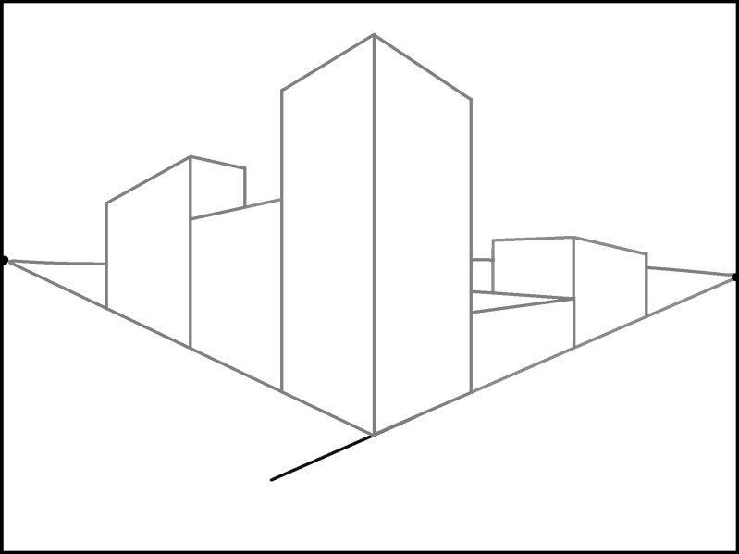

- Lengthen the other line too.

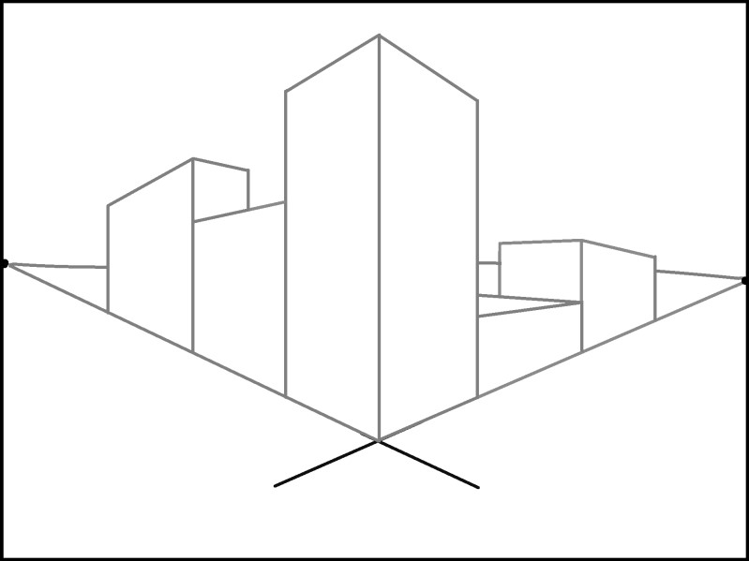
- Add two more orthogonal lines to create the edges of a sidewalk. Originate the lines from the vanishing points.

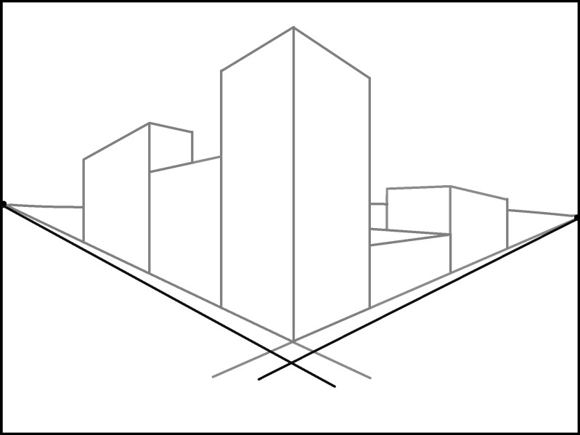

- Erase the extra lines that go past the corner.

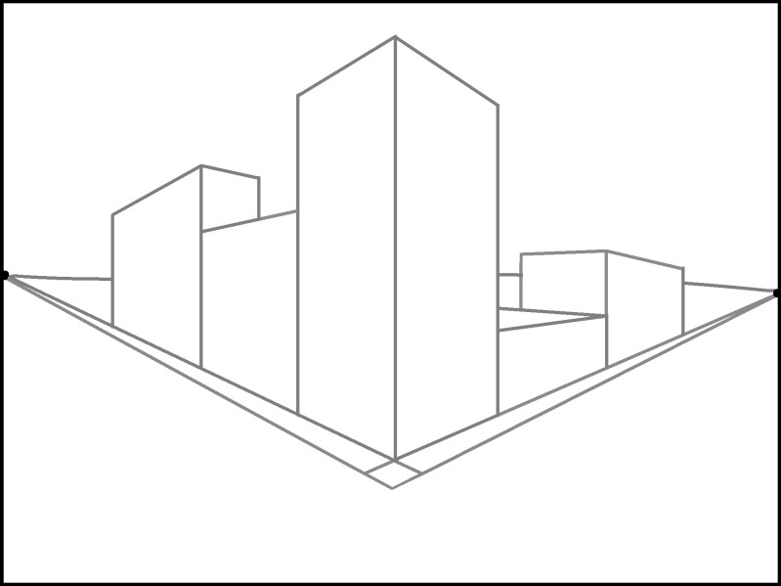
- To draw the sidewalk squares on the left, connect all of the lines to the right vanishing point. Make the spaces closer together as they go backwards.

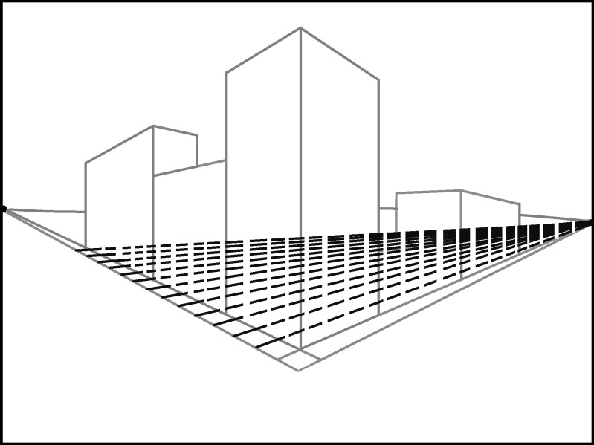

- Erase the unnecessary lines.

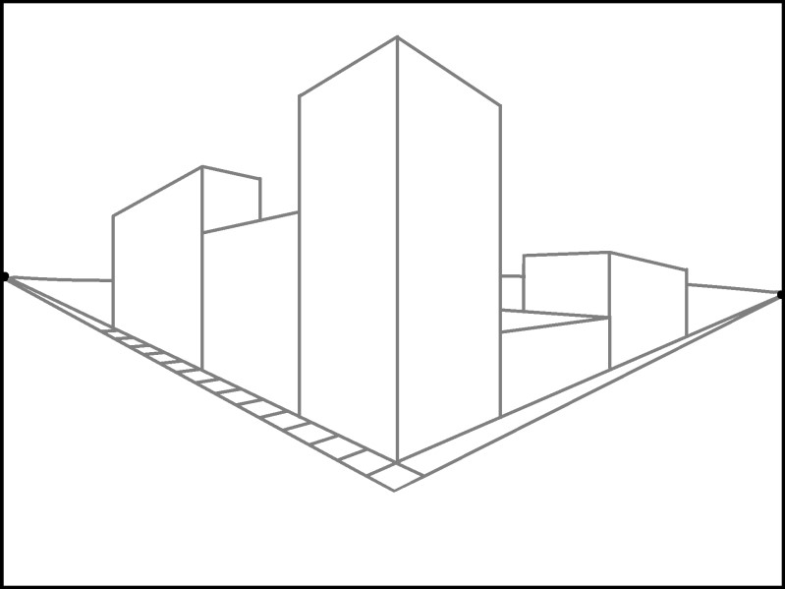
- Create the right sidewalk squares by connecting the orthogonal lines to the left vanishing point.

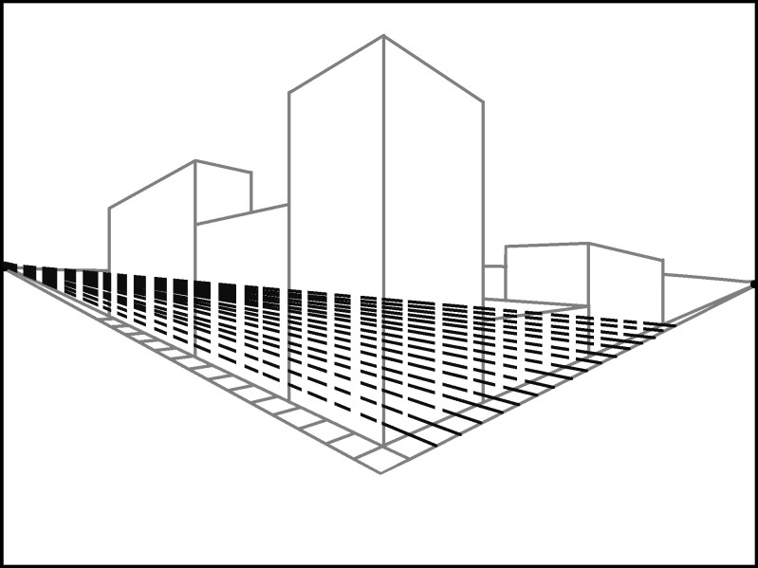

- Erase the extra lines.
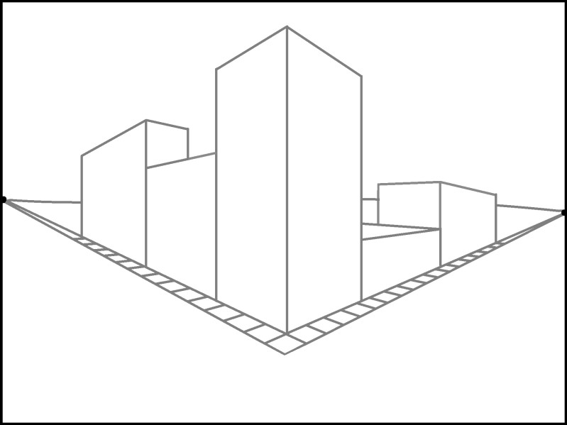

- To create a road, draw two orthogonal lines below the sidewalk. Connect the lines to the vanishing points.

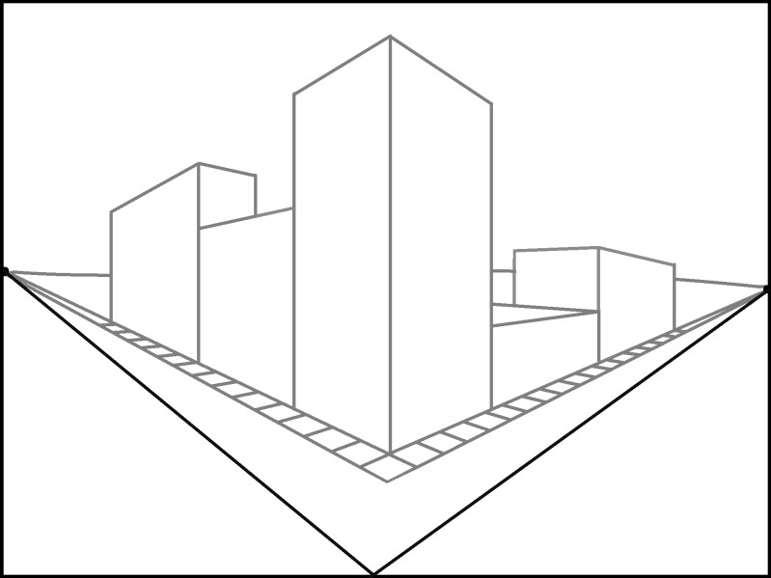

- To begin drawing windows on the corner building, draw two pairs of transversal lines on the left side of the building.

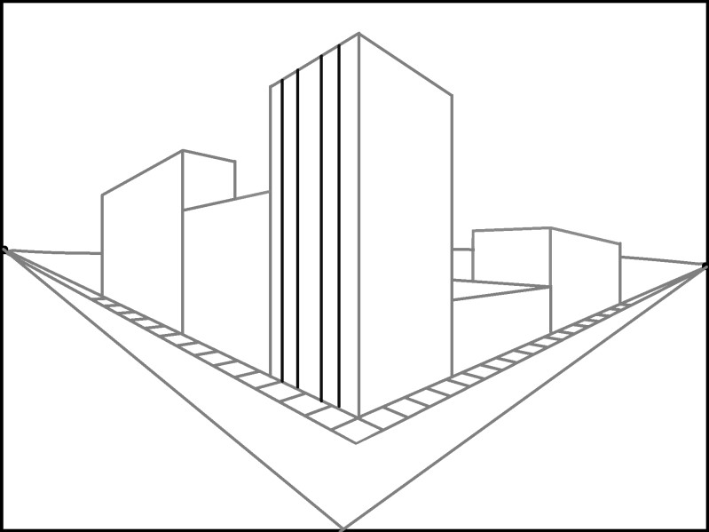

- Draw the tops and bottoms of the windows by connecting the orthogonal lines to the left vanishing point.

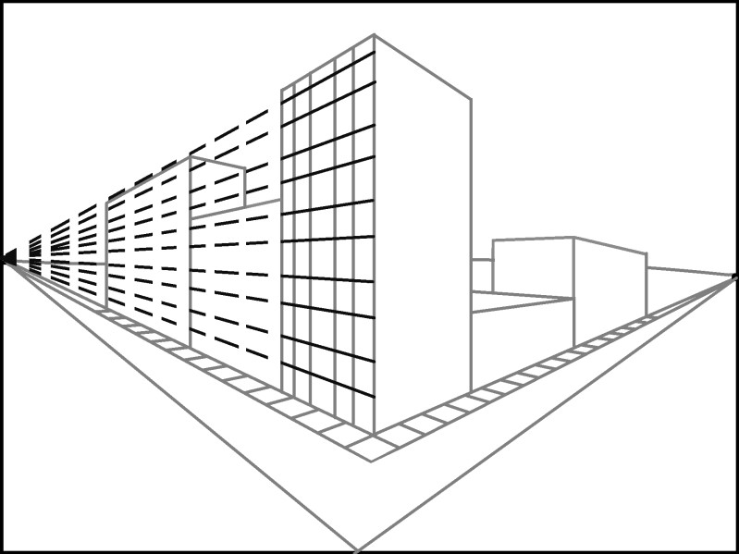

- Erase the extra lines so only the windows remain. Leave the marks at the corner of the building to align the windows on the other side.
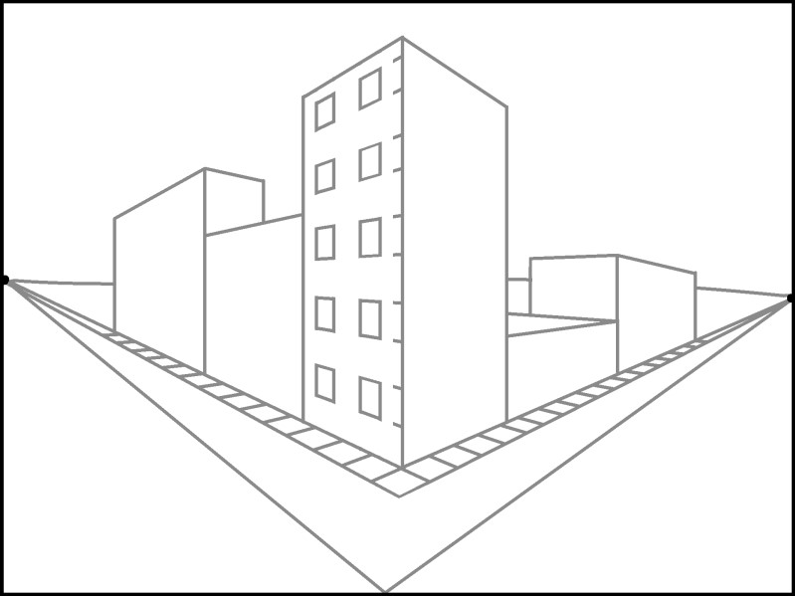

- Create windows on the right side of building by drawing the vertical lines first. Connect those lines to the right vanishing point.
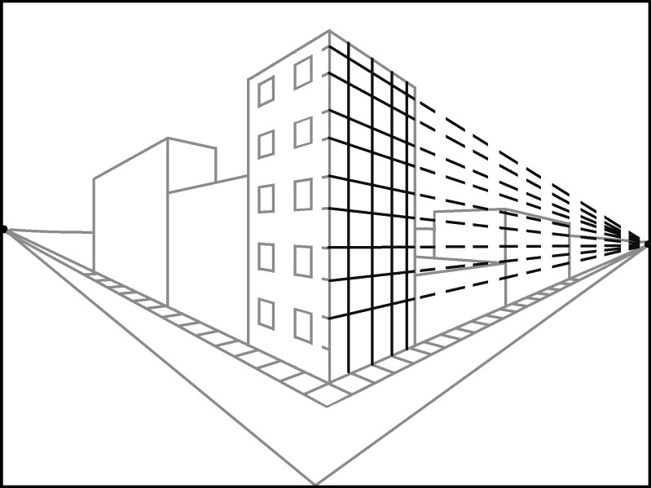

- Erase the connection lines.
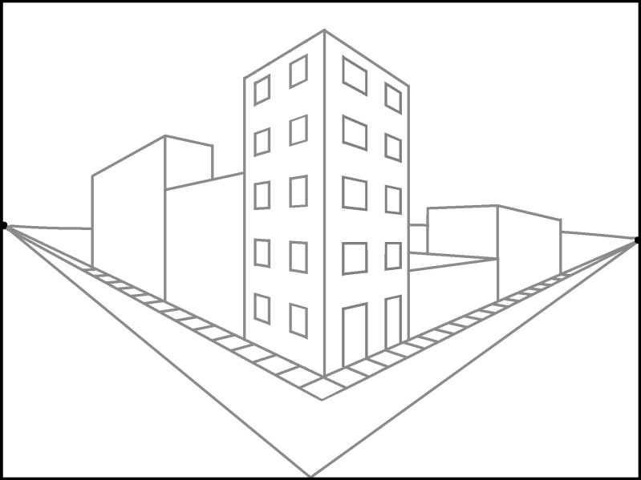
- To create a brick pattern on the center left building, draw orthogonal lines that connect to the left vanishing point.

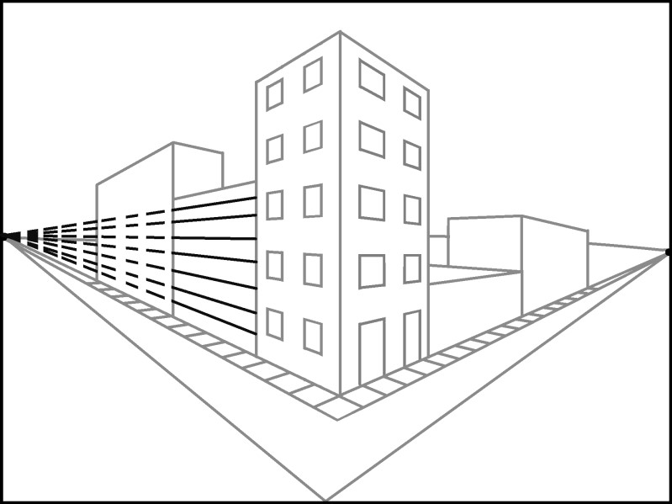

- Erase the connection lines. Then begin drawing stones or bricks with transversal lines on every other level.

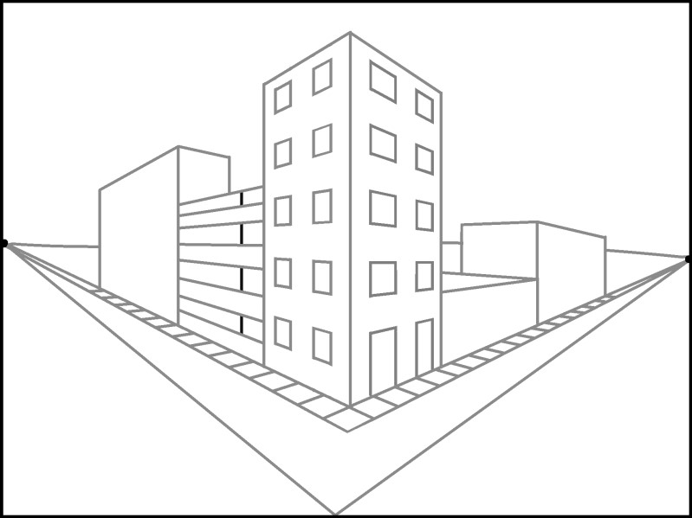

- Continue drawing stones or bricks by placing transversal lines on the opposite levels.

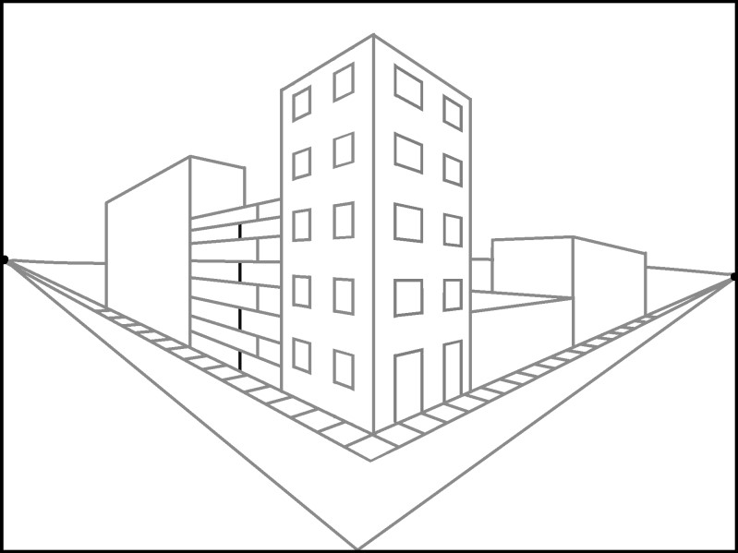

- Finish the stones or bricks by drawing more vertical lines. Place the lines closer together as they go farther back to help make them appear far back in the distance.

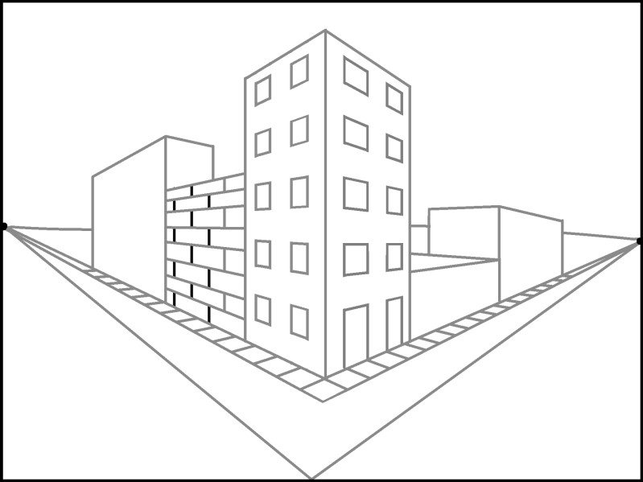

- Create a door by adding two vertical lines that end at one of the orthogonal lines so the top of the door is at a diagonal and aligns with the left vanishing point. Shade in the door to make it easy to see.
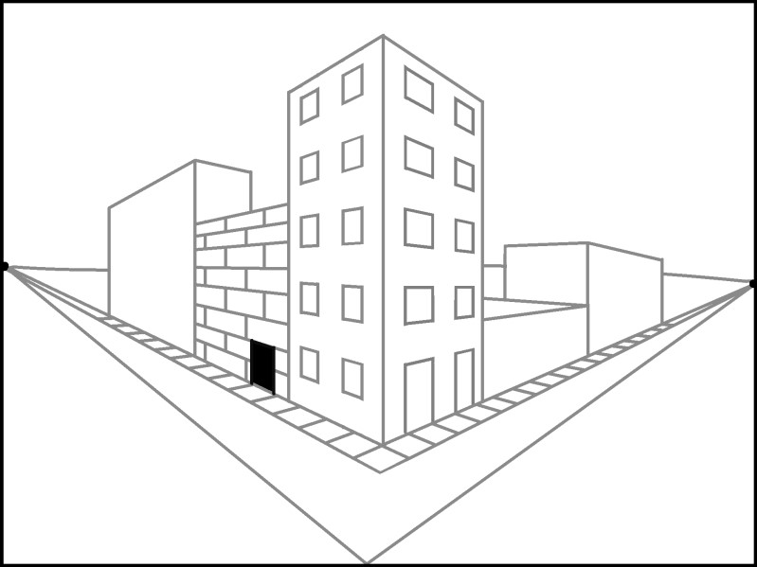

- Create windows by connecting two layers of bricks together with transversal lines and shading them.

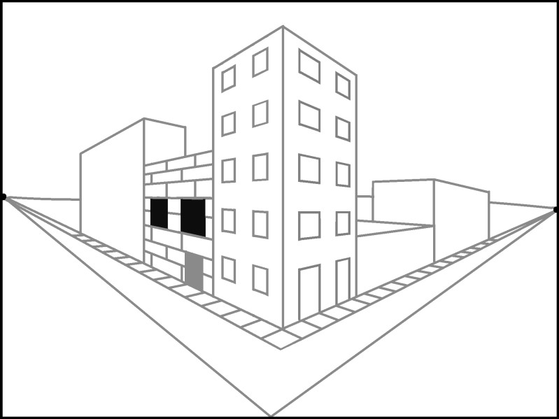

- Add paneling to the building on the far right by connecting the lines to the right vanishing point.

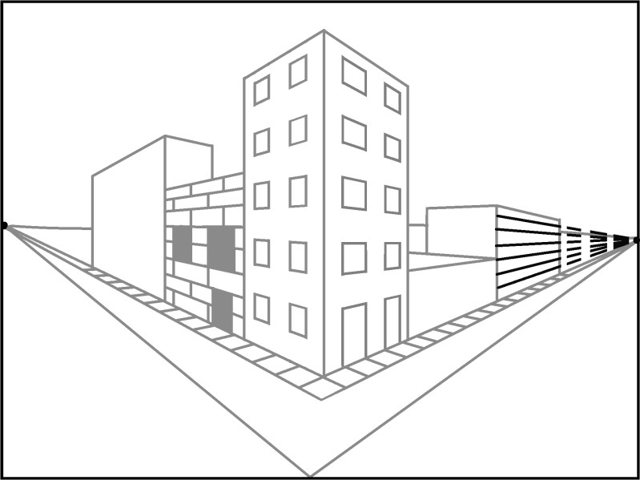

- To get the paneling to line up, connect the corners to the left vanishing point.

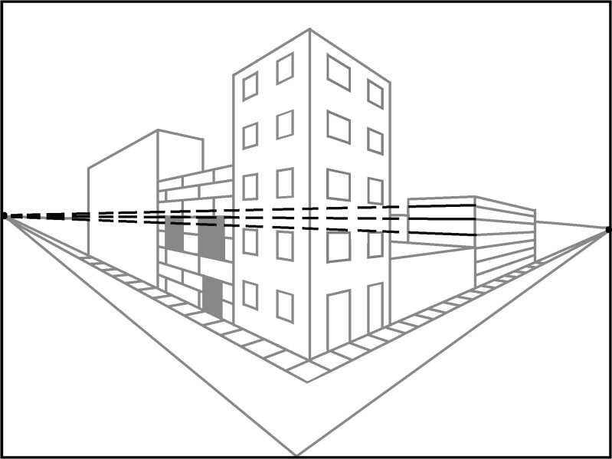

- Create a door by making two transversal lines that end at one of the panel lines. Make it easy to see by shading it.

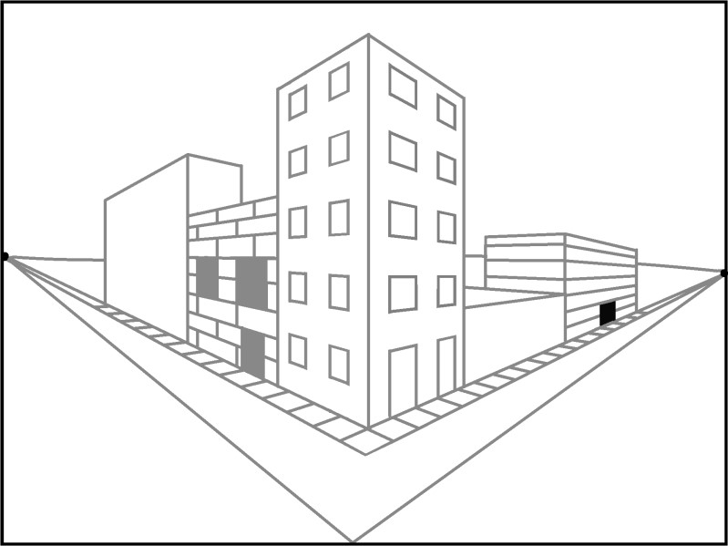

- Create a door on the left building by drawing an orthogonal line to the left vanishing point first. Draw two transversal lines between the bottom edge of the building and the new orthogonal line.
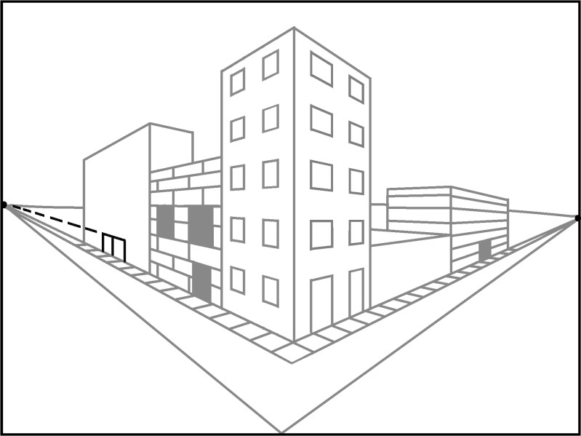
- Erase the extra lines from the door. Begin to draw the windows by connecting lines to the vanishing points.

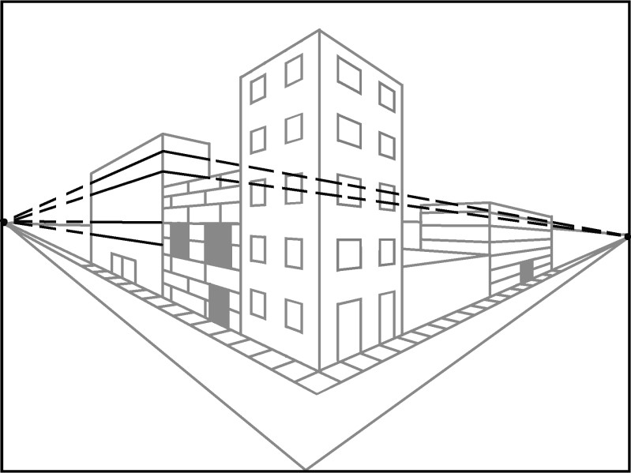

- Create windows with vertical lines that connect the orthogonal lines.
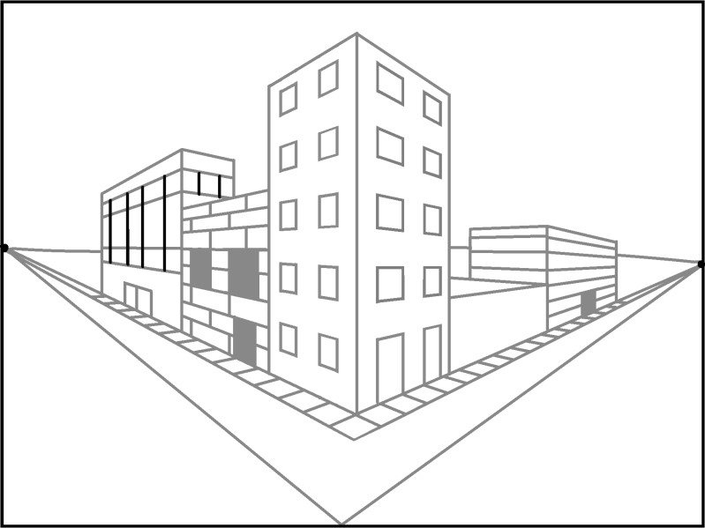

- Erase the supporting lines
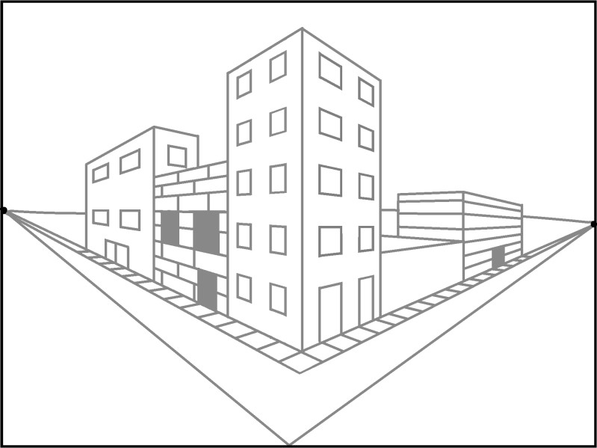

- Create a door on the middle building on the right by drawing an orthogonal line to the right vanishing point first. Then, draw two transversal lines.

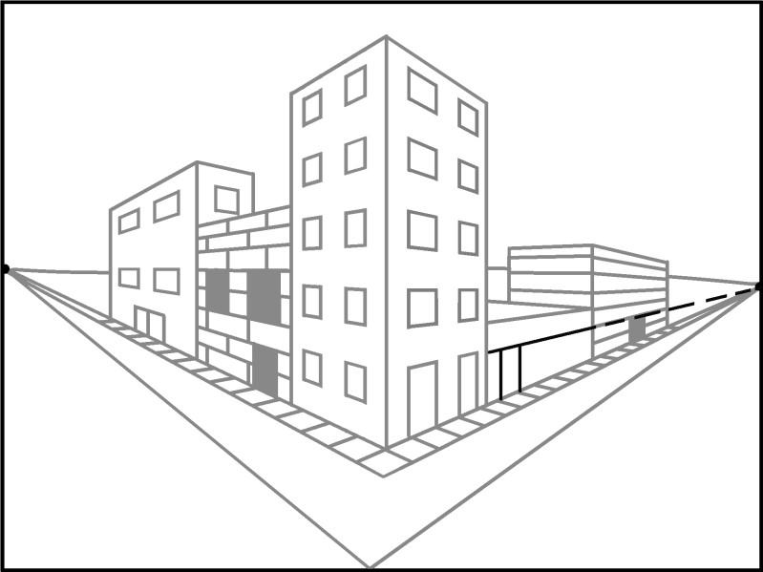
- Create a window by drawing second orthogonal line, and then add the transversal lines.

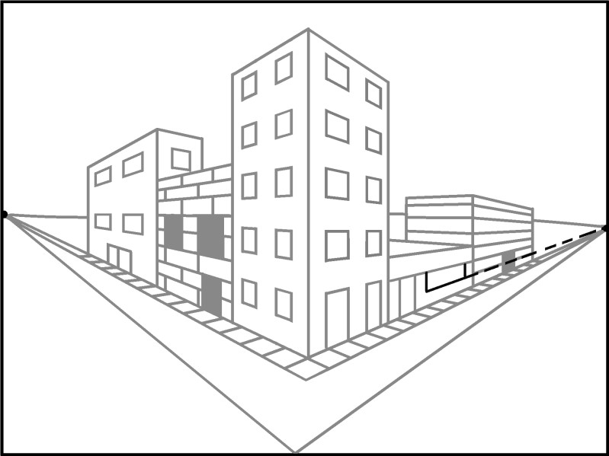

- Remove the extra lines.
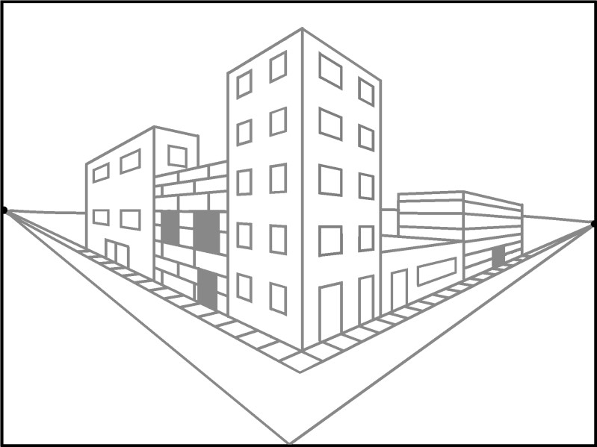
- Add final the details, such as another sidewalk, finish the street, or add plants.

2 Point Perspective Drawings Created by High School Students
