Art I: Animal Texture
On a 9x12 piece of paper draw a picture of an animal of your choosing. Keep in mind I am looking for texture. Use an animal that has fur, feathers, scales … anything that you will see value. Do not use animals that are smooth (example: Sharks and Dolphins). Be sure to incorporate value (areas of darks and lights).

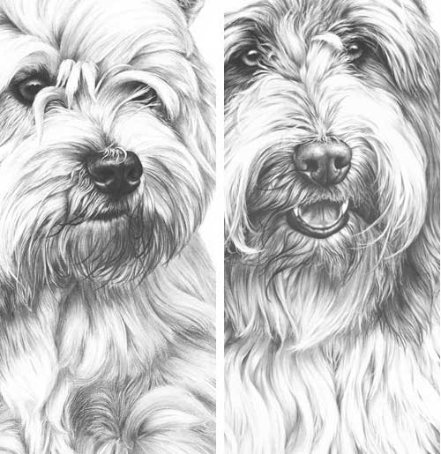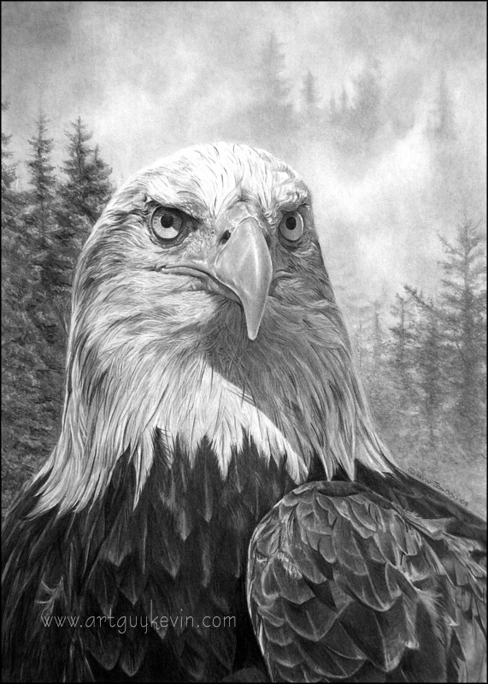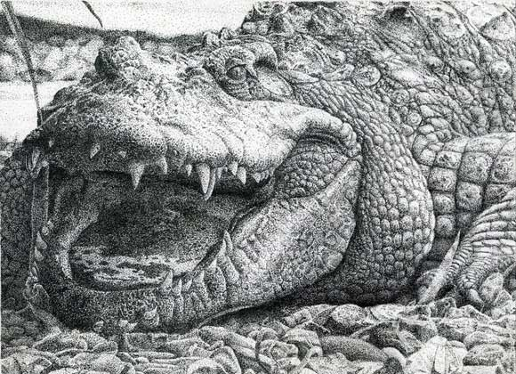
**Do Not Copy Any Of The Example Squares Given**
Grading Guidelines:
Creativity & Originality | Texture (fur, scales, feathers)
Composition | How well you drew that texture
Skill/Craftsmanship | Value
Directions | Detail
Time Usage/Effort | Animal Anatomy

