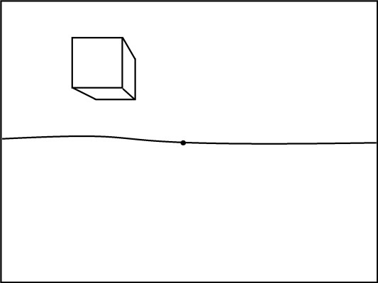
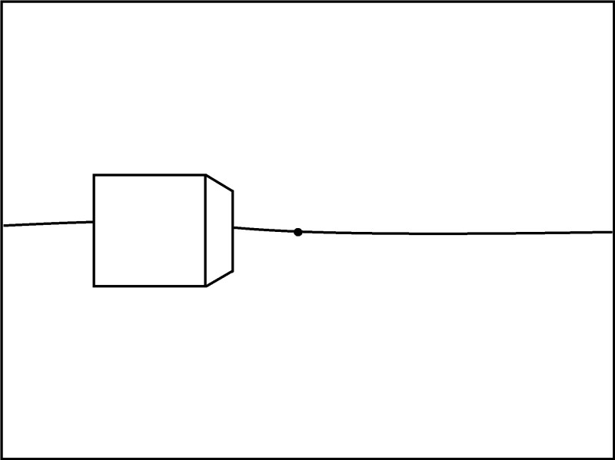
1 Point Perspective

How to Draw a Box above, on, and below the Horizon Line
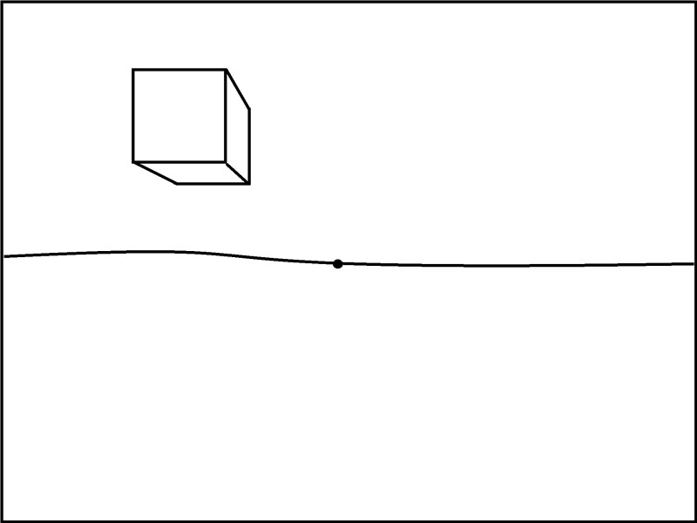
Created by Klaire Pearson

1 Point Perspective

How to Draw a Box above the Horizon Line

- Draw a horizon line across your paper. Don’t use a ruler.

- Place the vanishing point on the horizon line.

- Make a square in the top corner. Line up your ruler with the edges of the paper to make sure your lines are perfectly horizontal and vertical. These are your transversal lines.
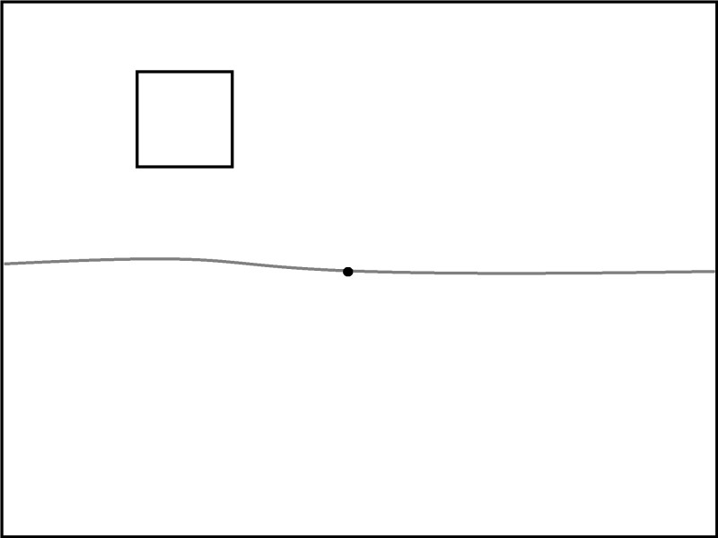

- Connect the corners on the bottom and side to the vanishing points with straight orthogonal lines to represent the side and bottom of the box.
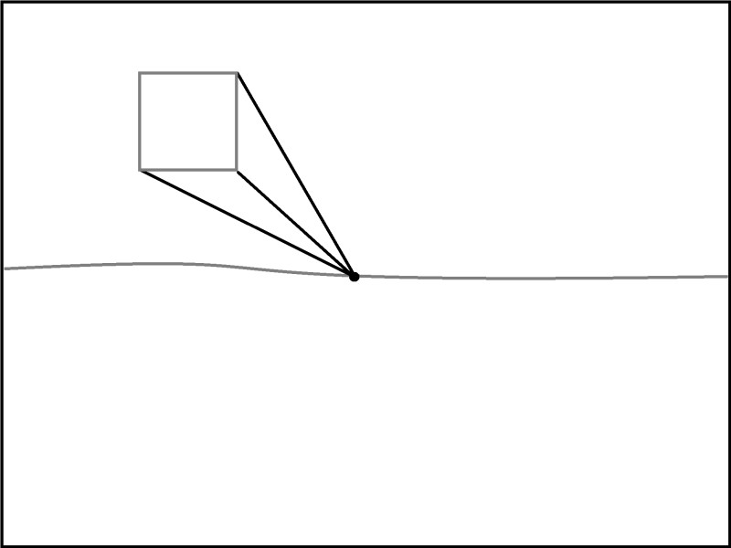

- Draw two transversal lines to show where the box ends. Line up your ruler to make sure the edges are perfectly straight.
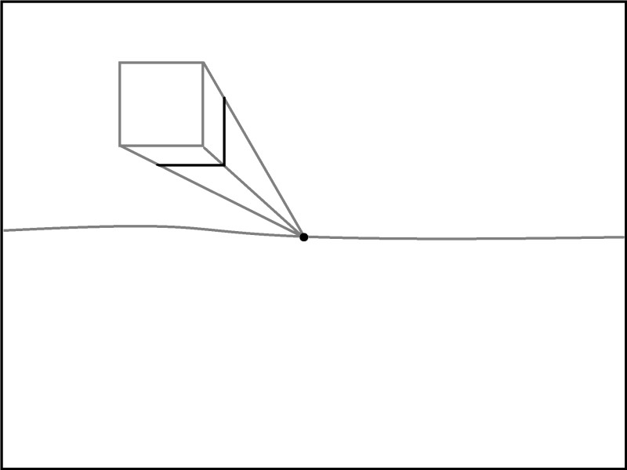

- Erase the parts of the orthogonal lines that connect the box to the vanishing point.

- Draw another box above the horizon line in the free space.

1 Point Perspective
How to Draw a Box on the Horizon Line

- Draw a horizon line across your paper. Don’t use a ruler.

- Place the vanishing point on the horizon line.

- Make a rectangle that overlaps the horizon line. Line up your ruler with the edges of the paper to make sure your lines are perfectly horizontal and vertical. These are your transversal lines.
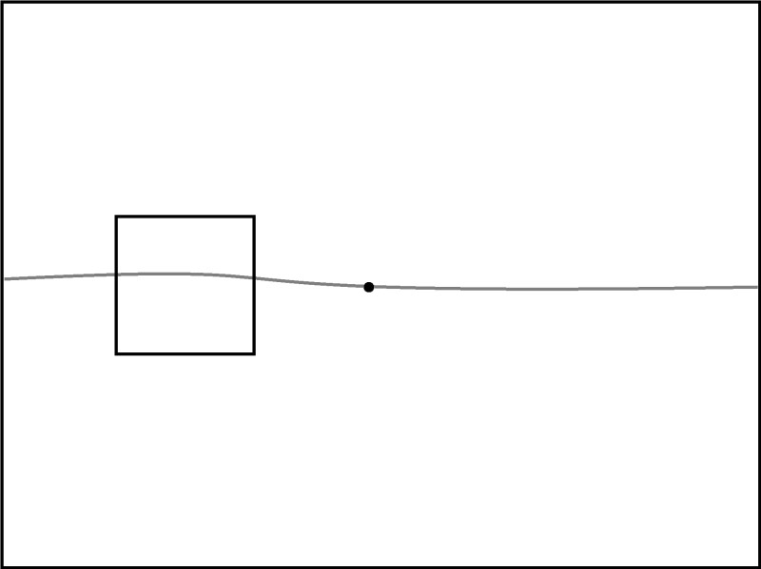

- Connect the top and bottom corners on the right to the vanishing point using the ruler. These are the orthogonal lines. You do not need to draw the orthogonal lines from the other corners because they are not visible from this viewpoint.
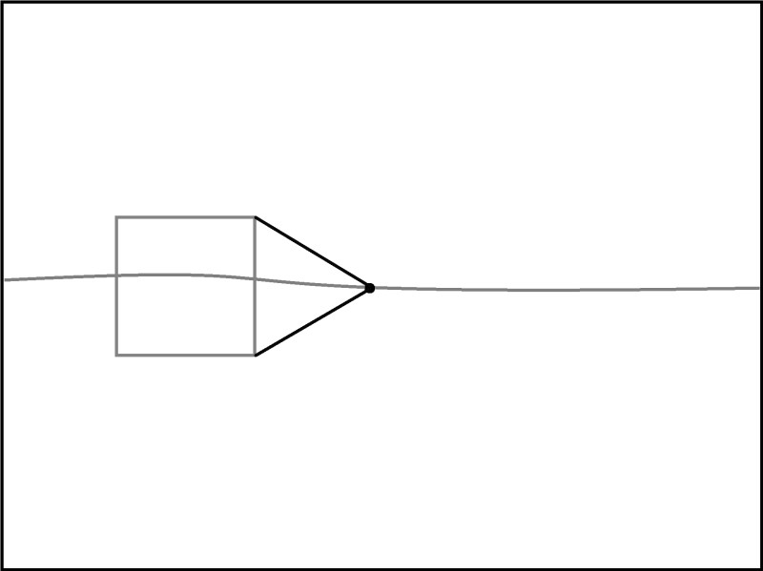

- Draw a cutoff transversal line between the right of the rectangle and the vanishing point making sure the line is perfectly straight up and down.

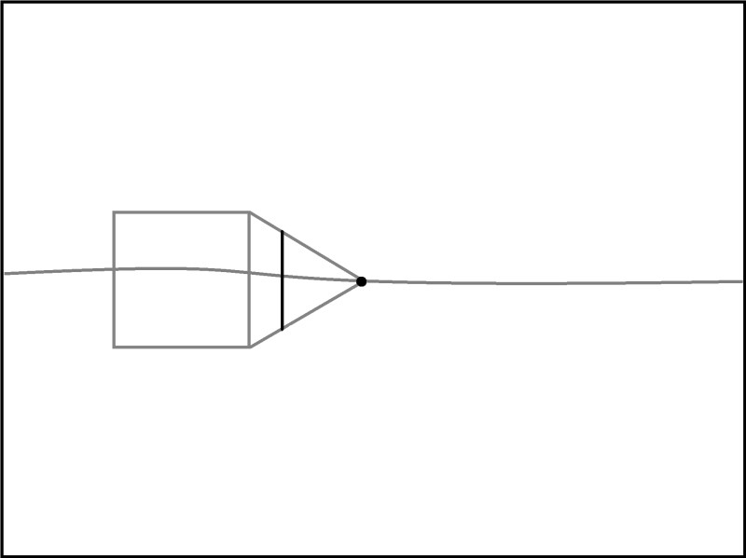

- Erase the orthogonal lines that connect back to the vanishing point. Erase the part of the horizon line that goes through the box.

- Make another box on the horizon line on the other side of the paper.

1 Point Perspective

How to Draw a Box below the Horizon Line

- Draw a horizon line across your paper. Don’t use a ruler.

- Place the vanishing point on the horizon line.

- Make a square in the bottom corner. Line up your ruler with the edges of the paper to make sure your lines are perfectly horizontal and vertical. These are your transversal lines.

- Connect the corners on the bottom and side to the vanishing points with straight orthogonal lines to represent the side and bottom of the box.

- Draw two transversal lines to show where the box ends. Line up your ruler to make sure the edges are perfectly straight.

- Erase the parts of the orthogonal lines that connect the box to the vanishing point.

- Draw another box below the horizon line in the free space.
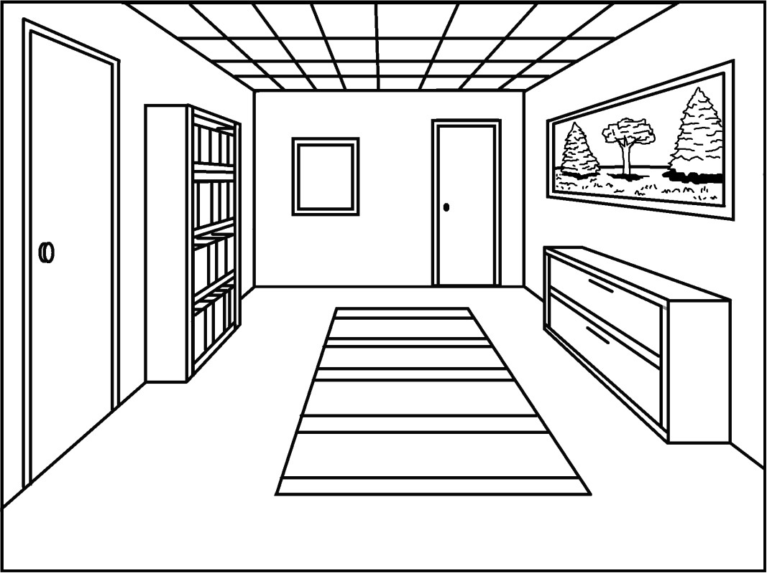

1 Point Perspective

How to Draw a Room

Created by Klaire Pearson

1 Point Perspective
How to Draw a Room

- Begin with a horizon line and vanishing point.

- Create the floor, walls, and ceiling edges with transversal lines. Make sure you line up your ruler with the edges of the paper to assure that the transversal lines are perfectly vertical and horizontal.

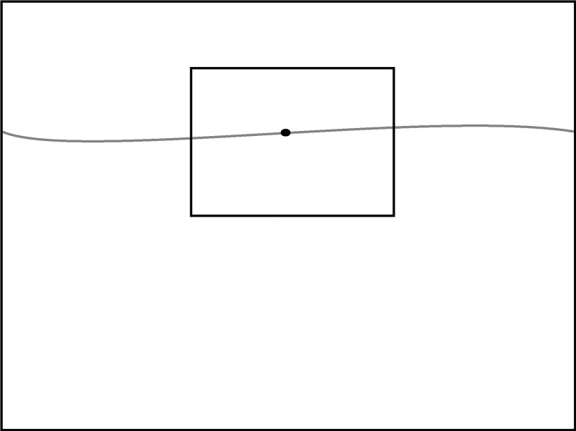

- Create the orthogonal lines by connecting the corners of the rectangle with the vanishing point. Use your ruler to make sure the lines are straight.

- Erase the orthogonal lines that are on the back wall that connect to the vanishing point. Keep the horizon line because it will help you when placing objects in the room.

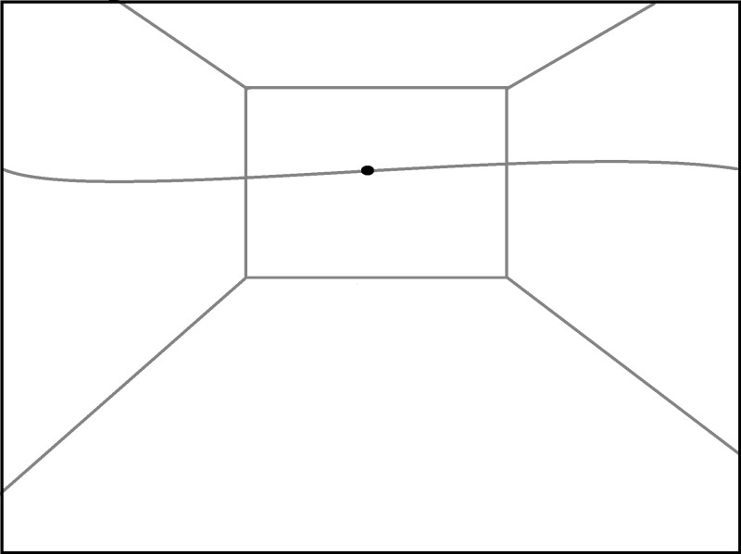

- Begin creating a door by drawing a vertical transversal line that touches the floor but stops before the ceiling.

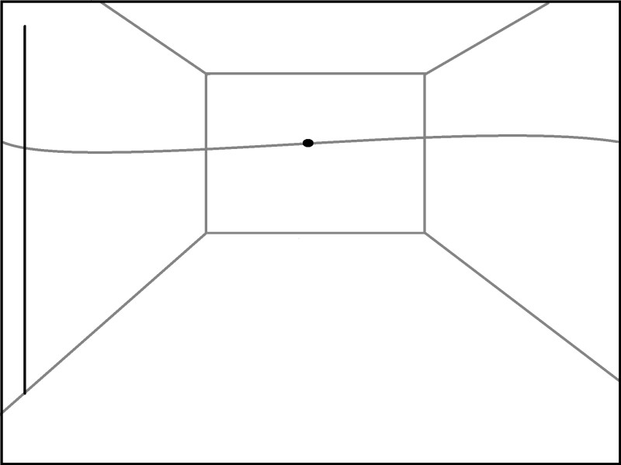

- Connect the top of that line to the vanishing point with an orthogonal line.

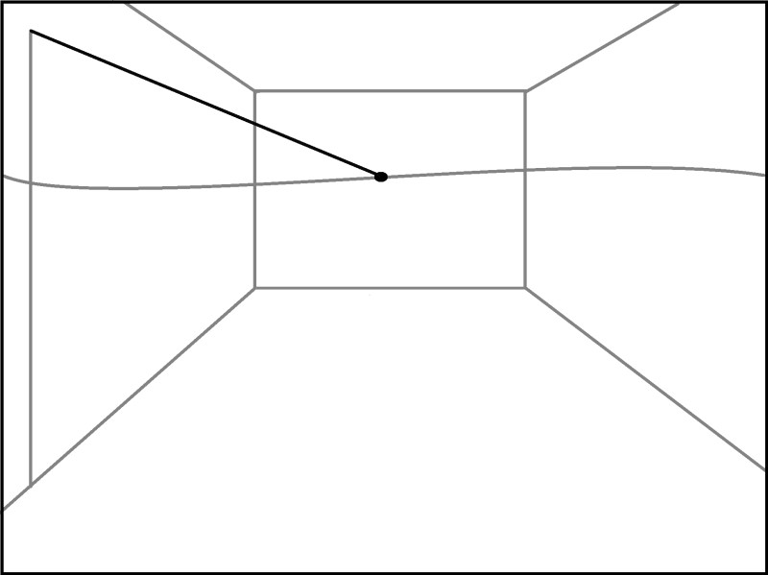

- Create the other side of the door with a vertical line.

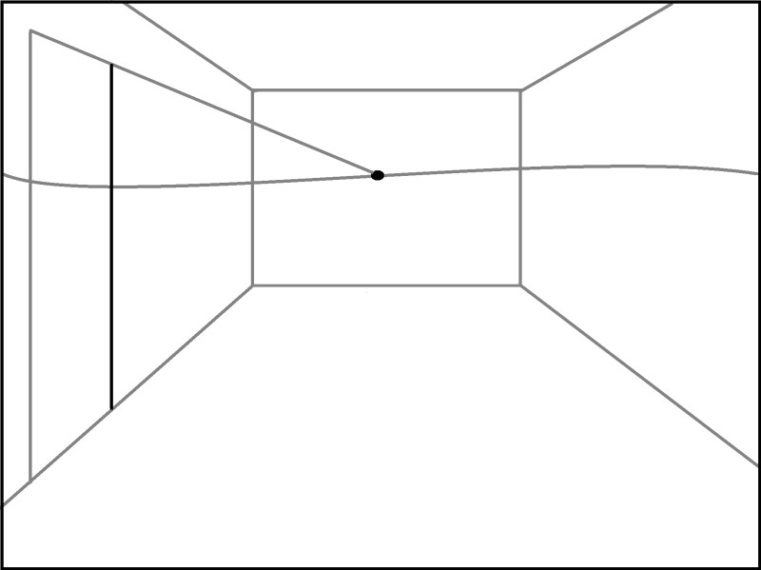

- Erase the extra part of the orthogonal line.

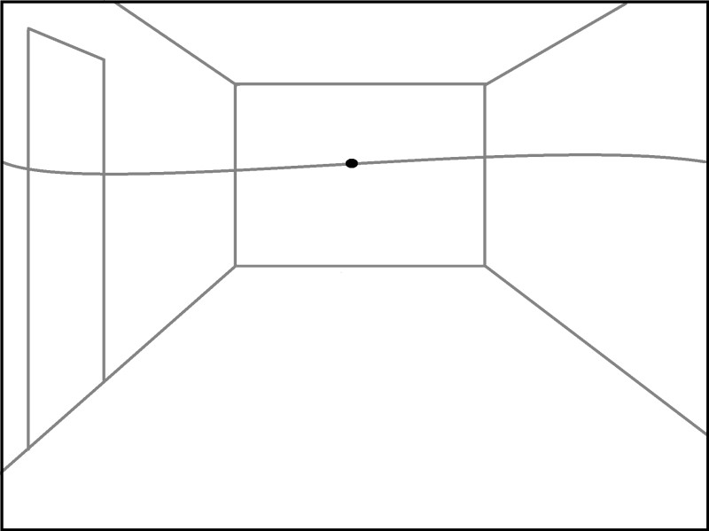

- Erase the horizon line inside of the door and add a doorknob.

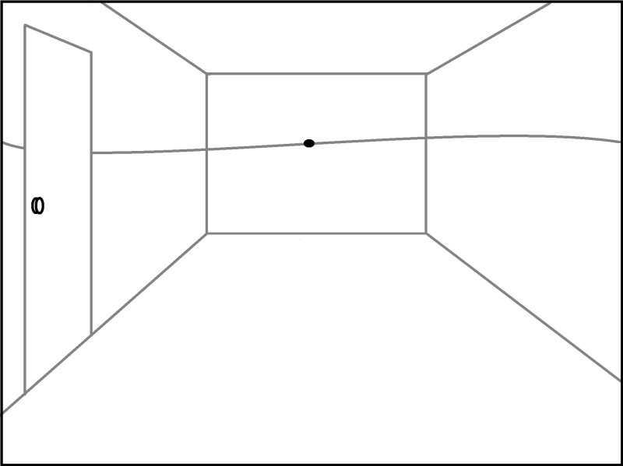

- Create a doorframe by starting with a transversal line outside of the door, and then connect it back to the vanishing point with an orthogonal line.

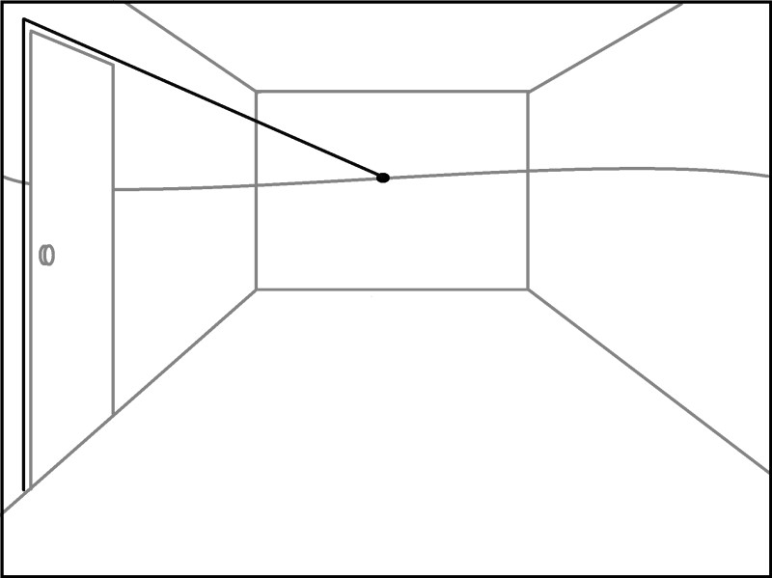

- Finish the doorframe with the last transversal line, and erase the extra orthogonal line.

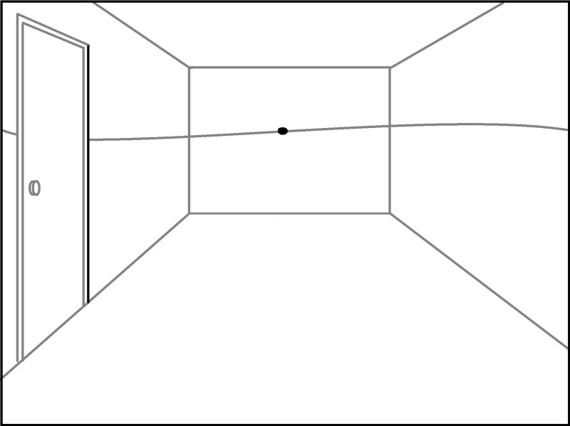

- Begin a window with a transversal line that intersects the horizon line.

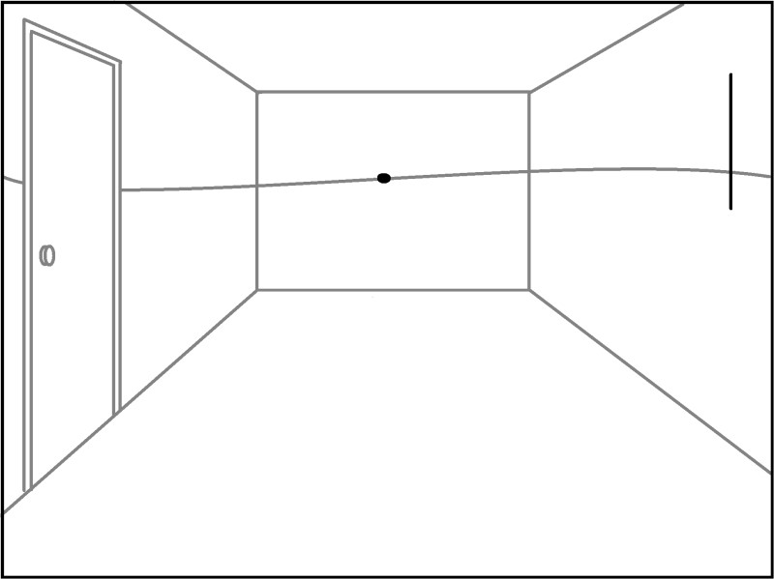
- Connect the top and bottom of that line back to the vanishing point.

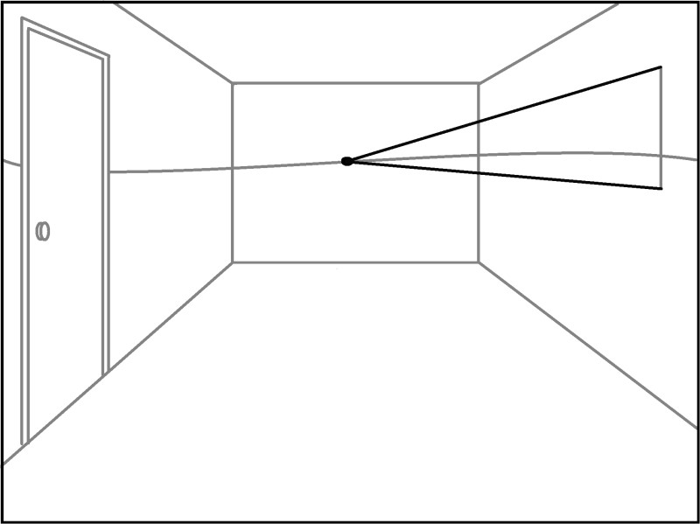

- Create the other side of the window with a vertical transversal line.
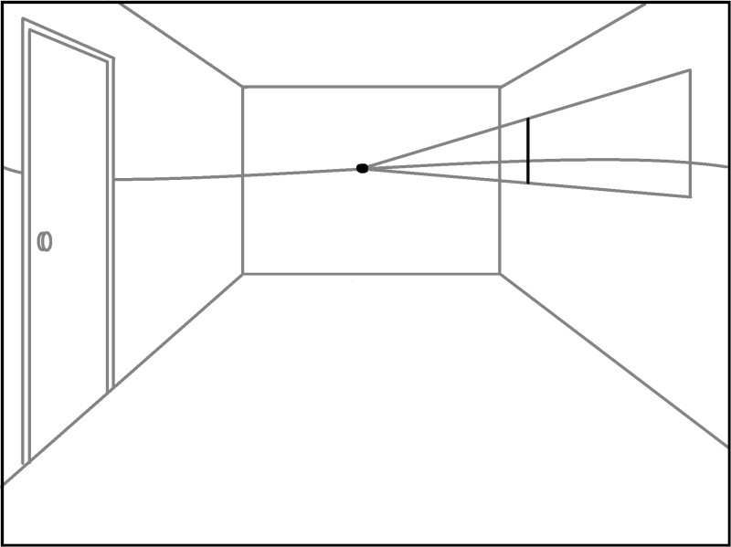
- Erase the extra orthogonal lines.

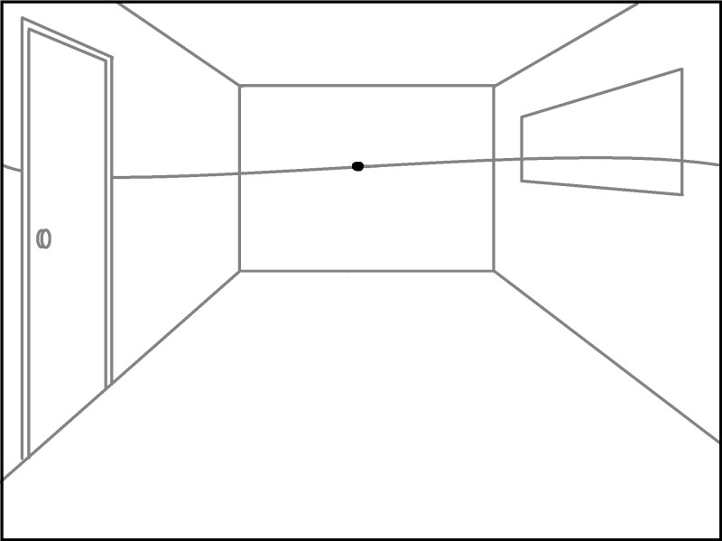

- Create a window frame by starting with a transversal line, adding the top and bottom orthogonal lines, and then finishing with the other side line.
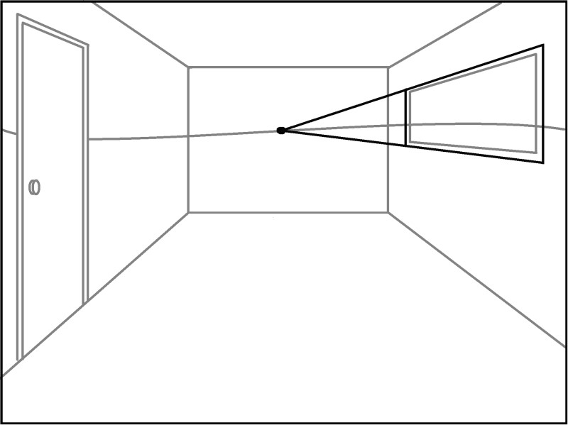
- Erase the connecting lines and the horizon line inside of the window frame.

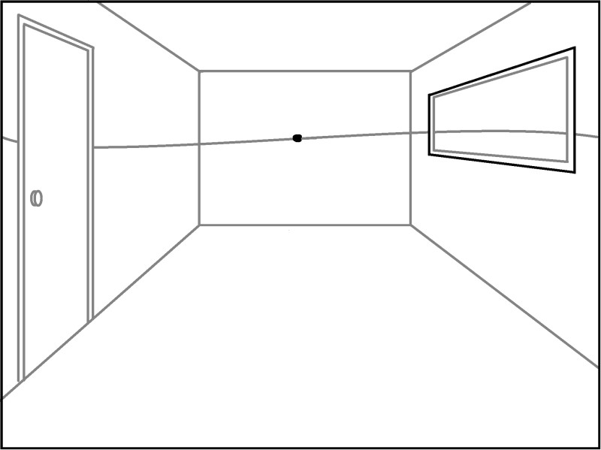

- Create a square that has a corner that lines up where the floor meets the wall.

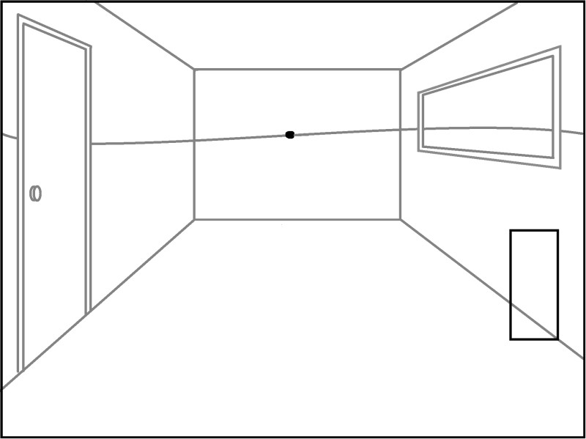
- Connect the 3 corners back to the vanishing point.

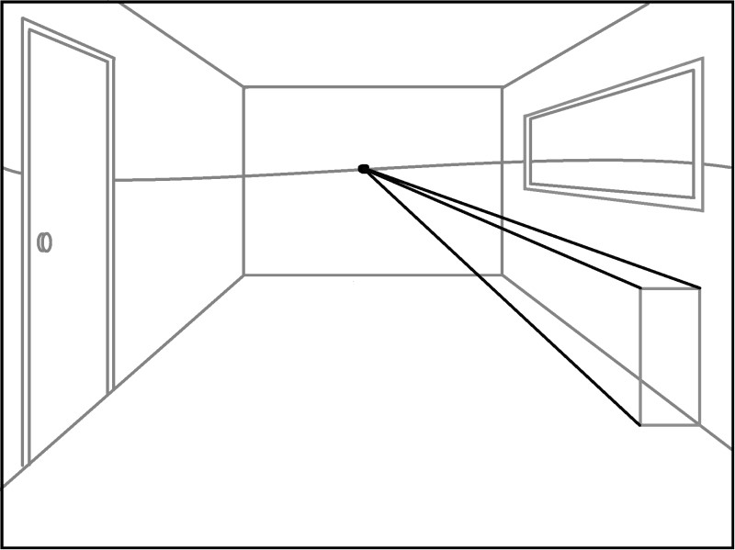

- Cut off the sides of the box with transversal lines on the side and top.

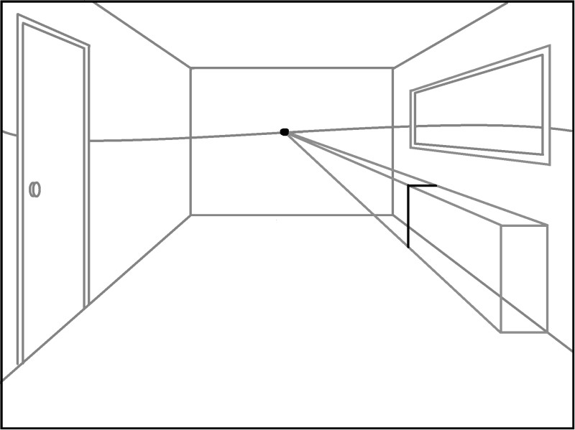
- Erase the connecting lines.

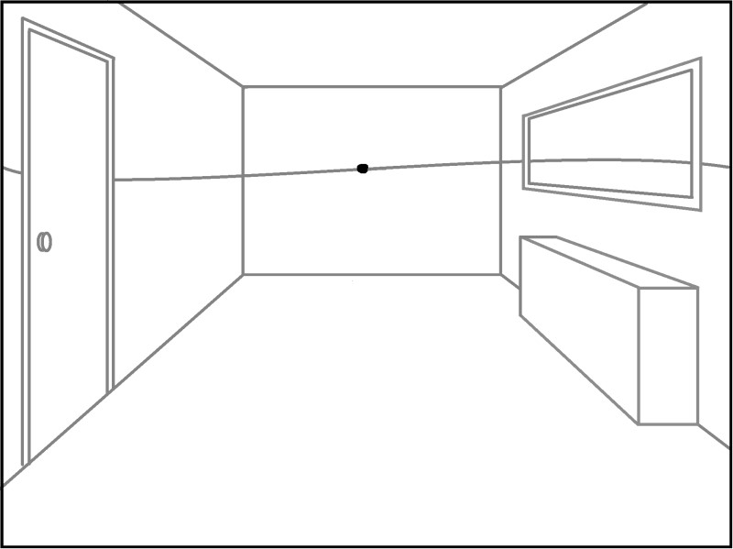

- Create a tall rectangle that is under and above the horizon line. Make sure the corner that aligns with the floor.

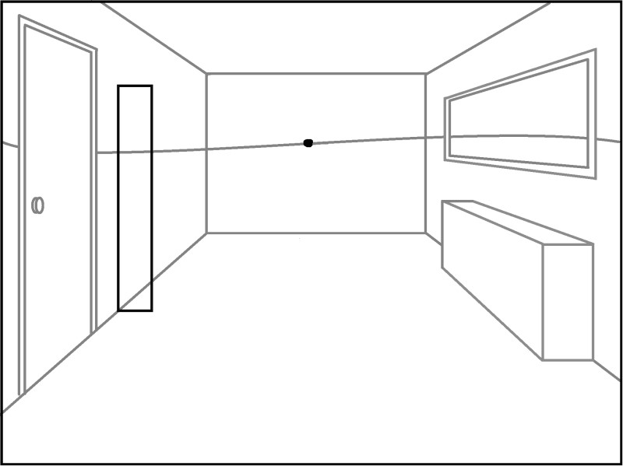
- Connect the top and bottom corners to the vanishing point.

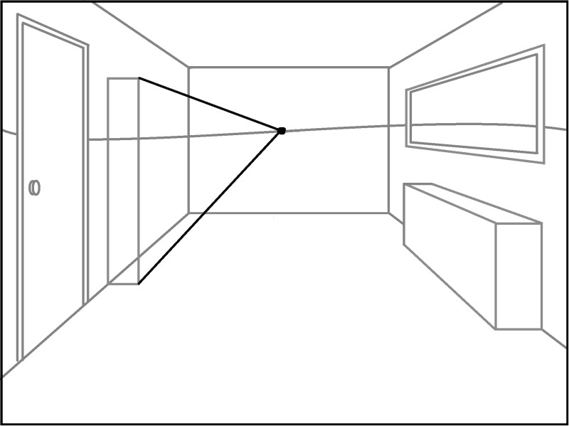

- Cut off the edge with a transversal line.

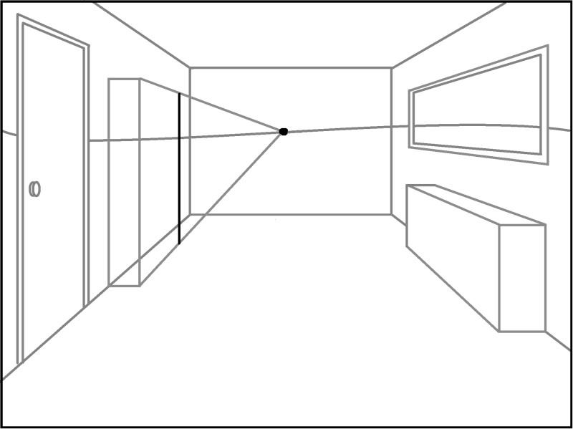
- Erase the extra orthogonal lines.
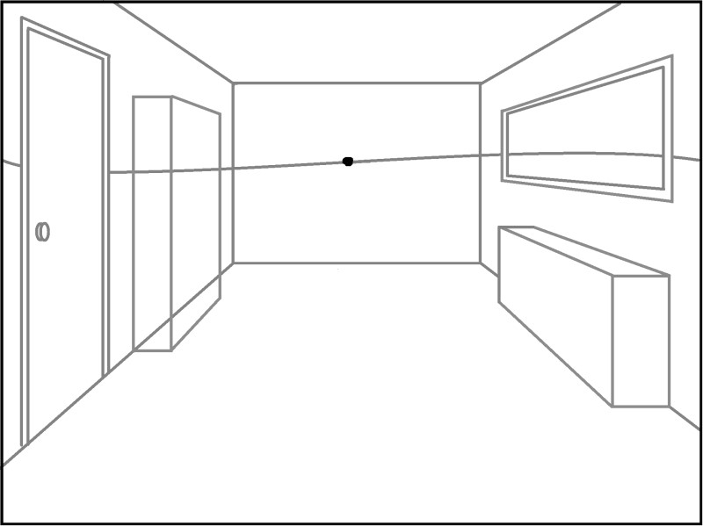

- Erase the other lines inside of the box.
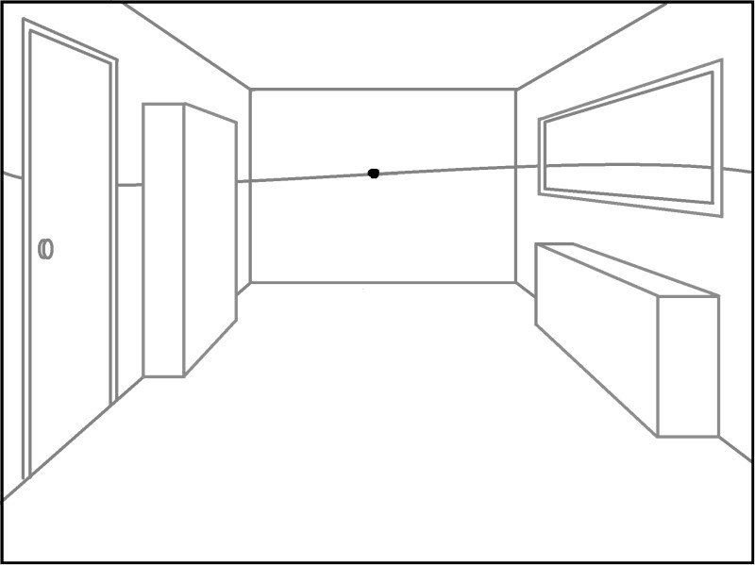
- Transform the box into a shelf by drawing 3 orthogonal lines that connect to the vanishing point.

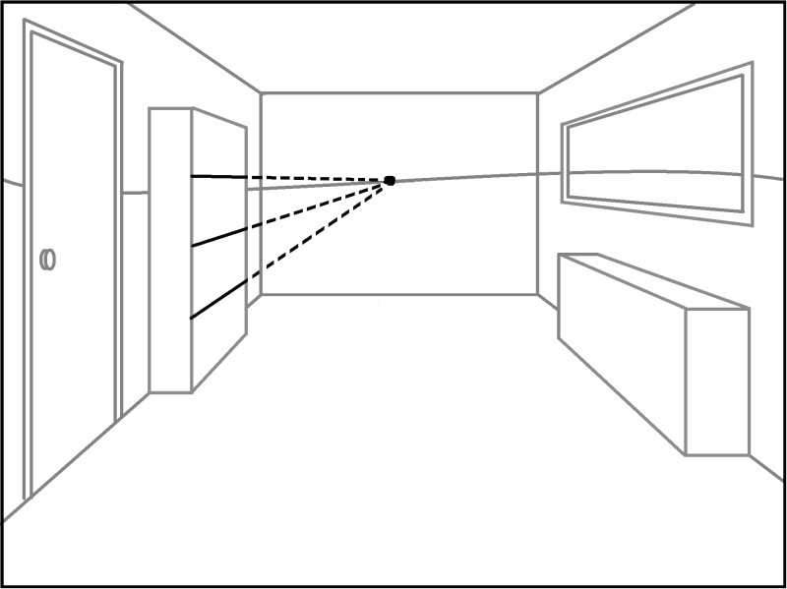

- Erase the extra lines orthogonal lines.
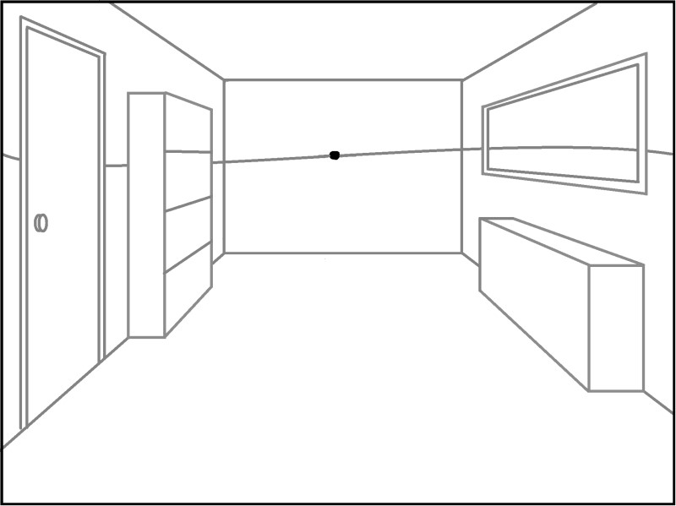

- Erase the horizon line everywhere except for the segment visible from the window. Draw an outdoor scene in the window and use the horizon line to show where the earth meets the sky.

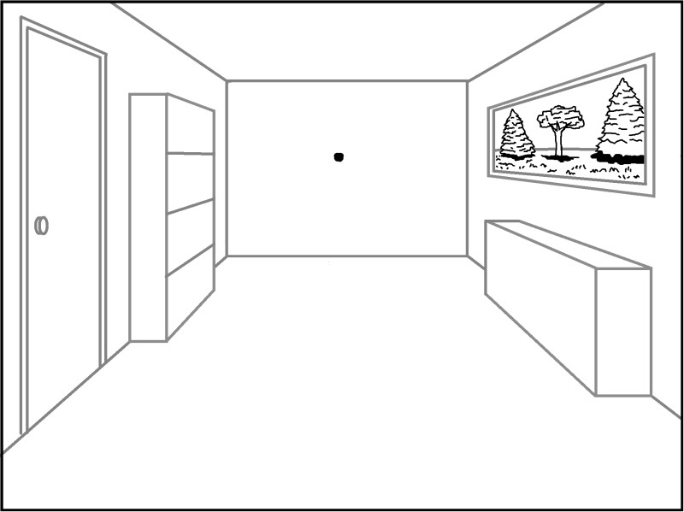

- To create ceiling tiles, draw orthogonal lines on the ceiling.

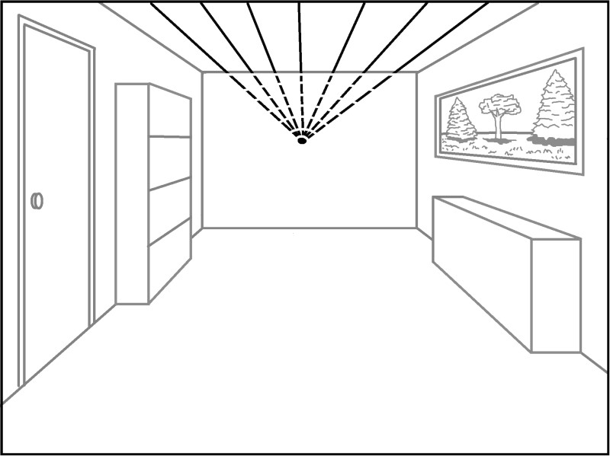

- When drawing the individual tiles, space the transversal lines closer together as they approach the back wall. They will appear smaller because they are farther away from the viewer.

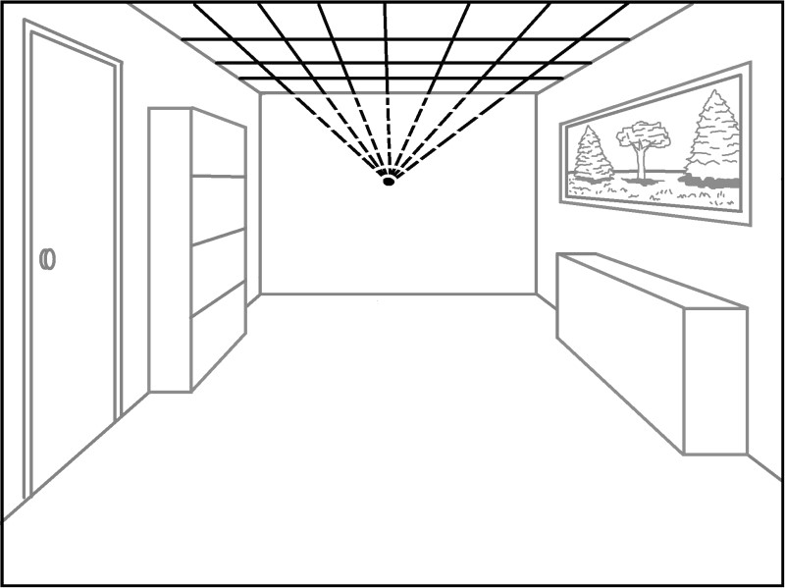

- Erase the orthogonal lines on the back wall.

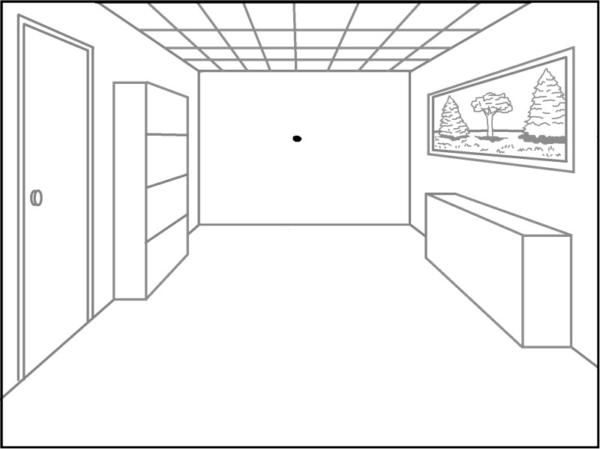

- Create a rug by starting with the closest transversal line, and then add the orthogonal lines. Finally, draw the back transversal line.

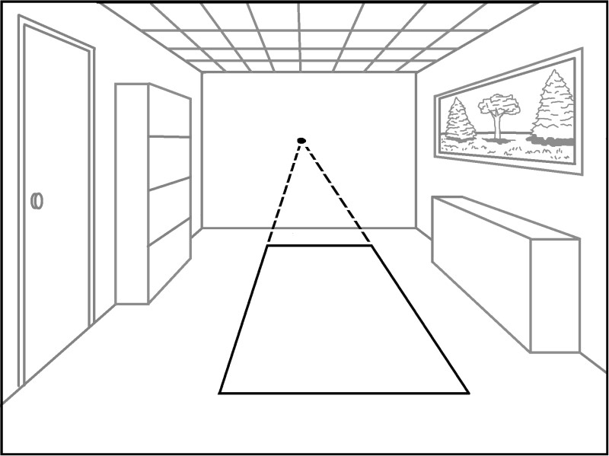

- Erase the connecting lines.

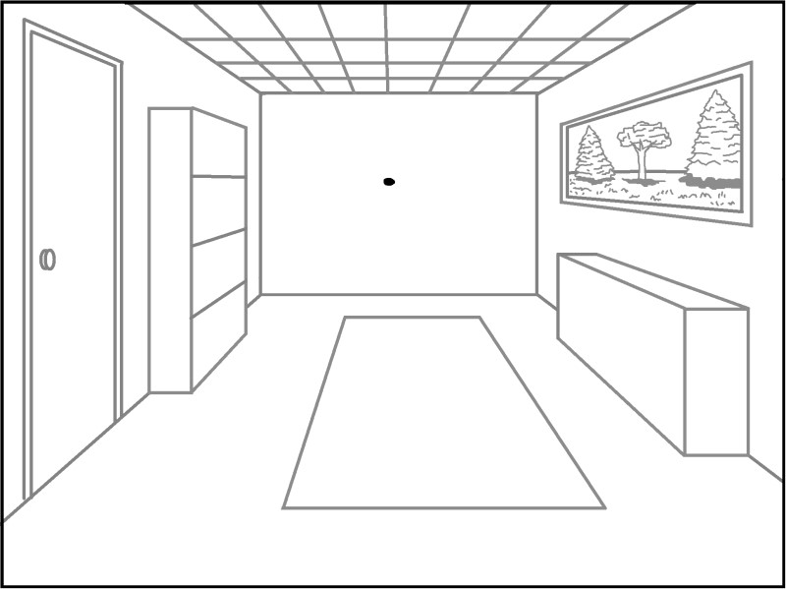

- Creating a door on the back wall is easy because it is only made of transversal lines.

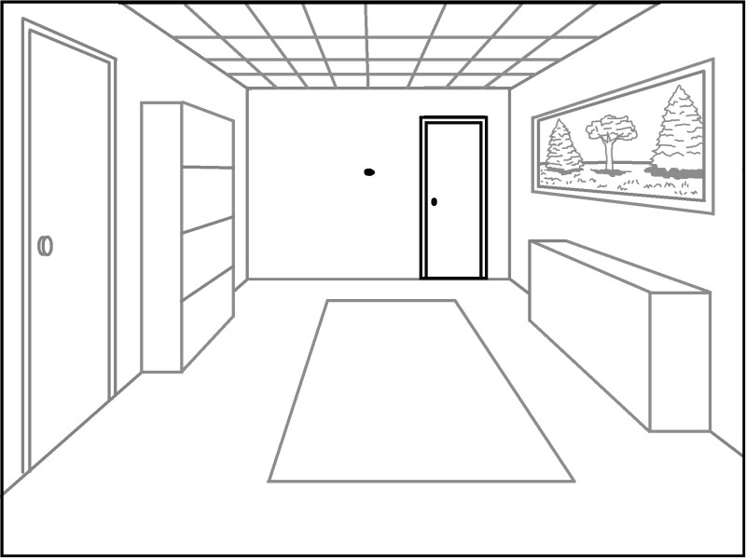

- After adding the final details, erase the vanishing point.

1 Point Perspective Drawings Created by High School Students
