Art I: Pop Art Painting
Due: Friday, 4/20
Pop Art has a distinct style. Flat areas of bright paint come together to make an ordinary object pop.
Most anything you can think of has been made into Pop Art. Think of a subject you would like to paint and you may find a resource. Please send it to my e-mail because we have to print these pictures in color.
I also have a white binder in the center of the room with references if you would like to use that instead. Be sure to return the pictures everyday. Other people will be using the pictures.
Draw out your design on a 12 x 16 paper provided. You do not have to draw a grid for this one. Take your time drawing your picture and make sure your painting has flat vibrant color that you have mixed yourself.
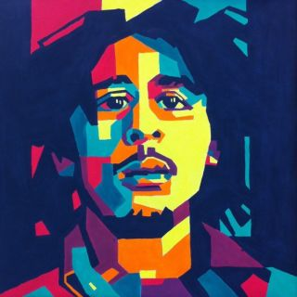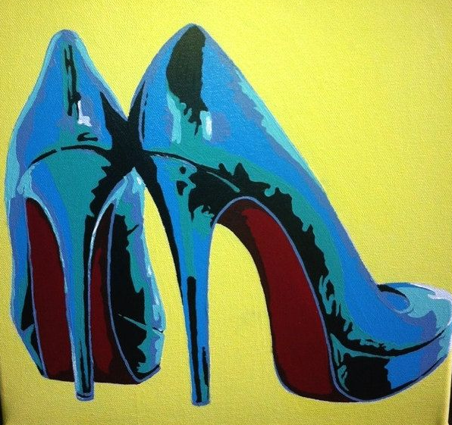

**Do Not Copy Any Of The Example Squares Given**
Grading Guidelines:
Creativity & Originality | Bold Use of Color
Composition | Paint is evenly put on paper, no streaks or empty spots
Skill/Craftsmanship | Painting is outlined in black
Directions | Details are used to finish your painting
Time Usage/Effort

