Art I: Monochromatic Painting
Due: Tuesday, 4/17
Monochromatic: containing or using one color.
- Gridding Your Paper: Use your ruler to measure out your grid squares in equal increments, depending on the size of your cropped image. In this case, printed photo will have a 1 inch grid and the large paper will have a 3 inch grid. Do not forget to measure and make marks on both sides of the image or paper for straight lines. You must have the same amount of grid squares on your large paper as is on your cropped image.
- Contour Grid Drawing: Use the grid to lightly draw in your image. You will do a contour drawing following the lines you have made on your photocopy defining the different grey values.
- Remember that your black and white photograph needs to have lots of dark and light areas.
- Mix one tint or shade at a time, and start painting either the darkest or lightest values.
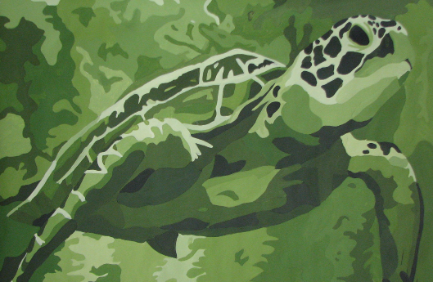
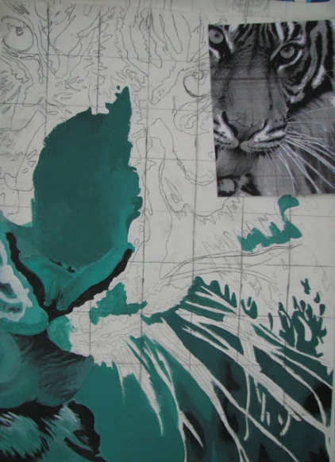
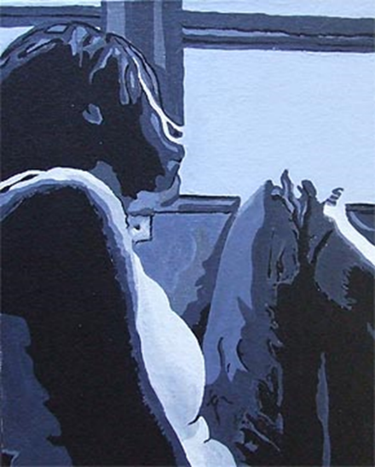

**Do Not Copy Any Of The Example Squares Given**
Grading Guidelines:
Creativity & Originality | Drawing done using the grid method
Composition | Tint, tone, and shade are achieved using one color + black and white
Skill/Craftsmanship | Value is correctly used in the painting
Directions | Details are used to finish your painting
Time Usage/Effort | Paint layers are even

