Art I: Oppositional Drawing
Create an oppositional drawing. (Ex. Good vs Evil, Fire vs Ice) You will need to brainstorm about two opposing/opposite ideas or forces. It can be very general or specific to a tv or movie. It is open ended for you to decide. Some things to remember:
- Think creatively! Do not use the same examples I give you.
- Create value using the colored pencils. (Remember 5-6 Colored Pencil Quality)Colored Pencil Quality is very important to receive a good grade.
- Fill the space
- Use colors that show opposition as well. (Cool Colors vs Warm Colors)
- Check for full use of the page, neatness and detail.
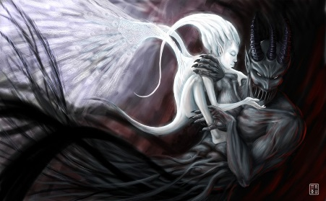
**Do Not Copy Any Of The Example Given**
Grading Guidelines
Creativity & Originality | Two Opposing Forces
Composition | Creative way of representing those two forces.
Skill/Craftsmanship | Composition was used to create an interesting drawing.
Directions | Lots of details used.
Time Usage/Effort | Used color pencils according to quality chart.

