Hidden Lizards

- Draw a lizard using your whole 9x12 page.
- Decide on a design that will hide your lizard.
- Draw the design on your paper.
- Color with colored pencils to hide your lizard.
- Make sure you pay attention to colored pencil quality.

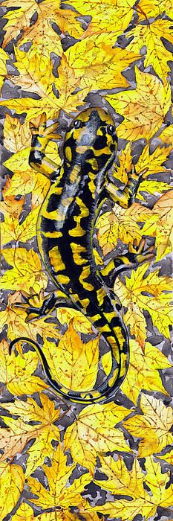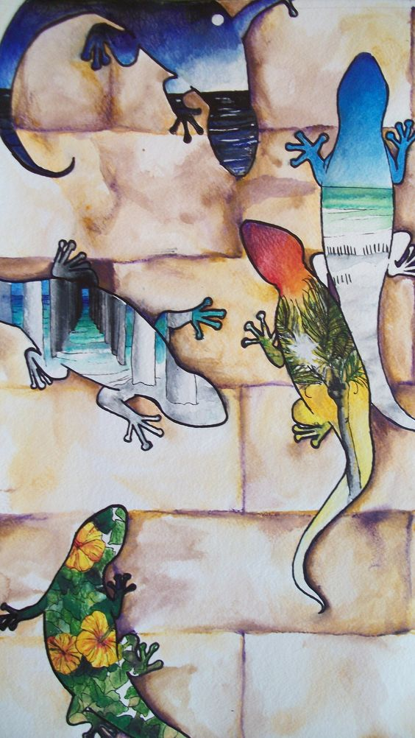
**Do Not Copy Any of the Example Given**
Grading Guidelines:
Creativity & Originality | Your drawing is accurate.
Composition | Your background is detailed.
Skill/Craftsmanship | Your lizard is detailed.
Directions | Color According to Color Pencil Quality Chart.
Time Usage/Effort | Lizard Looks 3 Dimensional

