DAILY 3
Practice sight words each night.
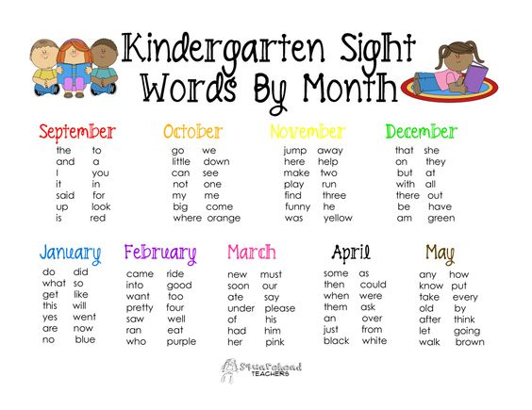

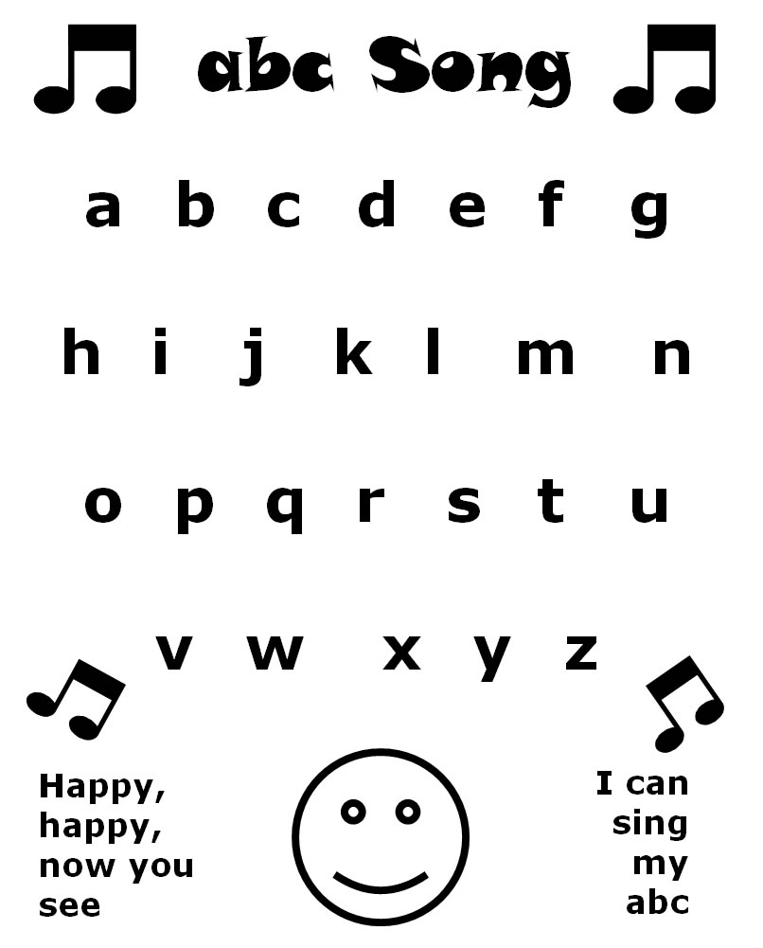
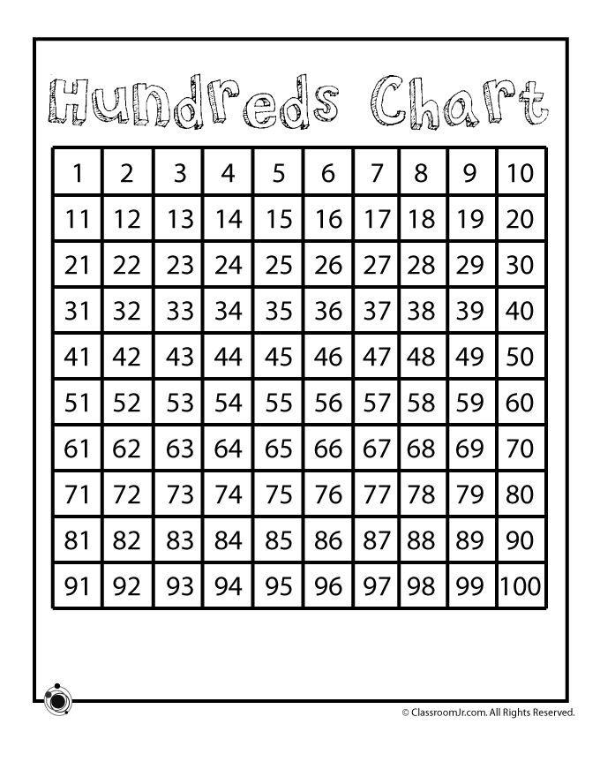
Practice counting and numbers. Practice singing your ABC’s!

